Building Apps for Wearables

[developer.android.com](http://developer.android.com/training/building-wearables.html)

These classes teach you how to build notifications in a handheld app that are automatically synced to wearables as well as how to build apps that run on wearables.

**Note:** For more information about the APIs used in these training classes, see the [Wear API reference documentation](http://developer.android.com/reference/packages-wearable-support.html).

Table of Contents

Android Wear 8

Suggest: The Context Stream 8

Demand: The Cue Card 8

Other UI Features 9

Creative Vision for Android Wear 10

Launched automatically 10

Glanceable 10

All about suggest and demand 10

Zero or low interaction 11

Design Principles for Android Wear 11

Focus on not stopping the user and all else will follow 11

Design for big gestures 12

Think about stream cards first 12

Do one thing, really fast 13

Design for the corner of the eye 13

Don’t be a constant shoulder tapper 13

App Structure for Android Wear 14

Bridged Notifications 14

Contextual Notifications 15

2D Picker 16

Breaking out of the card (with custom layouts) 18

Keeping the app always-on 19

Context Awareness on Android Wear 21

Pinterest 21

Trulia 21

Ski Conditions 22

Thermostat 22

Airport 23

Hotel 23

Conference 24

Restaurant 24

Oil Change 25

Car Sharing 25

Zoo 26

Location-based Query 26

UI Patterns for Android Wear 27

Cards 27

App icons 28

Pages 28

Dismissing cards 28

Action buttons 29

Action countdown and confirmation 29

Continuing activities on phone 30

Actions on cards (such as media controls) 30

Card stacks 31

2D Picker 31

Voice commands 32

Selection List 32

Style for Android Wear 33

Screen Size 33

Specific Assets Required 34

Peek Card Readability 34

Low Information Density 35

Separate Information into Chunks 36

Keep Notifications to a Minimum 36

Use Clear, Bold Typography 36

Use Consistent Branding and Color 37

Copywrite Sparingly 37

Be Discreet if Necessary 37

Confirmation Animations 37

Watch Faces for Android Wear 38

Creative Vision 39

Plan for Square and Round Devices 39

Plan for All Display Modes 42

Optimize for Special Screens 42

Accomodate System UI Elements 43

Design Data-Integrated Watch Faces 46

Support the Android Wear Companion App 48

Specifications and Assets 49

Adding Wearable Features to Notifications 50

Lessons 50

Creating a Notification for Wearables 51

Import the necessary classes 51

Create Notifications with the Notification Builder 51

Add Action Buttons 52

Specify Wearable-only Actions 53

Add a Big View 54

Add Wearable Features For a Notification 55

Deliver the Notification 56

Receiving Voice Input in a Notification 57

Define the Voice Input 57

Add Pre-defined Text Responses 58

Add the Voice Input as a Notification Action 59

Receiving the Voice Input as a String 60

Adding Pages to a Notification 60

Stacking Notifications 62

Add Each Notification to a Group 63

Add a Summary Notification 63

Creating Wearable Apps 65

Lessons 67

Creating and Running a Wearable App 68

Update Your SDK 68

Set Up an Android Wear Emulator or Device 68

Create a Project 70

Install the Wearable App 71

Include the Correct Libraries 71

Debugging over Bluetooth 72

Setup Devices for Debugging 72

Set Up a Debugging Session 73

Debug Your App 73

Creating Custom Layouts 74

Create Custom Notifications 74

Create Layouts with the Wearable UI Library 76

Wear UI library API reference 77

Download the Wearable UI library for Eclipse ADT 77

Keeping Your App Visible 77

Enable Ambient Mode in a Wearable App 78

Configure your development project 78

Create an activity that supports ambient mode 79

Handle transitions between modes 80

Update Content in Ambient Mode 81

Update once a minute 81

Update more frequently 81

Maintain Backward-compatibility 85

Adding Voice Capabilities 85

Declare System-provided Voice Actions 85

Declare App-provided Voice Actions 89

Obtaining Free-form Speech Input 90

Packaging Wearable Apps 90

Package with Android Studio 91

Signing the wearable and handheld app separately 92

Package Manually 92

Turn off Asset Compression 93

Creating Custom UIs for Wear Devices 94

Lessons 94

Defining Layouts 95

Add the Wearable UI Library 96

Specify Different Layouts for Square and Round Screens 97

Accessing layout views 98

Use a Shape-Aware Layout 98

Creating Cards 101

Create a Card Fragment 101

Add a CardFrame to Your Layout 103

Creating Lists 105

Add a List View 105

Create a Layout Implementation for List Items 106

Create a Layout Definition for Items 107

Create an Adapter to Populate the List 108

Associate the Adapter and Set a Click Listener 110

Creating a 2D Picker 111

Add a Page Grid 111

Implement a Page Adapter 111

Assign an adapter instance to the page grid 114

Showing Confirmations 115

Use Automatic Confirmation Timers 115

Show Confirmation Animation 117

Exiting Full-Screen Activities 118

Disable the Swipe-To-Dismiss Gesture 119

Implement the Long Press to Dismiss Pattern 119

Sending and Syncing Data 121

Lessons 122

Accessing the Wearable Data Layer 123

Syncing Data Items 124

Sync Data with a Data Map 125

Listen for Data Item Events 126

Transferring Assets 128

Transfer an Asset 128

Receive assets 129

Sending and Receiving Messages 130

Send a Message 130

Advertise capabilities 131

Retrieve the nodes with the required capabilities 131

Deliver the message 133

Receive a Message 134

Handling Data Layer Events 135

Wait for the Status of Data Layer Calls 135

Listen for Data Layer Events 136

With a Listener Activity 139

Creating Watch Faces 141

Lessons 141

Designing Watch Faces 142

Conform to the Design Guidelines 142

Create an Implementation Strategy 143

Building a Watch Face Service 144

Create and Configure Your Project 144

Dependencies 145

Implement the Service and Callback Methods 146

Register the Watch Face Service 148

Drawing Watch Faces 149

Initialize Your Watch Face 150

Configure the System UI 155

Obtain Information About the Device Screen 156

Respond to Changes Between Modes 157

Draw Your Watch Face 158

Showing Information in Watch Faces 160

Create a Compelling Experience 160

Add Data to Your Watch Face 161

Providing Configuration Activities 164

Addressing Common Issues 167

Detect the Shape of the Screen 167

Accomodate Peek Cards 168

Configure the System Indicators 169

Use Relative Measurements 170

Optimizing Performance and Battery Life 170

Reduce the Size of Your Bitmap Assets 170

Combine Bitmap Assets 171

Disable Anti-Aliasing when Drawing Scaled Bitmaps 171

Use bitmap filtering 172

Move Expensive Operations Outside the Drawing Method 172

Follow Best Practices to Save Power 172

Detecting Location on Android Wear 174

Connect to Google Play Services 174

Request Location Updates 176

Detect On-Board GPS 177

Handle Disconnection Events 178

Handle Location Not Found 179

Synchronize Data 179

Articles 181

Android Wear Security Analysis 181

WearableListenerService 182

WearableService 187

Conclusion 190

# Android Wear

Designing apps for wearable devices powered by Android Wear is substantially different than designing for phones or tablets: different strengths and weaknesses, different use cases, different ergonomics. To get started, you should understand the overall vision for the Android Wear experience, and how apps fit into and enhance this experience. We've also provided source files for UI resources that you can use in your own apps in the [Downloads](http://developer.android.com/design/downloads/index.html#Wear) section.

A new form factor deserves a new UI model. At a high level, the Android Wear UI consists of two main spaces centered around the core functions of **Suggest** and **Demand**. Your app will have an important role to play in both of these spaces.

### Suggest: The Context Stream

The context stream is a vertical list of cards, each showing a useful or timely piece of information. Much like the Google Now feature on Android phones and tablets, users swipe vertically to navigate from card to card. Only one card is displayed at a time, and background photos are used to provide additional visual information. Your application can create cards and inject them into the stream when they are most likely to be useful.

This UI model ensures that users don’t have to launch many different applications to check for updates; they can simply glance at their stream for a brief update on what’s important to them.

Cards in the stream are more than simple notifications. They can be swiped horizontally to reveal additional [pages](http://developer.android.com/design/wear/patterns.html#Pages). Further horizontal swiping may reveal [buttons](http://developer.android.com/design/wear/patterns.html#Actions), allowing the user to take action on the notification. Cards can also be dismissed by swiping left to right, removing them from the stream until the next time the app has useful information to display.

### Demand: The Cue Card

For cases where Android Wear does not suggest an answer proactively through the context stream, the cue card allows users to speak to Google. The cue card is opened by saying, “OK Google” or by tapping on the background of the home screen. Swiping up on the cue card shows a list of suggested voice commands, which can also be tapped.

At a technical level, each suggested voice command activates a specific type of intent. As a developer, you can match your applications to some of these intents so that users can complete tasks using these voice commands. Multiple applications may register for a single voice intent, and the user will have the opportunity to choose which application they prefer to use.

Applications can respond to a voice command in the same way as they can respond to a tap on a regular in-stream action button: by adding or updating a stream card, or by launching a full screen application. Voice input often takes the form of a command, such as "remind me to get milk," in which case a simple confirmation animation is sufficient to display before automatically returning to the Context Stream.

### Other UI Features

* The **Home screen** is the default state of the device and features:
  + The background, showing either content relating to the first card or a custom watch face design, depending on the watch face the user has chosen. Tapping anywhere on the background or saying "Ok Google" starts a voice query.
  + Status indicators, showing connectivity, charging status, airplane mode, and in some watch faces a count of unread items.
  + The top ranked card in the Context Stream, peeking up at the bottom of the screen. The amount of the peek card that appears is determined by the current watch face.
* **Watch faces** may be chosen by the user to appear in the background of the Home screen. Watch faces display the time and accommodate the top ranked peek card. The user can choose a different watch face by long pressing on the current one.
* Some devices may enter a low-power **Ambient Mode** when not being used. This usually involves dimming the screen in some way. The contents of a peek card will automatically be optimized for display in this state. Users can exit ambient mode by tapping on the screen, by tilting the screen towards them, or by pressing a hardware button if one exists.
* Swiping down on the Home screen reveals the **Date and Battery** display. Dragging further down toggles **Mute mode**, preventing interruptive notifications from vibrating and illuminating the screen.
* The **Settings screen** can be invoked from the cue card or on some devices using a hardware button. From here the user may shut down or restart their device, adjust screen brightness, toggle airplane mode, and access device information.
* **Full screen apps** can be launched on top of the main stream where a wider range of interaction is called for. Although not stylistically limited to the context stream pattern, apps should respect the same design principles as the rest of the system. For more information, see the [App Structure](http://developer.android.com/design/wear/structure.html) guide.

## Creative Vision for Android Wear

Android Wear devices provide just the right information at just the right time, allowing users to be more connected to both the virtual world and the real world. Great Android Wear experiences are:

### Launched automatically

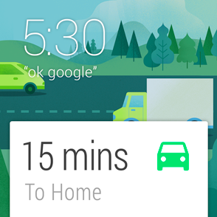Most people are used to launching apps by clicking an icon. Android Wear is different. Wearable apps are aware of the user’s context - time, location, physical activity, and so on. The apps use this information to insert cards into the stream when they become relevant. This makes Android Wear timely, relevant and very specific.

### Glanceable

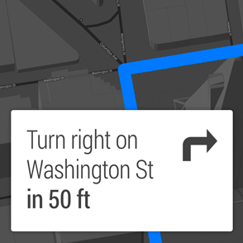A classic wrist watch is designed to let you see the time in a split second and get on with what you were doing. Designing for Android Wear is no different. The less time it takes to use your software, the more time the user can be present in whatever they are doing. Android wear is fast, sharp, and immediate.

### All about suggest and demand

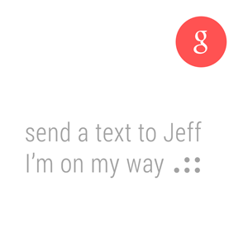Android Wear is like a great personal assistant: it knows you and your preferences, it only interrupts you when absolutely necessary, and it’s always on hand to provide a ready answer. Android Wear is helpful, respectful, and responsive.

### Zero or low interaction

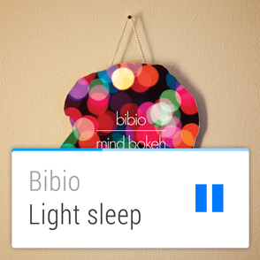Staying true to the strengths afforded by a smaller form factor, Android Wear focuses on simple interactions, only requiring input by the user when absolutely necessary. Most inputs are based around touch swipes or voice, and inputs requiring fine-grained finger movements are avoided. Android Wear is gestural, simple, and fast.

By providing a smart connection to the rest of the world while respecting the user’s attention, Android Wear feels personal and global, simple and smart, unobtrusive and ever-ready. Applications that represent these principles will feel most at home in the overall Android Wear experience.

Third party apps extend Android Wear to be more specialized and helpful throughout the day. Installing apps are a way for the user to tell the Android Wear how to do that.

## Design Principles for Android Wear

These design principles provide some simple heuristics about how you should plan and assess your Android Wear app design.

### Focus on not stopping the user and all else will follow



The time required for each action on the left is 5 seconds.

A watch is a perfect form factor for a device that you can use while doing something else, such as cooking, eating, walking, running, or even having a conversation. If using your wearable app causes the user to stop whatever they’re doing, it’s a good occasion to consider how to improve it using the principles in this section.

**Try this**: Time a typical use of your Wear app. If using it takes more than 5 seconds, you should think about making your app more focused. Also try using your app while you’re having a conversation, and see how it affects your train of thought and eye contact.

### Design for big gestures

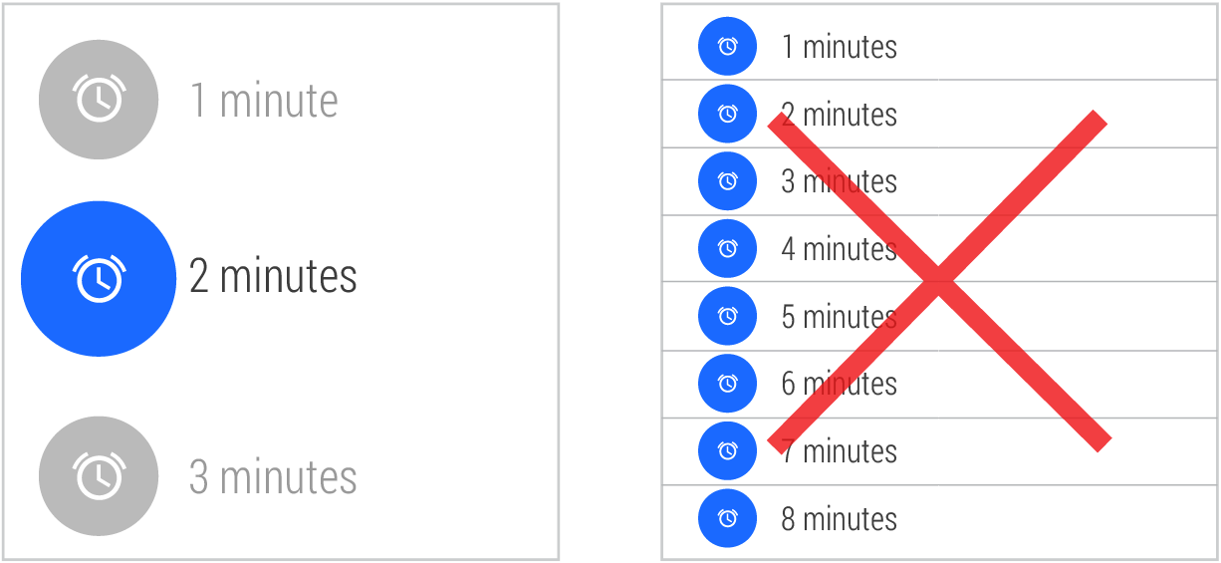

Use few and large touch targets.

When you swipe through photos on your phone, you’re using a large area of the display and precision isn't required. That’s the best kind of interaction for a wearable device. Your users are going to use your app in all sorts of situations, the least frequent one might actually be sitting down at their desk.

**Try this**: Use your app in various everyday situations, such as walking, eating, talking to people, or ordering coffee. If you have to slow down while walking or stop the conversation to be precise, you should consider how your gestures could be bigger.

### Think about stream cards first

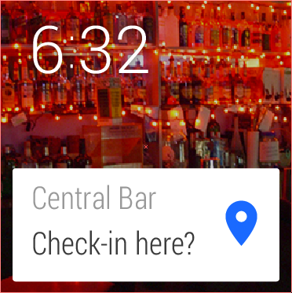An app that offers to check in users could appear in the stream suggesting the most likely place nearby, after a certain amount of time.

The best experience on a wearable device is when the right content is there just when the user needs it. You can figure out when to show your cards with sensors, or events happening in the cloud. For the cases where it’s impossible to know when the user needs your app, you can rely on a voice action or touch.

**Try this**: Make a list of all the situations a user would find your app useful. What do they have in common? Same location? Time of day? Certain physical activities? You will most likely come up with several different situations - that’s a good sign, because it means that you can specialize your cards to those situations. Remember that the user always has the option of completely muting your stream cards if they feel they aren’t relevant enough.

### Do one thing, really fast

While users will engage with your app for only a few seconds at time, they'll use it many times throughout the day. A well-designed stream card carries one bit of information and potentially offers a few action buttons when the user swipes over.

**Try this**: How many bits of information are there in your design? Is everything absolutely necessary, or could you split it up into separate cards? If you’re designing a card, don’t forget that you can use multiple pages.

### Design for the corner of the eye

The longer the user is looking at your app, the more you are pulling them out of the real world. Thinking about how to design your app for glanceability can vastly help the user get full value from your app and quickly go back to what they were doing.

**Try this**: To view your app with your peripheral vision, try focusing on your knuckles while your watch is displaying the app. Do you get a sense of what it is trying to do? Is it distinguishable from other apps? Does the background image help convey the message? Does it use photos or a distinct shape and color?

### Don’t be a constant shoulder tapper

A watch constantly touches the user’s skin. Being this intimate, you want to vibrate the watch fewer times than you might on a phone.

**Try this:** Next time you’re in a conversation, imagine someone tapping you on your shoulder, interrupting you with the information you want your app to deliver. If the information delivered did not justify suspending a conversation, you should not make the notification interruptive.

## App Structure for Android Wear

Users are used to tapping icons to launch apps. Android Wear is different. A typical Wear app adds a card to the stream at a contextually relevant moment. It might have a button that opens a full screen view for a fast micro interaction, but it just as well might not.

These are the building blocks, ordered by simplicity. You can use one of them or some of them, but we strongly recommend not building apps the user has to launch and quit before thinking really hard about how you could react to a specific location, activity, time of day, or something happening in the cloud.

* **Contextual card in the stream**:
  + [**Bridged notifications**](http://developer.android.com/design/wear/structure.html#Bridged), such as new message notifications, are pushed to the wearable from the connected handheld using standard Android notifications. They require very little or no Wear-specific code.
  + [**Contextual notifications**](http://developer.android.com/design/wear/structure.html#Contextual), such as an exercise card that appears when you begin running, are generated locally on the wearable and appear at contextually relevant moments. You can do more with this kind of card than with a notification bridged from the handheld.
* **Full screen UI app**:
  + [**2D Picker**](http://developer.android.com/design/wear/structure.html#2DPicker) is a design pattern that allows the user to select from a set of items, such as to select an artist then an album. We recommend using this pre-built component from the SDK whenever relevant.
  + [**Custom layouts**](http://developer.android.com/design/wear/structure.html#Custom) are also possible where apps need to extend beyond the basic card/stream metaphor, such as to present a graph or map.
  + [**Keep your app always-on**](http://developer.android.com/design/wear/structure.html#AlwaysOn) if you have information that refreshes or stays relevant, without draining the battery.

### Bridged Notifications

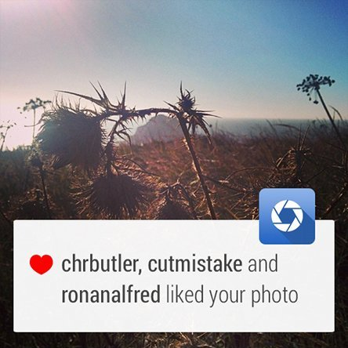

This is the simplest way to get on Android Wear. In fact, your app already does this if it uses notifications. You can add Wear-specific features like extra pages and voice replies by using the new notification APIs.

### Contextual Notifications

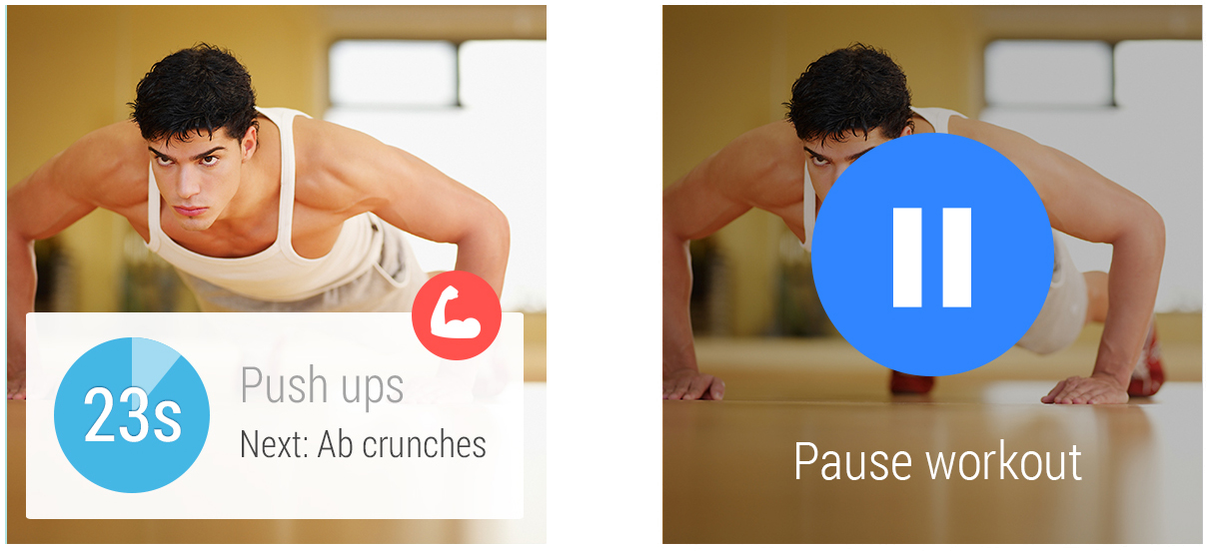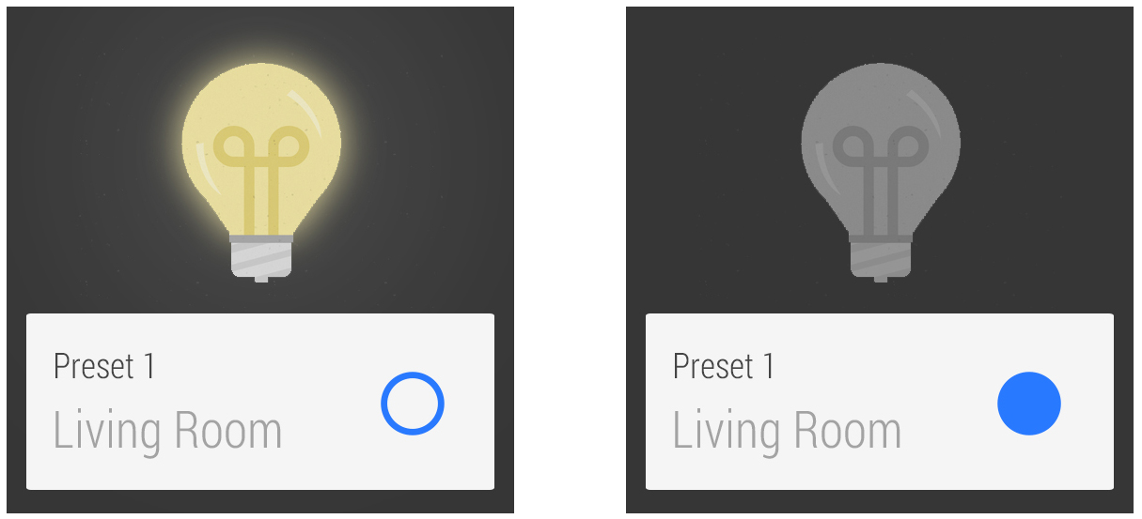

This is what Android Wear does best: showing users information and functionality just when they need it.

Here’s how it works: Your app knows when it is relevant for the user. When the appropriate event occurs, the app triggers a notification. Maybe you’re building a running app that’s relevant when the user is running. Maybe it’s a museum guide that’s relevant when the user is visiting your museum. Check out the [design principles](http://developer.android.com/design/wear/principles.html) for more about how to make your app contextual.

Getting contextual triggering right is one of the most impactful things you can do to craft a great user experience.

The easiest way to do this is to use standard templates for Android notifications. But you can also make your own layout from scratch with an [activity](http://developer.android.com/guide/components/activities.html) inside a card. If you decide to do this, we strongly recommend you take a look at the [Style](http://developer.android.com/design/wear/style.html) guide to make sure you stay consistent with the rest of the device.

Don’t forget to test your triggering thoroughly. Triggering too often can be so annoying that users might end up blocking all your notifications.

### 2D Picker

The 2D Picker design pattern (available as the [GridViewPager component](http://developer.android.com/training/wearables/apps/layouts.html#UiLibrary)) is useful for showing options in a list. Google search results are a great example of this pattern in action.

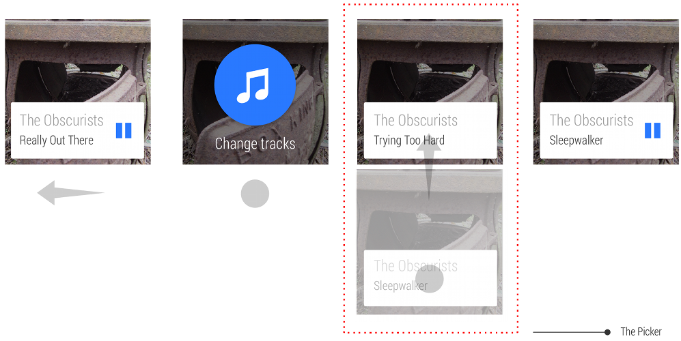

This pattern can be used to present a single vertical list, or a “1D Picker”

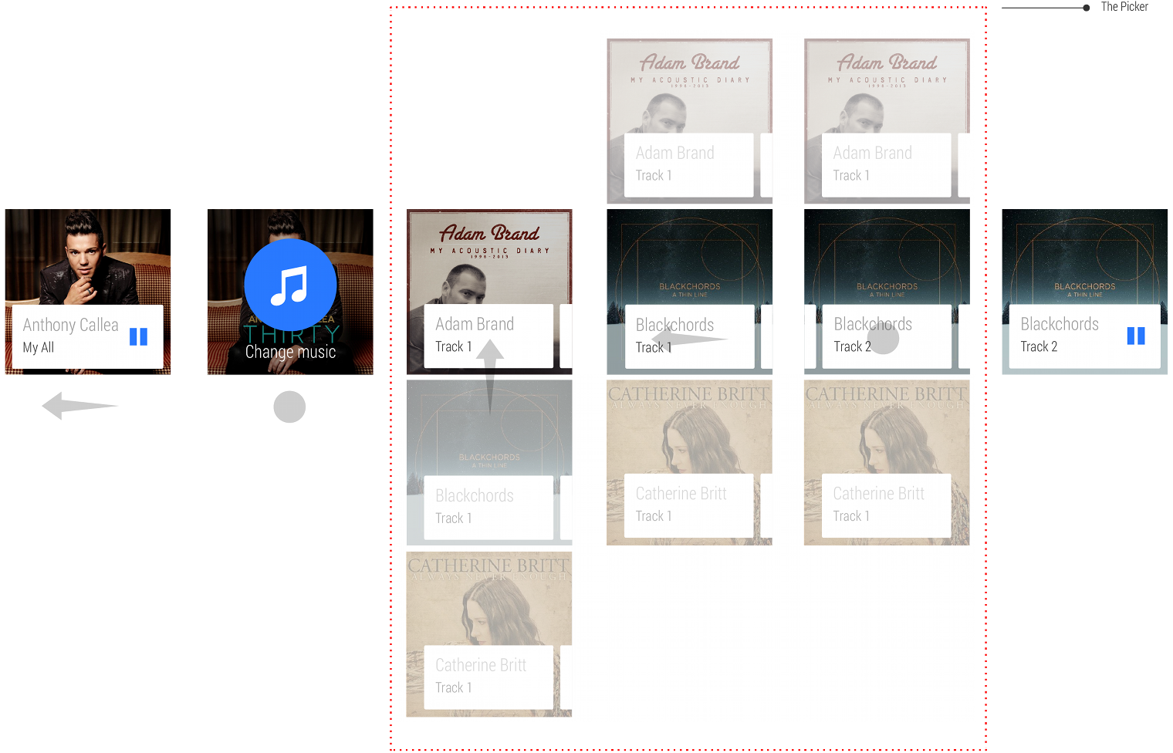

It can also be used as a 2D matrix of options, as a way of presenting categorized options.

#### Actions

For actions on each card, use the [Action cards pattern](http://developer.android.com/design/wear/patterns.html#Actions).

#### Making it fast

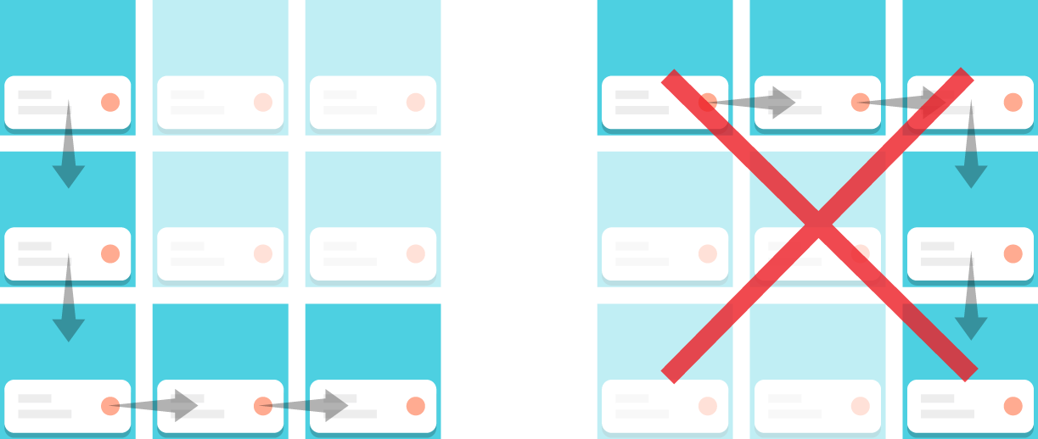

Navigation should be vertical-then-horizontal, not horizontal-then-vertical, and limit the vertical set to about five cards.

Here are a few of our favorite tips about how to make the 2D picker really fast for your users:

* Minimize the number of cards
* Show the most popular card at the top
* Keep the cards extremely simple
* Optimize for speed over customization

#### Exiting

Your app should dismiss the 2D picker when the user makes a selection. Users should also be able to exit by swiping the first card down, or swiping left to right on a left-most card.

### Breaking out of the card (with custom layouts)

There are some things you can’t do on a card. Swiping in many directions on a map or controlling a game with a joystick are a couple examples. In those cases it might be good idea to momentarily go full screen.

A typical user experience with a full screen app on Android Wear looks like this:

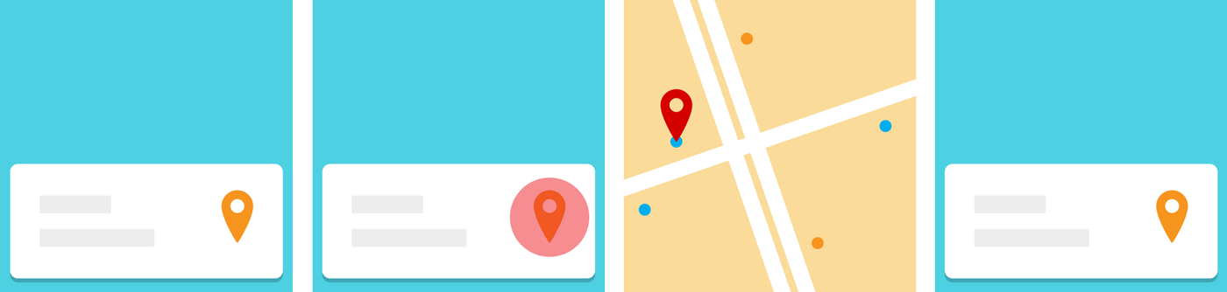

1. Your contextual card enters the stream.
2. The user taps the card action.
3. A full screen activity opens for a micro interaction.
4. The activity quits and the user returns to the stream.

#### When to go full screen

We highly recommend going full screen only when you can’t do what you want on a card, and quickly exit back to the stream the moment the user is done with the micro interaction. This will make your app will feel like an integrated part of the system. Android Wear itself uses full screen for voice replies and the stopwatch.

#### Making it distinct

Your full screen design shouldn’t look too much like the card stream as it could confuse users. If you do need a card-like UI, the [2D picker](http://developer.android.com/design/wear/structure.html#2DPicker) is always available.

#### Automatically exiting

Many devices don’t have back or home buttons, so exiting is something you have to think about. Here are a few examples of natural ways to exit:

* A map that asks the user to drop a pin should exit when the pin is dropped.
* A short game can exit when the game finishes.
* A drawing app can finish after 5 seconds of inactivity.

An app generally should not exit in [onPause()](http://developer.android.com/reference/android/app/Activity.html#onPause()). This is because events such as [Heads-up Notifications](http://developer.android.com/guide/topics/ui/notifiers/notifications.html#Heads-up) can trigger the [onPause()](http://developer.android.com/reference/android/app/Activity.html#onPause()) callback.

#### Manually exiting

Even with logical exit points like these, some cases may exist where the user may want to immediately exit. This may be common in apps that are used for a longer while. In all cases, you should treat long-press as the user's intent to exit, using [DismissOverlayView](http://developer.android.com/training/wearables/ui/exit.html).

## Keeping the app always-on

An Android Wear device has two modes:

* **Interactive mode -** A full-color mode where the user can interact with your app.
* **Ambient mode -** A low-power mode where the screen is rendered in black and white, with minimal grayscale graphics.

Interactive activities provide real-time information and feedback to the user, but it can quickly drain the device's battery. To reduce battery usage and still present useful information, apps can transition into an ambient mode called *always-on*.

Your app can display dynamic data on the device, even when the app is in ambient mode. This approach is useful if your app displays information that is continuously updated, like a running tracker app, or when it presents information the user needs for reference, like a grocery app.

Typical user experiences with apps that switch into ambient mode on Android Wear look like this:

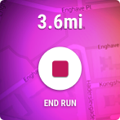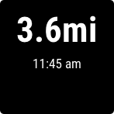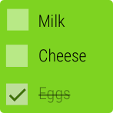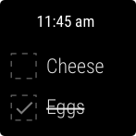

When the app switches to ambient mode, remove all elements that invite touch or indicate the elements are disabled. In addition, consider showing the current time.

#### Update frequency

You should only update the display once per minute, to preserve battery life of the wearable device. You can update the display every 10 seconds, but make sure you only update when absolutely necessary. Every update depletes the device's battery.

#### Interactive elements

Don’t present any buttons or other interactive elements when the app is in ambient mode. This approach could mislead the user into thinking the app is in interactive mode.

#### Colors and brightness

Use grayscale colors to help signal that the user must wake up the device before they can interact with it. Also note that any pixel that is not black will be noticeably bright for users in dimly lit rooms. We strongly recommend keeping the background black whenever possible.

#### Privacy

Consider the user’s privacy when designing and developing an app that displays data in ambient mode. For example, while keeping a messaging app on the screen could be convenient for a user who is in an ongoing conversation, displaying personal messages on the screen for an extended period of time while the app is in ambient mode may bother some users. Consider removing potentially private data after a short period of inactivity or refrain from showing sensitive data in ambient mode.

## Context Awareness on Android Wear

Some of the most powerful user experiences with Android Wear are based on context-aware notifications and actions. By using device sensors and other contextual cues, your app can reveal information and functionality precisely when the user needs it, at a glance.

For example, if you’re building a social app for restaurants, you can recommend popular menu items when your app recognizes that the user is at a restaurant. More examples below provide basic ideas about what you can do with a notification and action confirmation in your Android Wear app.

### Pinterest

Displays a notification when one of your geo-tagged pins is within walking distance.

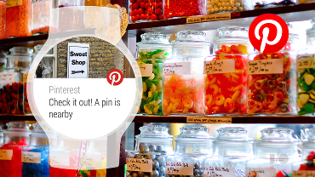

### Trulia

Displays property details and contact options when you are near a new home.

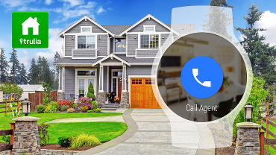

### Ski Conditions

Displays lift status and slope conditions when you arrive at a ski resort.

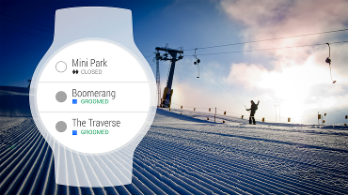

### Thermostat

Controls automatically appear when you are at home.

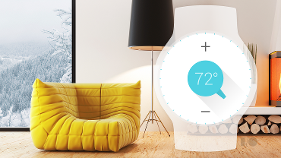

### Airport

Displays air miles while you are waiting at the gate.

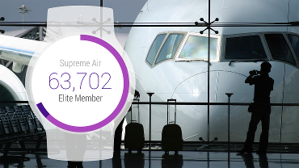

### Hotel

Displays late check out option on the morning of your departure.

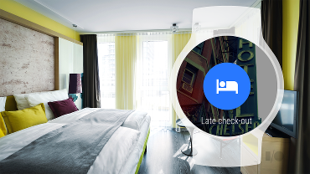

### Conference

Shows which of your friends are also attending the conference.

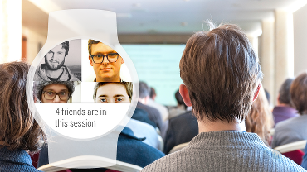

### Restaurant

Provides suggestions for the healthiest items on the menu when in a restaurant.

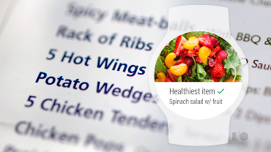

### Oil Change

Offers to set a reminder to change the oil again in six months while waiting at the garage.

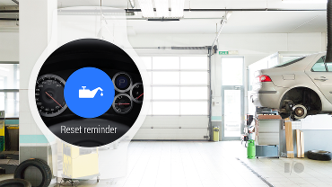

### Car Sharing

Unlocks the car as you approach it.

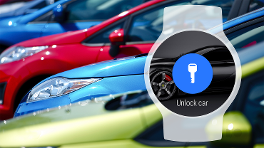

### Zoo

Notifies visitors when the penguins are going to be fed.

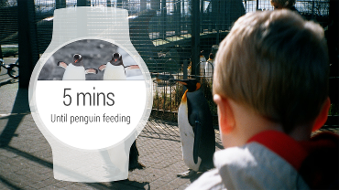

### Location-based Query

Ask questions like, "Are there any picnic tables free at the park?" and get answers in real-time from people in the area.

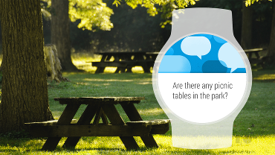

## UI Patterns for Android Wear

Android Wear is used for micro-interactions, and so adhering to consistent design patterns that users are already accustomed to is paramount.

### Cards

Cards in the stream can take slightly different forms:

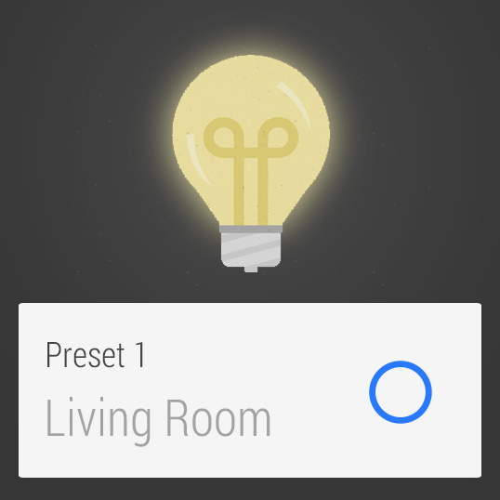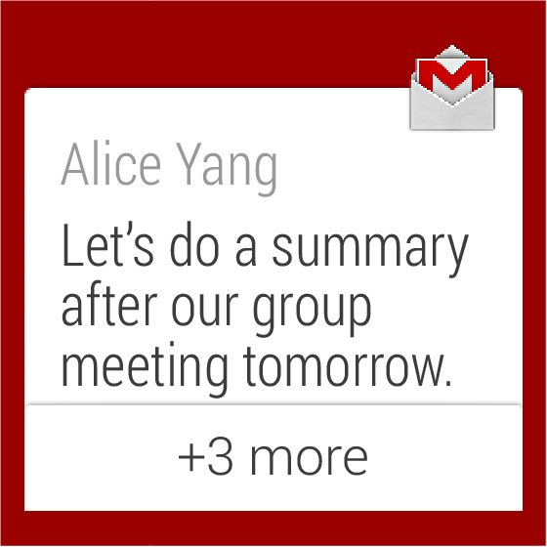

* Standard cards for displaying information from a notification
* Single-action controls (such as a play/pause toggle)
* Expandable stack of cards, for grouping a set of related notifications together

### App icons

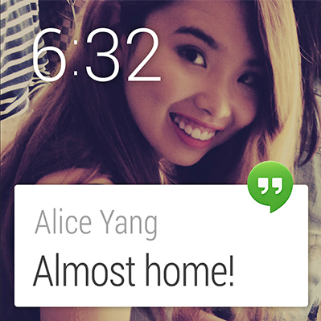App icons appear in a fixed position overhanging the edge at the top right of the card by default for all notifications in the Context Stream. This is an opportunity for cards to be recognized as coming from a specific source. Photo backgrounds should be used only to convey information, not to brand a card. App icons are necessary only on the leftmost card; it is not necessary to add the app icon to pages.

### Pages

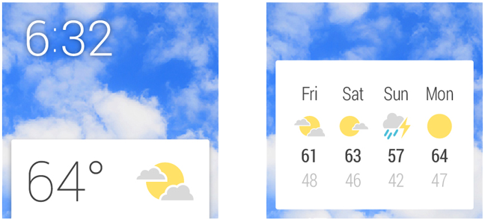

Supplementary information should be displayed on additional cards to the right of a main Context Stream card. In most cases one additional detail card should be sufficient. For example, a weather card might show the weather for the current location today, with subsequent days listed in an additional card to the right. Keep the number of detail cards as low as possible. Actions (see below) should always come after pages; don’t change the order or interleave them.

### Dismissing cards

Swiping from left to right on a card causes it to be dismissed from the stream. Dismissed cards may return when they next have relevant information. State is synced between the Android Wear context stream and the notifications on the Android handheld device, so dismissing from one causes an automatic dismissal from the other.

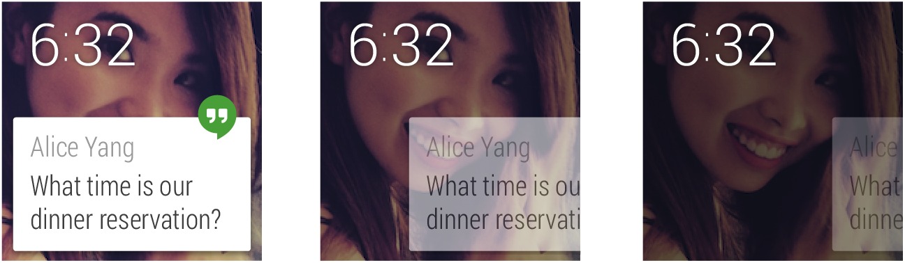

### Action buttons

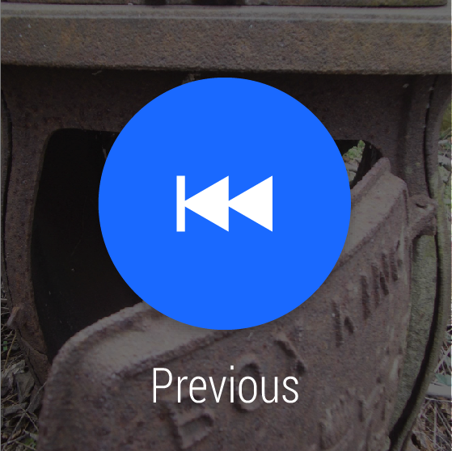Where the user may need to take action on the information shown in a notification, you can provide action buttons. These are system-rendered buttons that appear to the right of detail cards. They consist of a white icon set on a blue system-rendered circular button and a short caption with a verb. Actions should be limited to three for a single card row.

Tapping on an action button can cause an action to be executed, an action to be continued on the companion handheld, or a full screen activity to be invoked for further input (see the [2D Picker](http://developer.android.com/design/wear/patterns.html#2DPicker) section below).

Refer to the UI Toolkit provided in the [Downloads](http://developer.android.com/design/downloads/index.html#Wear) page for detailed specs regarding action icons.

### Action countdown and confirmation

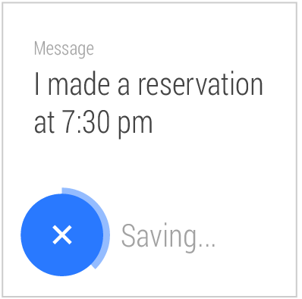

Where tapping on an action button results in an action being executed, one of the following can happen:

1. The action is completed immediately and the result of the action is shown (either by updating the relevant card contents immediately, or by showing a confirmation animation).
2. A short countdown animation to completing the action is played, which the user can interrupt to cancel. Once the timer has counted down, a confirmation animation is played. This animation can be custom-designed by developers.
3. A confirmation step is required. This is for actions that are potentially damaging if accidentally triggered. A generic confirmation template is supplied by the system. Once the user confirms, the standard confirmation animation is played.
4. The cue card can be invoked to continue specifying the action. For example in a messaging application, tapping a “Reply” action button invokes the Cue Card and prompts for voice input. In this case the prompt label (such as “Speak your message…”) and a set of sample voice suggestions can be specified by developers.

### Continuing activities on phone

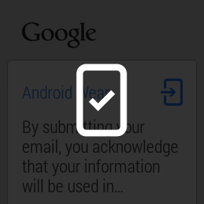

Developers should attempt to perform actions on the wearable device wherever possible. In cases where the phone must be used, a generic animation should be played once the action button has been tapped and the corresponding Android app will open on the phone.

### Actions on cards (such as media controls)

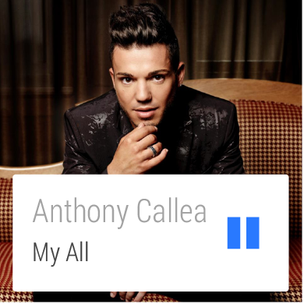

Some cards may benefit from having tappable actions directly on a card. Some guidance on when to use this pattern versus using an action button:

* This pattern should be used when only one possible action could be reasonably expected. For example, tapping on an address with a car icon and ETA seems like it would very obviously launch directions. Conversely, if you see a contact's photo and name, it's not clear what tapping would do (call them? email them?), so the pattern shouldn't be used in this case.
* On-card actions should not require a text label to be understood.
* On-card actions should only result in something happening on the wearable (apart from web links to open them on the phone).
* You should only have one action per card.
* Do not put menus on a single card.

Good examples of using an action on card include: play and pause music, toggle light switch on and off, navigate to an address, and call a phone number.

### Card stacks



Card stacks group related cards together and allow them to be progressively expanded vertically in the stream. A tap on a stack fans the cards out so that the top edge of each card can be seen. A subsequent tap on a fanned card reveals that card fully. Stacks of cards revert to a fully collapsed state once the user has swiped away from them.

### 2D Picker

A 2D Picker component in your app can be invoked from the cue card or from an action button. It allows users to choose from a list of items, and optionally select an attribute of each item. For example, for a social check-in app, you could show a 2D Picker with a vertical list of places to check-in to.

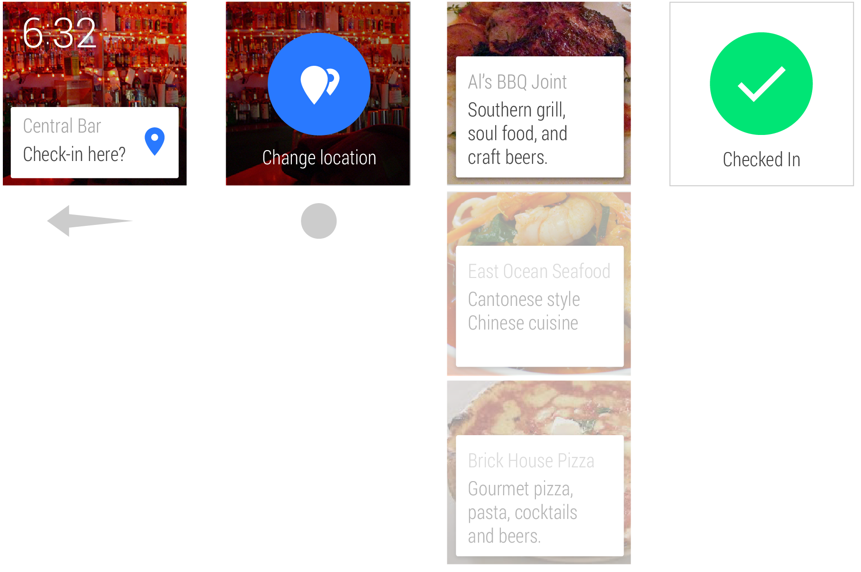

In some instances, further information may be required. In these cases, the most probable default values for these choices should be chosen on the user’s behalf with the option to edit before completing the action. This pattern is in keeping with Android Wear’s core design principle of minimizing interactions required.

More information about how to use the 2D Picker pattern is provided in the [App Structure](http://developer.android.com/design/wear/structure.html#2DPicker) guide.

### Voice commands

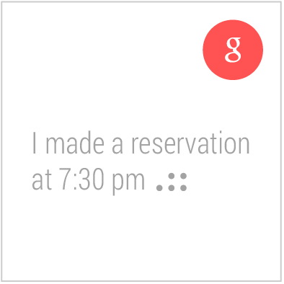

It is possible for apps to take action in response to Android voice commands that invoke intents. For example, an app can register for the “Take a note” intent and capture the subsequent voice input for processing. In the case where multiple apps registered for the same intent, user preference will be captured once and saved. Users can edit their intent preferences in the Android Wear app on their handheld.

### Selection List

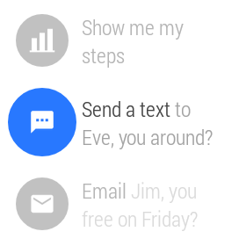

Choosing an item from a list is a common interaction. The Selection List pattern (available as the [WearableListView](http://developer.android.com/training/wearables/apps/layouts.html#UiLibrary) component) creates a simple list optimized for ease of use on a small screen where the focused item snaps to the center of the screen and a single tap selects. This widget is recommended as a common pattern for selecting items. It is used throughout the system UI, including in the list that can be accessed by swiping up on the cue card.

Of course, it is possible for Android Wear apps to extend themselves beyond the familiarities of these patterns. For a deeper look at the options available, see the [App Structure](http://developer.android.com/design/wear/structure.html) guide.

## Style for Android Wear

Here are a number of design considerations to bear in mind that are particular to Android Wear.

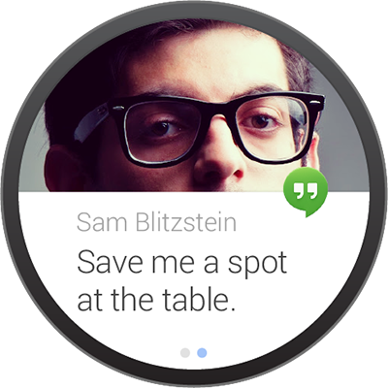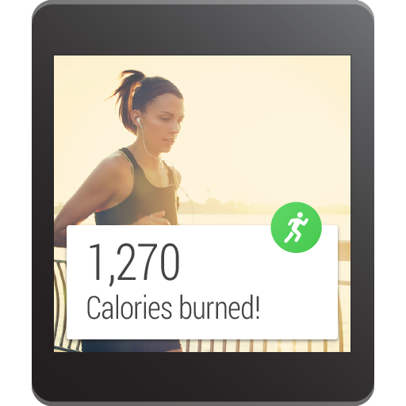

### Screen Size

Be mindful of different device sizes and shapes. Wearable devices are a form of fashion and expression for their owners, and so Android Wear supports a variety of forms. Most of the complexities of supporting these different devices are taken care of at a system level, but bear in mind different screen types when designing custom full screen apps.

Use the Android Wear emulator to test both square and round devices, and note that [WatchViewStub](http://developer.android.com/training/wearables/apps/layouts.html#UiLibrary) is available to activities to detect whether a square or round device is being used.

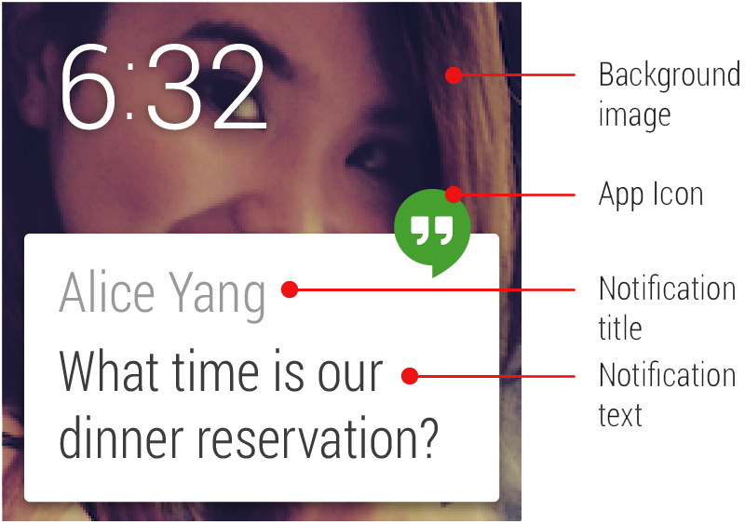

### Specific Assets Required

A core set of standard assets may need to be provided depending on your card design: app icon, background image or images, action icons, and action confirmation animations. Of course, your specific design may necessitate other assets. Background images should be provided in landscape format at least 600px width for notifications that include pages of cards, since the system automatically adds a parallaxing effect.

### Peek Card Readability

Test your card layout to ensure that useful information is conveyed in the peek state on the Home screen. The main message of the card should be readable in the peek state, particularly for contextual cards. Content that requires an interaction to be read, for example a long message, should be cropped appropriately to provide an affordance to the user to swipe the card to read more.

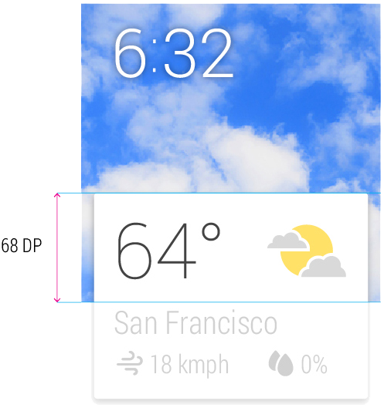

### Low Information Density

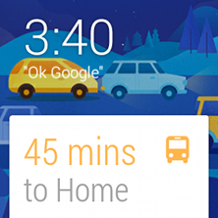

Cards should be designed to be glanceable in a split second, just like reading the time on a traditional watch. In most cases a pairing of an icon and value, or a title and short caption should be enough to convey a meaningful message. Note that the background photo should also be used to convey information; backgrounds that change to reflect and support the primary message in the card work great. For example, in the case illustrated to the right, a suitable background image is chosen to reflect the severity of current traffic conditions. This is not just a nice piece of attention to detail; the background actually reinforces the message and makes the content more glanceable.

### Separate Information into Chunks

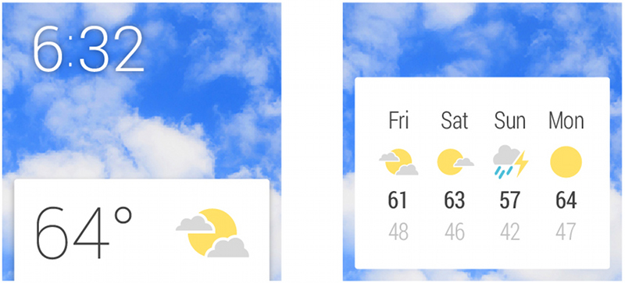

In cases where additional information is absolutely necessary, don’t crowd out a card layout to the point where glanceability is affected. Instead, add an additional [page](http://developer.android.com/design/wear/patterns.html#Pages) (or multiple pages, if needed) to the right of the main card in the stream to which the user can swipe for more information. See also [Continuing activities on phone](http://developer.android.com/design/wear/patterns.html#Continuing).

### Keep Notifications to a Minimum

Don’t abuse the user’s attention. Active notifications (that is, those that cause the device to vibrate) should only be used in cases that are both timely and involve a contact, for example receiving a message from a friend. Non-urgent notifications should be silently added to the Context Stream. See also the general [Android Notifications Guidelines](http://developer.android.com/design/patterns/notifications.html).

### Use Clear, Bold Typography



The system font is Roboto Condensed, with Regular and Light variants. Text should adhere to the size and color recommendations (see the UI Toolkit in the [Downloads](http://developer.android.com/design/downloads/index.html#Wear) page). In general, text should be displayed as large as possible. Your goal should be to convey maximum information with minimum fuss.

### Use Consistent Branding and Color

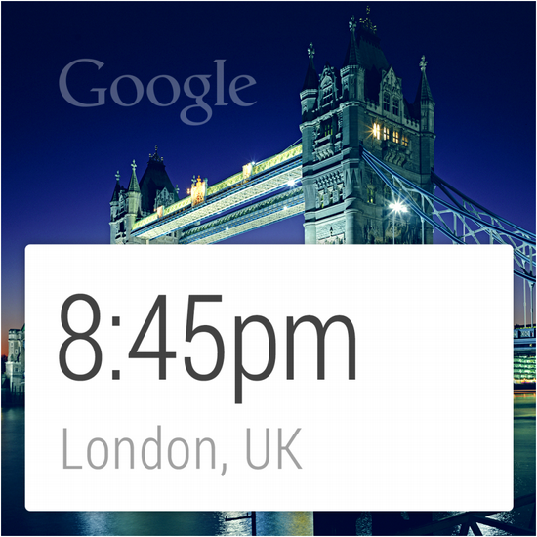

The app icon is used to identify and brand your application. The icon is optional but when present always appears in the same location, overhanging the top right edge of the card. Note that app icons or branding should not be displayed in the background photo, which is reserved to display an image relevant to the information on the card.

### Copywrite Sparingly

Omit needless text. Design for glanceability and not for reading. Use words and phrases, not sentences. Use icons paired with values instead of text wherever possible. Text strings should be as concise as possible, and long pieces of text will be truncated to fit on a single card.

### Be Discreet if Necessary

Wearables are personal devices by nature, but they are not completely private. If your notification serves content that may be particularly sensitive or embarrassing (such as notifications from a dating app or a medical status report), consider not displaying all of the information in a peek card. A notification could place the sensitive information on a second page that must be swiped to, or an application could show different amounts of detail in peek and focused card positions.

### Confirmation Animations

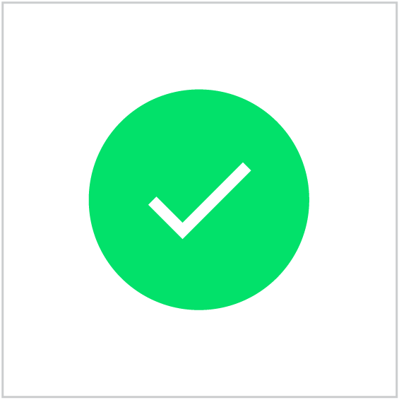

If your app allows the user to perform an action, it is necessary to provide positive feedback. Show a generic confirmation animation or create your own. A confirmation animation is an opportunity to express your app’s character and insert a moment of delight for your user. Keep animations short (less than 1000ms) and simple. Animating the confirmation icon is an effective way of transitioning the user to a new state after completing an action.

## Watch Faces for Android Wear

Android Wear supports custom watch faces with designs that can show contextually relevant information to users. Designing a watch face requires a careful blending of data and visual elements that informs users without requiring close attention. Simple, attractive layouts that can adjust to different screen shapes and sizes, provide options for color and presentation, let users create a deeply personalized experience with the Wear device that fits them best. Watch faces exist as part of the Wear user interface, so it is important to provide interactive and ambient modes, and consider how system user interface elements will interact with your design.

Follow the guidelines in this page to design your custom watch faces.

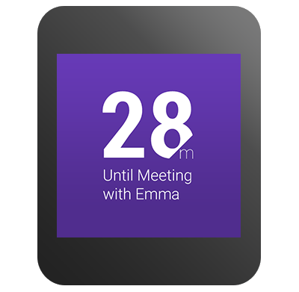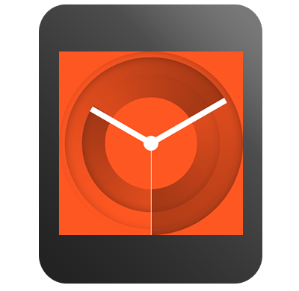

### Creative Vision

Creating a watch face for Android Wear is an exercise centered around visualizing time clearly. Android Wear devices provide a unique digital canvas to reimagine the ways in which we tell time. Android Wear also lets you integrate data on watch faces for a higher level of personalization and contextual relevance.

These powerful new tools to create watch faces run the risk of overcomplicating a design. The most successful watch face designs leverage these advanced capabilities while delivering a singular, elegant expression of information.

Glanceability is the single most important principle to consider when creating a watch face design. Your watch face designs should deliver a singular expression of time and related data. Experiment with bold, minimal, and expressive design directions that are highly readable at a distance.

### Plan for Square and Round Devices

Android Wear devices come in different shapes and sizes. You will need to consider both square and round faces as well as different resolutions. Some concepts work better in a certain format, but a little planning will allow users to enjoy your watch face regardless of screen format.

These guidelines help your concepts align across devices:

#### Create flexible concepts

Ideally, the visual functionality of the watch face works for both round and square formats. In this example, the visual functionality of the watch face is flexible enough to work well in either format without any adjustment. However, other design concepts require different executions for square and round screens.

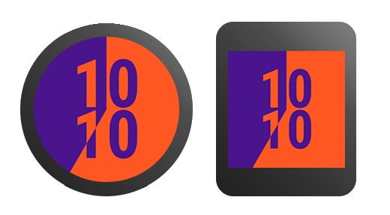

#### Use a common design language

Try using a common set of colors, line weights, shading, and other design elements to draw a visual connection between your square and round versions. By using similar color palettes and a few consistent visual elements, the overall appearance of square and round can be appropriately customized while still feeling like part of the same visual system.

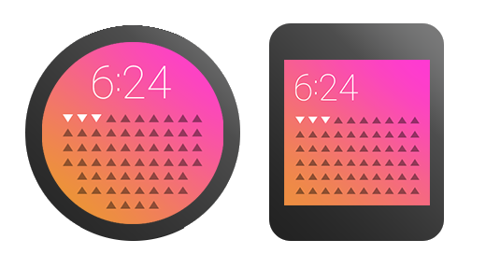

#### Adjust for analog concepts

Some of your concepts will naturally take the shape of an analog clock, like a center dial with hour and minute hands. In this case, consider the corner areas that are exposed when translating to a square format. Try extending and exploring this extra space.

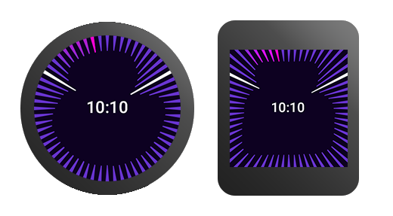

  
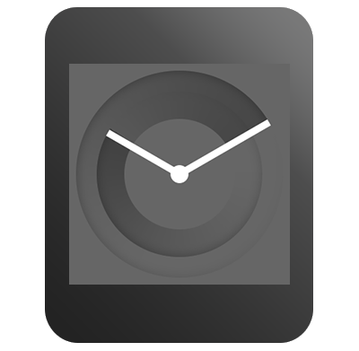

### Plan for All Display Modes

Android Wear devices operate in two main modes: ambient and interactive. Your watch face designs should take these modes into account. Generally, if your watch face design looks great in ambient mode, it will look even better in interactive mode. The opposite is not always true.

#### Interactive mode

When the user moves their wrist to glance at their watch, the screen goes into interactive mode. Your design can use full color with fluid animation in this mode.

#### Ambient mode

Ambient mode helps the device conserve power. Your design should make clear to the user that the screen is in ambient mode. The background color scheme is strictly limited to black, white, and grays. Your watch face may use some color elements on screens that support it provided it is unambiguous that the device is in ambient mode. You can use color elements for up to 5 percent of total pixels. In this mode, the screen is only updated once every minute. Only show hours and minutes in ambient mode; do not show seconds. Your watch face is notified when the device switches to ambient mode, and you should thoughtfully design for it.

### Optimize for Special Screens

Android Wear devices feature a variety of screen technologies, each with their own advantages and considerations. One important consideration when designing the ambient mode display for your watch face is how it affects battery life and screen burn-in on some screens. You can configure your watch face to display different ambient designs depending on the kind of screen available on the device. Consider the best design for your watch faces on all screens.

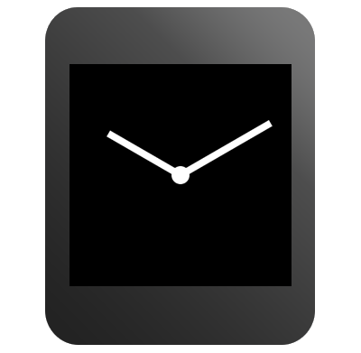

#### Reduced color space

Some displays use a reduced color space in ambient mode to save power.

One reduced color space power saving method is to use a "low-bit" mode. In low-bit mode, the available colors are limited to black, white, blue, red, magenta, green, cyan, and yellow. When designing for low-bit ambient mode, use a black or a white background. For OLED screens, you must use a black background. Non-background pixels must be less than 10 percent of total pixels. You can use low-bit color for up to 5 percent of pixels on screens that support it. You should also disable antialiasing in your paint styles for this mode. Make sure to test your design on devices with low-bit ambient mode.

Other displays save power in ambient mode by not producing any color. When designing for displays which do not use color in ambient mode, the background may be either black or white.

#### Burn protection techniques

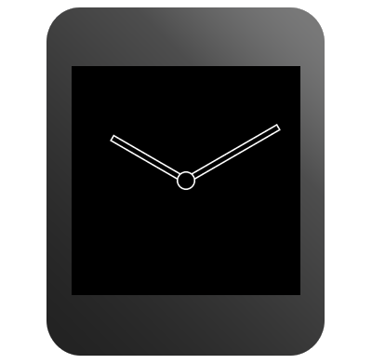

When designing for OLED screens, you should consider power efficiency and the screen burn-in effect. When these screens are in ambient mode, the system shifts the contents of the screen periodically by a few pixels to avoid pixel burn-in. Do not use large blocks of pixels in your ambient mode designs and keep 95% of the pixels black. Replace solid shapes in your regular ambient mode designs with outlined shapes in burn-protected ambient mode. Also replace filled images with pixel patterns. For analog watch face designs, hollow out the center where the hands meet to avoid pixel burn-in in this mode.

### Accomodate System UI Elements

Your watch face designs should accommodate Android Wear UI elements. These elements give the user the status of the wearable and show notifications from services on the user's phone. Try to keep critical elements in your watch face designs from being obscured by the UI elements.

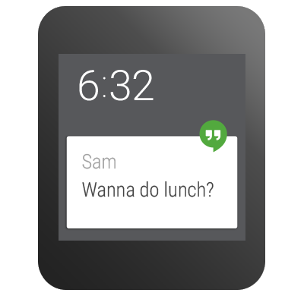

#### Cards

Cards are the notification system that bridges information between the wearable and a mobile device. Cards are also how most applications communicate with users. The user will be notified on the wearable about items such as emails and messages. As a watch face developer, you need to accommodate both large and small cards in your design. Your watch face can specify a preference for the card size, but users may override this setting. Users can also temporarily hide cards by swiping down on them.

The peek card is the top card in the stream that is partially visible at the bottom of the screen. A variable peek card has a height that is determined by the amount of text within a given notification. A small peek card leaves more room for your design. Round faces with analog hands should have a small peek card. If the time signature is clearly visible above the maximum height of the variable peek card, you may choose to include the variable peek card. The benefit of a variable peek card is that it displays more notification information. Faces with information on the bottom half of the face should leverage the small peek card instead.

The system notifies your watch face when the bounds of a peek card change, so you can rearrange the elements in your design if necessary.

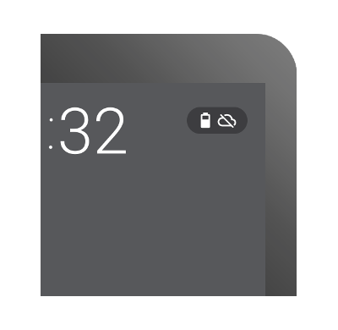

#### Indicators

Indicators tell the user the status of the wearable, such as charging and airplane mode. When designing a watch face, consider how the indicator will fall over the watch face.

The indicators can be placed in several fixed locations on the wearable. If you have a large peek card, the indicators should go on the top or on the center of the screen. When you position the status icons or the hotword on the bottom of the screen, the system forces small peek cards. If the edge of the watch face contains strong visual elements, such as ticks or numbers, place the indicators on the center of the screen.

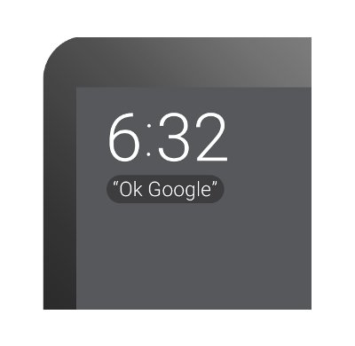

#### The hotword

The hotword is the phrase "OK Google", which tells the user that they can interact with the watch using voice commands. When a user turns on the wearable, the hotword appears on the screen for a few seconds.

The hotword no longer appears after the user says "OK Google" five times, so the placement of this element is not as critical. You should still avoid covering up elements of your watch face. Finally, background protection for the hotword and the indicators should be turned on unless your design is tailored to have these elements appear on top of them, for example using dark solid colors with no patterns.

For more information about measurements and positioning of system UI elements, see [Specifications and Assets](http://developer.android.com/design/wear/watchfaces.html#SpecsAssets).

### Design Data-Integrated Watch Faces

Your watch face can show users contextually relevant data and react to it by changing styles and colors in your design.

#### What do you want your user to know?

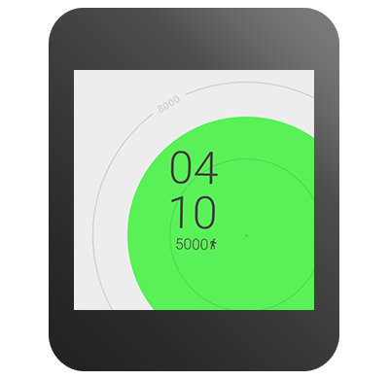

The first step in designing a data-integrated watch face is to define a conceptual user outcome based on available data. First, generate a strong concept or outcome you believe is supported by real user needs. What do you want your users to know after they have glanced at your design? Once you have identified your outcome, you need to determine how to obtain the required data.

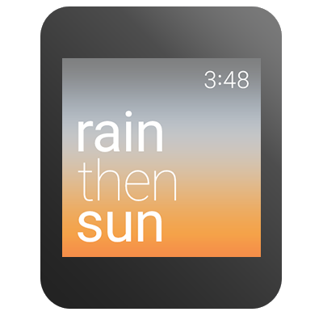

#### A watch dial is a timeline; add data to it

Your watch face concept may include use of data beyond time, such as weather, calendar and fitness data. Consider the inclusion of data integration creatively. Avoid simply overlaying a time-based watch face with extra data. Rather, think about how the data can be expressed through the lens of time. For example, instead of designing a weather-related watch face as a clock with an indication of the current temperature in degrees overlayed, you might design a watch face that describes how the temperature will change over the course of the day.

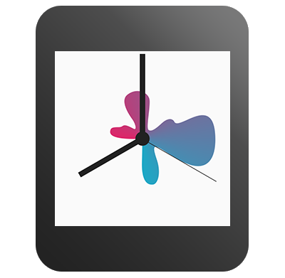

#### Stick to one message

Once you have solidified your conceptual direction or desired outcome, you will need to begin visualizing your watch face. The strongest watch face designs are highly glanceable and deliver a singular expression of data. In order to identify your singular message, you must identify the most important supporting data point. For instance, instead of displaying an entire month of calendar events, you might decide to display only the next upcoming event. By a process of reduction, you should arrive at a powerful singular expression of data to include in your design.

#### Begin with some insight and test as you go

Make sure your approach begins with insight into the needs and expectations of your users. Test your designs with users to check any assumptions you might have made about your design along the way. Try making a rough sketch on paper and asking a friend to tell you what it means. Try your concept out with lots of different types of data and scenarios. Test your designs with an actual watch screen before you start coding.

### Support the Android Wear Companion App

The Android Wear companion app gives the user access to all installed watch faces and their settings.

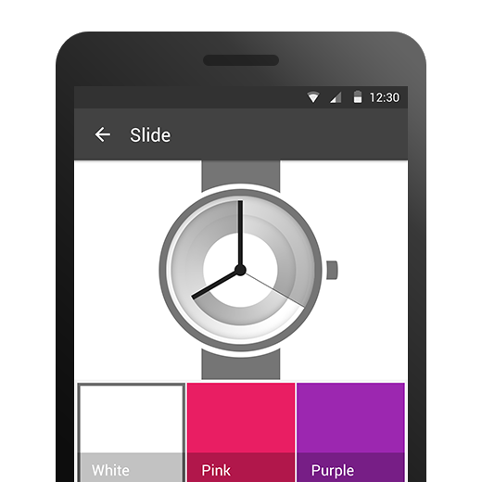 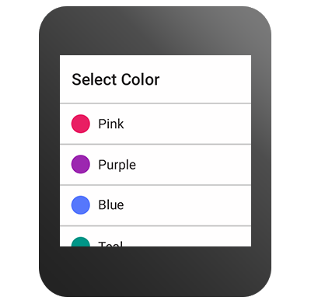

#### Don't use a launcher icon

All available watch faces are accessible from the Android Wear companion app or from your bundled third party app. There is no need for a stand-alone launcher icon for Android Wear watch faces.

#### Settings

Each watch face that has useful settings can have a Settings panel, accessible from the watch itself and from the companion app on the phone. Standard UI components work in most cases, but you can explore other creative executions once you have built a foundation designing watch faces.

Settings on the watch should be limited to binary selections or scrollable lists. Settings on the phone may include any complex configuration items in addition to the settings available on the watch.

### Specifications and Assets

To obtain watch face design examples and detailed measurements for the system UI elements, see the [Design Downloads for Android Wear](http://developer.android.com/design/downloads/index.html#Wear).

# Adding Wearable Features to Notifications

When an Android handheld (phone or tablet) and Android wearable are connected, the handheld automatically shares notifications with the wearable. On the wearable, each notification appears as a new card in the [context stream](http://developer.android.com/design/wear/index.html).

However, to give users the best experience, you should add wearable-specific functionality to the notifications you already create. The following lessons show you how to create notifications that are catered for handhelds and wearables at the same time.

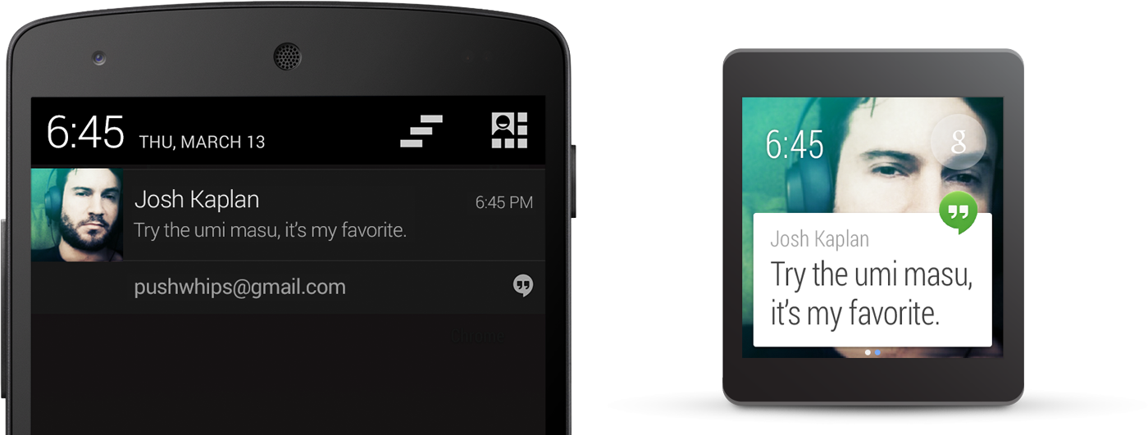

Figure 1. The same notification displayed on a handheld and wearable.

### Lessons

[Creating a notification](http://developer.android.com/training/wearables/notifications/creating.html) - Learn how to create notifications with wearable features with the Android support library.

[Receiving Voice Input in a Notification](http://developer.android.com/training/wearables/notifications/voice-input.html) - Learn how to add an action to a wearable notification that receives voice input from users and delivers the transcribed message to your handset app.

[Adding Pages to a Notification](http://developer.android.com/training/wearables/notifications/pages.html) - Learn how to add additional pages of information that are visible when the user swipes to the left.

[Stacking Notifications](http://developer.android.com/training/wearables/notifications/stacks.html) - Learn how to place all similar notifications from your app in a stack, allowing users to view each notification individually without adding multiple cards to the card stream.

## Creating a Notification for Wearables

To build handheld notifications that are also sent to wearables, use [NotificationCompat.Builder](http://developer.android.com/reference/android/support/v4/app/NotificationCompat.Builder.html). When you build notifications with this class, the system takes care of displaying notifications properly, whether they appear on a handheld or wearable.

**Note:** Notifications using [RemoteViews](http://developer.android.com/reference/android/widget/RemoteViews.html) are stripped of custom layouts and the wearable only displays the text and icons. However, you can create [create custom notifications](http://developer.android.com/training/wearables/apps/layouts.html#CustomNotifications) that use custom card layouts by creating a wearable app that runs on the wearable device.

### Import the necessary classes

To import the necessary packages, add this line to your build.gradle file:

compile "com.android.support:support-v4:20.0.+"

Now that your project has access to the necessary packages, import the necessary classes from the support library:

import android.support.v4.app.NotificationCompat;  
import android.support.v4.app.NotificationManagerCompat;  
import android.support.v4.app.NotificationCompat.WearableExtender;

### Create Notifications with the Notification Builder

The [v4 support library](http://developer.android.com/tools/support-library/features.html#v4) allows you to create notifications using the latest notification features such as action buttons and large icons, while remaining compatible with Android 1.6 (API level 4) and higher.

To create a notification with the support library, you create an instance of [NotificationCompat.Builder](http://developer.android.com/reference/android/support/v4/app/NotificationCompat.Builder.html) and issue the notification by passing it to [notify()](http://developer.android.com/reference/java/lang/Object.html#notify()). For example:

int notificationId = 001;  
// Build intent for notification content  
Intent viewIntent = new Intent(this, ViewEventActivity.class);  
viewIntent.putExtra(EXTRA_EVENT_ID, eventId);  
PendingIntent viewPendingIntent =  
        PendingIntent.getActivity(this, 0, viewIntent, 0);  
  
NotificationCompat.Builder notificationBuilder =  
        new NotificationCompat.Builder(this)  
        .setSmallIcon(R.drawable.ic_event)  
        .setContentTitle(eventTitle)  
        .setContentText(eventLocation)  
        .setContentIntent(viewPendingIntent);  
  
// Get an instance of the NotificationManager service  
NotificationManagerCompat notificationManager =  
        NotificationManagerCompat.from(this);  
  
// Build the notification and issues it with notification manager.  
notificationManager.notify(notificationId, notificationBuilder.build());

When this notification appears on a handheld device, the user can invoke the [PendingIntent](http://developer.android.com/reference/android/app/PendingIntent.html) specified by the [setContentIntent()](http://developer.android.com/reference/android/support/v4/app/NotificationCompat.Builder.html#setContentIntent(android.app.PendingIntent)) method by touching the notification. When this notification appears on an Android wearable, the user can swipe the notification to the left to reveal the **Open** action, which invokes the intent on the handheld device.

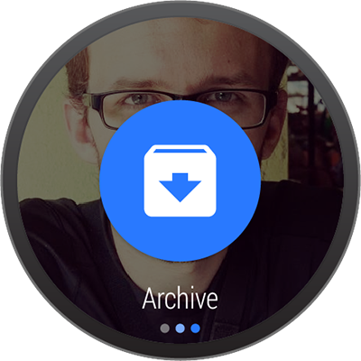

### Add Action Buttons

In addition to the primary content action defined by [setContentIntent()](http://developer.android.com/reference/android/support/v4/app/NotificationCompat.Builder.html#setContentIntent(android.app.PendingIntent)), you can add other actions by passing a [PendingIntent](http://developer.android.com/reference/android/app/PendingIntent.html) to the [addAction()](http://developer.android.com/reference/android/support/v4/app/NotificationCompat.Builder.html#addAction(android.support.v4.app.NotificationCompat.Action)) method.

For example, the following code shows the same type of notification from above, but adds an action to view the event location on a map.

// Build an intent for an action to view a map  
Intent mapIntent = new Intent(Intent.ACTION_VIEW);  
Uri geoUri = Uri.parse("geo:0,0?q=" + Uri.encode(location));  
mapIntent.setData(geoUri);  
PendingIntent mapPendingIntent =  
        PendingIntent.getActivity(this, 0, mapIntent, 0);  
  
NotificationCompat.Builder notificationBuilder =  
        new NotificationCompat.Builder(this)  
        .setSmallIcon(R.drawable.ic_event)  
        .setContentTitle(eventTitle)  
        .setContentText(eventLocation)  
        .setContentIntent(viewPendingIntent)  
        **.addAction(R.drawable.ic_map,  
                getString(R.string.map), mapPendingIntent);**

On a handheld, the action appears as an additional button attached to the notification. On a wearable, the action appears as a large button when the user swipes the notification to the left. When the user taps the action, the associated intent is invoked on the handheld.

**Tip:** If your notifications include a "Reply" action (such as for a messaging app), you can enhance the behavior by enabling voice input replies directly from the Android wearable. For more information, read [Receiving Voice Input from a Notification](http://developer.android.com/training/wearables/notifications/voice-input.html).

### Specify Wearable-only Actions

If you want the actions available on the wearable to be different from those on the handheld, then use [WearableExtender.addAction()](http://developer.android.com/reference/android/support/v4/app/NotificationCompat.WearableExtender.html#addAction(android.support.v4.app.NotificationCompat.Action)). Once you add an action with this method, the wearable does not display any other actions added with [NotificationCompat.Builder.addAction()](http://developer.android.com/reference/android/support/v4/app/NotificationCompat.Builder.html#addAction(android.support.v4.app.NotificationCompat.Action)). That is, only the actions added with [WearableExtender.addAction()](http://developer.android.com/reference/android/support/v4/app/NotificationCompat.WearableExtender.html#addAction(android.support.v4.app.NotificationCompat.Action)) appear on the wearable and they do not appear on the handheld.

// Create an intent for the reply action  
Intent actionIntent = new Intent(this, ActionActivity.class);  
PendingIntent actionPendingIntent =  
        PendingIntent.getActivity(this, 0, actionIntent,  
                PendingIntent.FLAG_UPDATE_CURRENT);  
  
// Create the action  
NotificationCompat.Action action =  
        new NotificationCompat.Action.Builder(R.drawable.ic_action,  
                getString(R.string.label), actionPendingIntent)  
                .build();  
  
// Build the notification and add the action via WearableExtender  
Notification notification =  
        new NotificationCompat.Builder(mContext)  
                .setSmallIcon(R.drawable.ic_message)  
                .setContentTitle(getString(R.string.title))  
                .setContentText(getString(R.string.content))  
                .extend(new WearableExtender().addAction(action))  
                .build();

### Add a Big View

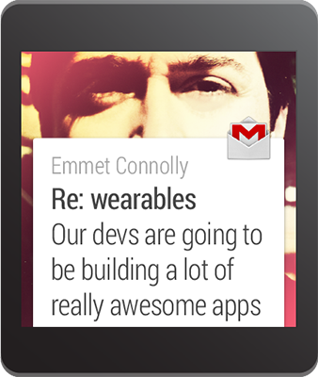

You can insert extended text content to your notification by adding one of the "big view" styles to your notification. On a handheld device, users can see the big view content by expanding the notification. On a wearable device, the big view content is visible by default.

To add the extended content to your notification, call [setStyle()](http://developer.android.com/reference/android/support/v4/app/NotificationCompat.Builder.html#setStyle(android.support.v4.app.NotificationCompat.Style)) on the [NotificationCompat.Builder](http://developer.android.com/reference/android/support/v4/app/NotificationCompat.Builder.html) object, passing it an instance of either [BigTextStyle](http://developer.android.com/reference/android/support/v4/app/NotificationCompat.BigTextStyle.html) or [InboxStyle](http://developer.android.com/reference/android/support/v4/app/NotificationCompat.InboxStyle.html).

For example, the following code adds an instance of [NotificationCompat.BigTextStyle](http://developer.android.com/reference/android/support/v4/app/NotificationCompat.BigTextStyle.html) to the event notification, in order to include the complete event description (which includes more text than can fit into the space provided for [setContentText()](http://developer.android.com/reference/android/support/v4/app/NotificationCompat.Builder.html#setContentText(java.lang.CharSequence))).

// Specify the 'big view' content to display the long  
// event description that may not fit the normal content text.  
BigTextStyle bigStyle = new NotificationCompat.BigTextStyle();  
bigStyle.bigText(eventDescription);  
  
NotificationCompat.Builder notificationBuilder =  
        new NotificationCompat.Builder(this)  
        .setSmallIcon(R.drawable.ic_event)  
        .setLargeIcon(BitmapFactory.decodeResource(  
                getResources(), R.drawable.notif_background))  
        .setContentTitle(eventTitle)  
        .setContentText(eventLocation)  
        .setContentIntent(viewPendingIntent)  
        .addAction(R.drawable.ic_map,  
                getString(R.string.map), mapPendingIntent)  
        **.setStyle(bigStyle);**

Notice that you can add a large icon image to any notification using the [setLargeIcon()](http://developer.android.com/reference/android/support/v4/app/NotificationCompat.Builder.html#setLargeIcon(android.graphics.Bitmap)) method. However, these icons appear as large background images on a wearable and do not look good as they are scaled up to fit the wearable screen. To add a wearable-specific background image to a notification, see [Add Wearable Features For a Notification](http://developer.android.com/training/wearables/notifications/creating.html#AddWearableFeatures). For more information about designing notifications with large images, see the [Design Principles of Android Wear](http://developer.android.com/design/wear/index.html).

### Add Wearable Features For a Notification

If you ever need to add wearable-specific options to a notification, such as specifying additional pages of content or letting users dictate a text response with voice input, you can use the [NotificationCompat.WearableExtender](http://developer.android.com/reference/android/support/v4/app/NotificationCompat.WearableExtender.html) class to specify the options. To use this API:

1. Create an instance of a [WearableExtender](http://developer.android.com/reference/android/support/v4/app/NotificationCompat.WearableExtender.html), setting the wearable-specific options for the notification.
2. Create an instance of [NotificationCompat.Builder](http://developer.android.com/reference/android/support/v4/app/NotificationCompat.Builder.html), setting the desired properties for your notification as described earlier in this lesson.
3. Call [extend()](http://developer.android.com/reference/android/support/v4/app/NotificationCompat.Builder.html#extend(android.support.v4.app.NotificationCompat.Extender)) on the notification and pass in the [WearableExtender](http://developer.android.com/reference/android/support/v4/app/NotificationCompat.WearableExtender.html). This applies the wearable options to the notification.
4. Call [build()](http://developer.android.com/reference/android/support/v4/app/NotificationCompat.Builder.html#build()) to build the notification.

For example, the following code calls the [setHintHideIcon()](http://developer.android.com/reference/android/support/v4/app/NotificationCompat.WearableExtender.html#setHintHideIcon(boolean)) method to remove the app icon from the notification card.

// Create a WearableExtender to add functionality for wearables  
NotificationCompat.WearableExtender wearableExtender =  
        new NotificationCompat.WearableExtender()  
        .setHintHideIcon(true)  
        .setBackground(mBitmap);  
  
// Create a NotificationCompat.Builder to build a standard notification  
// then extend it with the WearableExtender  
Notification notif = new NotificationCompat.Builder(mContext)  
        .setContentTitle("New mail from " + sender)  
        .setContentText(subject)  
        .setSmallIcon(R.drawable.new_mail)  
        .extend(wearableExtender)  
        .build();

The [setHintHideIcon()](http://developer.android.com/reference/android/support/v4/app/NotificationCompat.WearableExtender.html#setHintHideIcon(boolean)) and [setBackground()](http://developer.android.com/reference/android/support/v4/app/NotificationCompat.WearableExtender.html#setBackground(android.graphics.Bitmap)) methods are just two examples of new notification features available with [NotificationCompat.WearableExtender](http://developer.android.com/reference/android/support/v4/app/NotificationCompat.WearableExtender.html).

**Note:** The bitmap that you use with [setBackground()](http://developer.android.com/reference/android/support/v4/app/NotificationCompat.WearableExtender.html#setBackground(android.graphics.Bitmap)) should have a resolution of 400x400 for non-scrolling backgrounds and 640x400 for backgrounds that support parallax scrolling. Place these bitmap images in the res/drawable-nodpi directory. Place other non-bitmap resources for wearable notifications, such as those used with the [setContentIcon()](http://developer.android.com/reference/android/support/v4/app/NotificationCompat.WearableExtender.html#setContentIcon(int)) method, in the res/drawable-hdpi directory.

If you ever need to read wearable-specific options at a later time, use the corresponding get method for the option. This example calls the [getHintHideIcon()](http://developer.android.com/reference/android/support/v4/app/NotificationCompat.WearableExtender.html#getHintHideIcon()) method to get whether or not this notification hides the icon:

NotificationCompat.WearableExtender wearableExtender =  
        new NotificationCompat.WearableExtender(notif);  
boolean hintHideIcon = wearableExtender.getHintHideIcon();

### Deliver the Notification

When you want to deliver your notifications, always use the [NotificationManagerCompat](http://developer.android.com/reference/android/support/v4/app/NotificationManagerCompat.html) API instead of [NotificationManager](http://developer.android.com/reference/android/app/NotificationManager.html):

// Get an instance of the NotificationManager service  
NotificationManagerCompat notificationManager =  
        NotificationManagerCompat.from(mContext);  
  
// Issue the notification with notification manager.  
notificationManager.notify(notificationId, notif);

If you use the framework's [NotificationManager](http://developer.android.com/reference/android/app/NotificationManager.html), some features from [NotificationCompat.WearableExtender](http://developer.android.com/reference/android/support/v4/app/NotificationCompat.WearableExtender.html) do not work, so make sure to use [NotificationCompat](http://developer.android.com/reference/android/support/v4/app/NotificationCompat.html).

## Receiving Voice Input in a Notification

If you have handheld notifications that include an action to input text, such as reply to an email, it should normally launch an activity on the handheld device to input the text. However, when your notification appears on a wearable, there is no keyboard input, so you can let users dictate a reply or provide pre-defined text messages using [RemoteInput](http://developer.android.com/reference/android/support/v4/app/RemoteInput.html).

When users reply with voice or select one of the available messages, the system attaches the text response to the [Intent](http://developer.android.com/reference/android/content/Intent.html) you specified for the notification action and sends that intent to your handheld app.

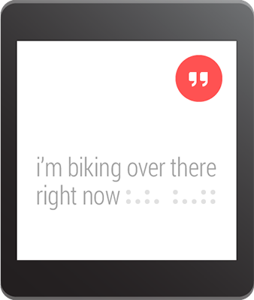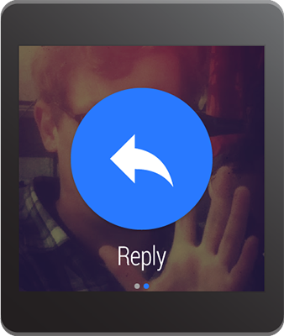

**Note:** The Android emulator does not support voice input. When using the emulator for a wearable device, enable **Hardware keyboard present** in the AVD settings so you can type replies instead.

### Define the Voice Input

To create an action that supports voice input, create an instance of [RemoteInput.Builder](http://developer.android.com/reference/android/support/v4/app/RemoteInput.Builder.html) that you can add to your notification action. This class's constructor accepts a string that the system uses as the key for the voice input, which you'll later use to retrieve the text of the input in your handheld app.

For example, here's how to create a [RemoteInput](http://developer.android.com/reference/android/support/v4/app/RemoteInput.html) object that provides a custom label for the voice input prompt:

// Key for the string that's delivered in the action's intent  
private static final String EXTRA_VOICE_REPLY = "extra_voice_reply";  
  
String replyLabel = getResources().getString(R.string.reply_label);  
  
RemoteInput remoteInput = new RemoteInput.Builder(EXTRA_VOICE_REPLY)  
        .setLabel(replyLabel)  
        .build();

### Add Pre-defined Text Responses

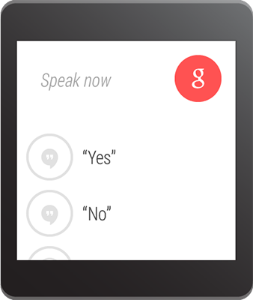

In addition to allowing voice input, you can provide up to five text responses that the user can select for quick replies. Call [setChoices()](http://developer.android.com/reference/android/support/v4/app/RemoteInput.Builder.html#setChoices(java.lang.CharSequence%5B%5D)) and pass it a string array.

For example, you can define some responses in a resource array:

res/values/strings.xml

<?xml version="1.0" encoding="utf-8"?>  
<resources>  
    <string-array name="reply_choices">  
        <item>Yes</item>  
        <item>No</item>  
        <item>Maybe</item>  
    </string-array>  
</resources>

Then, inflate the string array and add it to the [RemoteInput](http://developer.android.com/reference/android/support/v4/app/RemoteInput.html):

public static final String EXTRA_VOICE_REPLY = "extra_voice_reply";  
...  
String replyLabel = getResources().getString(R.string.reply_label);  
String[] replyChoices = getResources().getStringArray(R.array.reply_choices);  
  
RemoteInput remoteInput = new RemoteInput.Builder(EXTRA_VOICE_REPLY)  
        .setLabel(replyLabel)  
        .setChoices(replyChoices)  
        .build();

### Add the Voice Input as a Notification Action

To set the voice input, attach your [RemoteInput](http://developer.android.com/reference/android/support/v4/app/RemoteInput.html) object to an action using [addRemoteInput()](http://developer.android.com/reference/android/support/v4/app/NotificationCompat.Action.Builder.html#addRemoteInput(android.support.v4.app.RemoteInput)). You can then apply the action to the notification. For example:

// Create an intent for the reply action  
Intent replyIntent = new Intent(this, ReplyActivity.class);  
PendingIntent replyPendingIntent =  
        PendingIntent.getActivity(this, 0, replyIntent,  
                PendingIntent.FLAG_UPDATE_CURRENT);  
  
// Create the reply action and add the remote input  
NotificationCompat.Action action =  
        new NotificationCompat.Action.Builder(R.drawable.ic_reply_icon,  
                getString(R.string.label), replyPendingIntent)  
                .addRemoteInput(remoteInput)  
                .build();  
  
// Build the notification and add the action via WearableExtender  
Notification notification =  
        new NotificationCompat.Builder(mContext)  
                .setSmallIcon(R.drawable.ic_message)  
                .setContentTitle(getString(R.string.title))  
                .setContentText(getString(R.string.content))  
                .extend(new WearableExtender().addAction(action))  
                .build();  
  
// Issue the notification  
NotificationManagerCompat notificationManager =  
        NotificationManagerCompat.from(mContext);  
notificationManager.notify(notificationId, notification);

When you issue this notification, users can swipe to the left to see the "Reply" action button.

### Receiving the Voice Input as a String

To receive the user's transcribed message in the activity you declared in the reply action's intent, call [getResultsFromIntent()](http://developer.android.com/reference/android/support/v4/app/RemoteInput.html#getResultsFromIntent(android.content.Intent)), passing in the "Reply" action's intent. This method returns a [Bundle](http://developer.android.com/reference/android/os/Bundle.html) that contains the text response. You can then query the [Bundle](http://developer.android.com/reference/android/os/Bundle.html) to obtain the response.

**Note:** Do not use [Intent.getExtras()](http://developer.android.com/reference/android/content/Intent.html#getExtras()) to obtain the voice result, because the voice input is stored as [ClipData](http://developer.android.com/reference/android/content/ClipData.html). The [getResultsFromIntent()](http://developer.android.com/reference/android/support/v4/app/RemoteInput.html#getResultsFromIntent(android.content.Intent)) method provides a convenient way to receive a character sequence without having to process the [ClipData](http://developer.android.com/reference/android/content/ClipData.html) yourself.

The following code shows a method that accepts an intent and returns the voice response, which is referenced by the EXTRA_VOICE_REPLY key that is used in the previous examples:

/**  
 * Obtain the intent that started this activity by calling  
 * Activity.getIntent() and pass it into this method to  
 * get the associated voice input string.  
 */  
  
private CharSequence getMessageText(Intent intent) {  
    Bundle remoteInput = RemoteInput.getResultsFromIntent(intent);  
    if (remoteInput != null) {  
        return remoteInput.getCharSequence(EXTRA_VOICE_REPLY);  
    }  
    return null;  
}

## Adding Pages to a Notification

When you'd like to provide more information without requiring users to open your app on their handheld device, you can add one or more pages to the notification on the wearable. The additional pages appear immediately to the right of the main notification card.

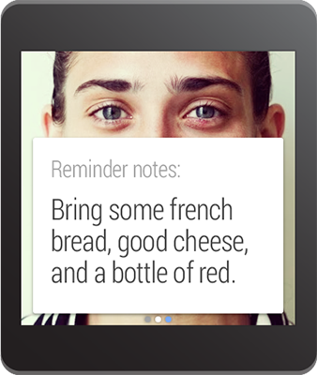 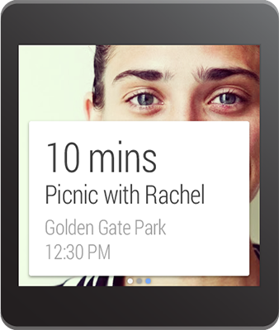

To create a notification with multiple pages:

1. Create the main notification (the first page) with [NotificationCompat.Builder](http://developer.android.com/reference/android/support/v4/app/NotificationCompat.Builder.html), in the way you'd like the notification to appear on a handset.
2. Create the additional pages for the wearable with [NotificationCompat.Builder](http://developer.android.com/reference/android/support/v4/app/NotificationCompat.Builder.html).
3. Apply the pages to the main notification with the [addPage()](http://developer.android.com/reference/android/support/v4/app/NotificationCompat.WearableExtender.html#addPage(android.app.Notification)) method or add multiple pages in a [Collection](http://developer.android.com/reference/java/util/Collection.html) with the [addPages()](http://developer.android.com/reference/android/support/v4/app/NotificationCompat.WearableExtender.html#addPage(android.app.Notification)) method.

For example, here's some code that adds a second page to a notification:

// Create builder for the main notification  
NotificationCompat.Builder notificationBuilder =  
        new NotificationCompat.Builder(this)  
        .setSmallIcon(R.drawable.new_message)  
        .setContentTitle("Page 1")  
        .setContentText("Short message")  
        .setContentIntent(viewPendingIntent);  
  
// Create a big text style for the second page  
BigTextStyle secondPageStyle = new NotificationCompat.BigTextStyle();  
secondPageStyle.setBigContentTitle("Page 2")  
               .bigText("A lot of text...");  
  
// Create second page notification  
Notification secondPageNotification =  
        new NotificationCompat.Builder(this)  
        .setStyle(secondPageStyle)  
        .build();  
  
// Extend the notification builder with the second page  
Notification notification = notificationBuilder  
        .extend(new NotificationCompat.WearableExtender()  
                .addPage(secondPageNotification))  
        .build();  
  
// Issue the notification  
notificationManager =  
        NotificationManagerCompat.from(this);  
notificationManager.notify(notificationId, notification);

## Stacking Notifications

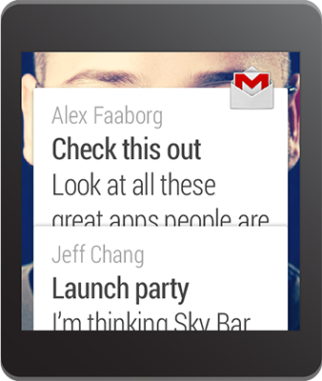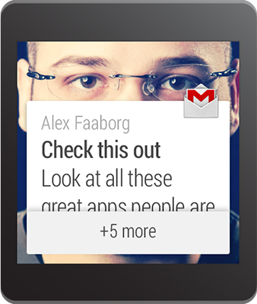

When creating notifications for a handheld device, you should always aggregate similar notifications into a single summary notification. For example, if your app creates notifications for received messages, you should not show more than one notification on a handheld device—when more than one is message is received, use a single notification to provide a summary such as "2 new messages."

However, a summary notification is less useful on an Android wearable because users are not able to read details from each message on the wearable (they must open your app on the handheld to view more information). So for the wearable device, you should group all the notifications together in a stack. The stack of notifications appears as a single card, which users can expand to view the details from each notification separately. The new [setGroup()](http://developer.android.com/reference/android/support/v4/app/NotificationCompat.Builder.html#setGroup(java.lang.String)) method makes this possible while allowing you to still provide only one summary notification on the handheld device.

### Add Each Notification to a Group

To create a stack, call [setGroup()](http://developer.android.com/reference/android/support/v4/app/NotificationCompat.Builder.html#setGroup(java.lang.String)) for each notification you want in the stack and specify a group key. Then call [notify()](http://developer.android.com/reference/java/lang/Object.html#notify()) to send it to the wearable.

final static String GROUP_KEY_EMAILS = "group_key_emails";  
  
// Build the notification, setting the group appropriately  
Notification notif = new NotificationCompat.Builder(mContext)  
         .setContentTitle("New mail from " + sender1)  
         .setContentText(subject1)  
         .setSmallIcon(R.drawable.new_mail)  
         .setGroup(GROUP_KEY_EMAILS)  
         .build();  
  
// Issue the notification  
NotificationManagerCompat notificationManager =  
        NotificationManagerCompat.from(this);  
notificationManager.notify(notificationId1, notif);

Later on, when you create another notification, specify the same group key. When you call [notify()](http://developer.android.com/reference/java/lang/Object.html#notify()), this notification appears in the same stack as the previous notification, instead of as a new card:

Notification notif2 = new NotificationCompat.Builder(mContext)  
         .setContentTitle("New mail from " + sender2)  
         .setContentText(subject2)  
         .setSmallIcon(R.drawable.new_mail)  
         .setGroup(GROUP_KEY_EMAILS)  
         .build();  
  
notificationManager.notify(notificationId2, notif2);

By default, notifications appear in the order in which you added them, with the most recent notification visible at the top. You can order notifications in another fashion by calling [setSortKey()](http://developer.android.com/reference/android/support/v4/app/NotificationCompat.Builder.html#setSortKey(java.lang.String)).

### Add a Summary Notification

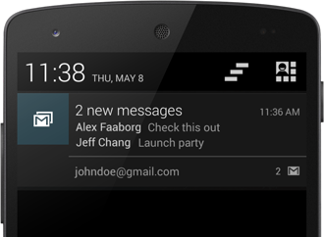

It's important that you still provide a summary notification that appears on handheld devices. So in addition to adding each unique notification to the same stack group, also add a summary notification and call [setGroupSummary()](http://developer.android.com/reference/android/support/v4/app/NotificationCompat.Builder.html#setGroupSummary(boolean)) on the summary notification.

This notification does not appear in your stack of notifications on the wearable, but it appears as the only notification on the handheld device.

Bitmap largeIcon = BitmapFactory.decodeResource(getResources(),  
        R.drawable.ic_large_icon);  
  
// Create an InboxStyle notification  
Notification summaryNotification = new NotificationCompat.Builder(mContext)  
        .setContentTitle("2 new messages")  
        .setSmallIcon(R.drawable.ic_small_icon)  
        .setLargeIcon(largeIcon)  
        .setStyle(new NotificationCompat.InboxStyle()  
                .addLine("Alex Faaborg   Check this out")  
                .addLine("Jeff Chang   Launch Party")  
                .setBigContentTitle("2 new messages")  
                .setSummaryText("johndoe@gmail.com"))  
        .setGroup(GROUP_KEY_EMAILS)  
        .setGroupSummary(true)  
        .build();  
  
notificationManager.notify(notificationId3, summaryNotification);

This notification uses [NotificationCompat.InboxStyle](http://developer.android.com/reference/android/support/v4/app/NotificationCompat.InboxStyle.html), which gives you an easy way to create notifications for email or messaging apps. You can use this style, another one defined in [NotificationCompat](http://developer.android.com/reference/android/support/v4/app/NotificationCompat.html), or no style for the summary notification.

**Tip:** To style the text like in the example screenshot, see [Styling with HTML markup](http://developer.android.com/guide/topics/resources/string-resource.html#StylingWithHTML) and [Styling with Spannables](http://developer.android.com/guide/topics/resources/string-resource.html#StylingWithSpannables).

Summary notifications can also affect notifications on wearables without being displayed on them. When creating a summary notification, you can use the [NotificationCompat.WearableExtender](http://developer.android.com/reference/android/support/v4/app/NotificationCompat.WearableExtender.html) class and call [setBackground()](http://developer.android.com/reference/android/support/v4/app/NotificationCompat.WearableExtender.html#setBackground(android.graphics.Bitmap)) or [addAction()](http://developer.android.com/reference/android/support/v4/app/NotificationCompat.WearableExtender.html#addAction(android.support.v4.app.NotificationCompat.Action)) to set a background image or an action that applies to the entire stack on the wearable. For instance, to set the background for an entire stack of notifications:

Bitmap background = BitmapFactory.decodeResource(getResources(),  
        R.drawable.ic_background);  
  
NotificationCompat.WearableExtender wearableExtender =  
        new NotificationCompat.WearableExtender()  
        .setBackground(background);  
  
// Create an InboxStyle notification  
Notification summaryNotificationWithBackground =  
        new NotificationCompat.Builder(mContext)  
        .setContentTitle("2 new messages")  
        ...  
        .extend(wearableExtender)  
        .setGroup(GROUP_KEY_EMAILS)  
        .setGroupSummary(true)  
        .build();

# Creating Wearable Apps

Wearable apps run directly on the device, giving you access to hardware such as sensors and the GPU. They are fundamentally the same as apps built for other devices using the Android SDK, but differ greatly in design and usability and the amount of functionality provided. These are the main differences between handheld and wearable apps:

* Wearable apps are relatively small in size and functionality compared to handheld apps. They contain only what makes sense on the wearable, which is usually a small subset of the corresponding handheld app. In general, you should carry out operations on the handheld when possible and send the results to the wearable.
* Users don't download apps directly onto the wearable. Instead, you bundle the wearable app inside the handheld app. When users install the handheld app, the system automatically installs the wearable app. However, for development purposes, you can still install the wearable app directly to the wearable.
* Wearable apps can access much of the standard Android APIs, but don't support the following APIs:
  + [android.webkit](http://developer.android.com/reference/android/webkit/package-summary.html)
  + [android.print](http://developer.android.com/reference/android/print/package-summary.html)
  + [android.app.backup](http://developer.android.com/reference/android/app/backup/package-summary.html)
  + [android.appwidget](http://developer.android.com/reference/android/appwidget/package-summary.html)
  + [android.hardware.usb](http://developer.android.com/reference/android/hardware/usb/package-summary.html)

You can check if a wearable supports a feature by calling [hasSystemFeature()](http://developer.android.com/reference/android/content/pm/PackageManager.html#hasSystemFeature(java.lang.String)) before trying to use an API.

To conserve power on a wearable device, you can enable ambient mode for your Wear app. Devices transition from interactive to ambient mode when the user is idle on an activity or when the user covers the screen with their palm. Wearable apps that can transition into ambient mode are called *always-on* apps. The following describes the two modes of operation for always-on apps:

**Interactive**

Use full color with fluid animation in this mode. The app is also responsive to input.

**Ambient**

Render the screen with grayscale graphics and do not present any input cues in this mode. This display mode is only supported on devices running Android 5.1 or higher.

On devices running versions prior to Android 5.1 or for apps that do not support ambient mode, when a user is idle on an activity or when the user covers the screen with their palm on an activity, the Wear home screen is displayed instead of your activity in ambient mode. If you need to show persistent content on versions prior to Android 5.1, create a notification in the context stream instead.

**Note:** We recommend using Android Studio for Android Wear development as it provides project setup, library inclusion, and packaging conveniences that aren't available in ADT. The rest of this training assumes you're using Android Studio.

### Lessons

[Creating and Running a Wearable App](http://developer.android.com/training/wearables/apps/creating.html)

Learn how to create an Android Studio project that contains both the wearable and handheld app modules and how to run the app on a device or emulator.

[Creating Custom Layouts](http://developer.android.com/training/wearables/apps/layouts.html)

Learn how to create and display custom layouts for notifications and activities.

[Keeping Your App Visible](http://developer.android.com/training/wearables/apps/always-on.html)

Learn how to enable ambient mode for your apps, so they remain visible while still saving battery power.

[Adding Voice Capabilities](http://developer.android.com/training/wearables/apps/voice.html)

Learn how to launch an activity with voice actions and how to start the system speech recognizer app to obtain free-form voice input.

[Packaging Wearable Apps](http://developer.android.com/training/wearables/apps/packaging.html)

Learn how to package a wearable app inside a handheld app. This allows the system to install the wearable app automatically when users install the companion handheld app from the Google Play store.

[Debugging over Bluetooth](http://developer.android.com/training/wearables/apps/bt-debugging.html)

Learn how to debug your wearable over Bluetooth instead of USB.

## Creating and Running a Wearable App

Wearable apps run directly on the wearable device, giving you access to low-level hardware such as sensors, activities, services, and more, right on the wearable.

A companion handheld app that contains the wearable app is also required when you want to publish to the Google Play store. Wearables don't support the Google Play store, so users download the companion handheld app, which automatically pushes the wearable app to the wearable. The handheld app is also useful for doing heavy processing, network actions, or other work and sending the results to the wearable.

This lesson goes over how to set up a device or emulator and create one project to contain both your wearable and handheld apps.

### Update Your SDK

Before you begin building wearable apps, you must:

* **Update your SDK tools to version 23.0.0 or higher**   
  The updated SDK tools enable you to build and test wearable apps.
* **Update your SDK with Android 4.4W.2 (API 20) or higher**   
  The updated platform version provides new APIs for wearable apps.

To update your SDK with these components, see [Get the latest SDK tools](http://developer.android.com/sdk/installing/adding-packages.html#GetTools).

### Set Up an Android Wear Emulator or Device

We recommend that you develop on real hardware so you can better gauge the user experience. However, the emulator lets you test out different types of screen shapes, which is useful for testing.

#### Set up an Android Wear Virtual Device

To set up an Android Wear virtual device:

1. Click **Tools > Android > AVD Manager**.
2. Click **Create Virtual Device...**.
   1. Click **Wear** in the Category list:
   2. Select Android Wear Square or Android Wear Round.
   3. Click **Next**.
   4. Select a release name (for example, KitKat Wear).
   5. Click **Next**.
   6. (Optional) Change any preferences for your virtual device.
   7. Click **Finish**.
3. Start the emulator:
   1. Select the virtual device you just created.
   2. Click the **Play** button.
   3. Wait until the emulator initializes and shows the Android Wear home screen.
4. Pair your handheld with the emulator:
   1. On your handheld, install the Android Wear app from Google Play.
   2. Connect the handheld to your machine through USB.
   3. Forward the AVD's communication port to the connected handheld device (you must do this every time the handheld is connected):

adb -d forward tcp:5601 tcp:5601

* 1. Start the Android Wear app on your handheld device and connect to the emulator.
  2. Tap the menu on the top right corner of the Android Wear app and select **Demo Cards**.
  3. The cards you select appear as notifications on the home screen of the emulator.

#### Set Up an Android Wear Device

To set up an Android Wear device:

1. Install the Android Wear app, available on Google Play, on your handheld.
2. Follow the app's instructions to pair your handheld with your wearable. This allows you to test out synced handheld notifications, if you're building them.
3. Leave the Android Wear app open on your phone.
4. Enable adb debugging on the Android Wear device.
   1. Go to **Settings > About**.
   2. Tap **Build number** seven times.
   3. Swipe right to return to the Settings menu.
   4. Go to **Developer options** at the bottom of the screen.
   5. Tap **ADB Debugging** to enable adb.
5. Connect the wearable to your machine through USB, so you can install apps directly to it as you develop. A message appears on both the wearable and the Android Wear app prompting you to allow debugging.

**Note:** If you can not connect your wearable to your machine via USB, you can try [connecting over Bluetooth](http://developer.android.com/training/wearables/apps/bt-debugging.html).

1. On the Android Wear app, check **Always allow from this computer** and tap **OK**.

The *Android* tool window on Android Studio shows the system log from the wearable. The wearable should also be listed when you run the adb devices command.

### Create a Project

To begin development, create an app project that contains wearable and handheld app modules. In Android Studio, click **File** > **New Project** and follow the Project Wizard instructions, as described in [Creating a Project](http://developer.android.com/sdk/installing/create-project.html). As you follow the wizard, enter the following information:

1. In the **Configure your Project** window, enter a name for your app and a package name.
2. In the **Form Factors** window:
   * Select **Phone and Tablet** and select **API 9: Android 2.3 (Gingerbread)** under **Minimum SDK**.
   * Select **Wear** and select **API 20: Android 4.4 (KitKat Wear)** under **Minimum SDK**.
3. In the first **Add an Activity** window, add a blank activity for mobile.
4. In the second **Add an Activity** window, add a blank activity for Wear.

When the wizard completes, Android Studio creates a new project with two modules, **mobile** and **wear**. You now have a project for both your handheld and wearable apps for which you can create activities, services, and custom layouts. The handheld app does most of the heavy lifting, such as network communications, intensive processing, or tasks that require long amounts of user interaction. When the app completes these operations, your app should notify the wearable of the results through notifications or by syncing and sending data to the wearable.

**Note:** The **wear** module also contains a "Hello World" activity that uses a [WatchViewStub](http://developer.android.com/reference/android/support/wearable/view/WatchViewStub.html). This class inflates a layout based on whether the device's screen is round or square. The [WatchViewStub](http://developer.android.com/reference/android/support/wearable/view/WatchViewStub.html) class is one of the UI widgets that the [wearable support library](http://developer.android.com/training/wearables/apps/layouts.html#UiLibrary) provides.

### Install the Wearable App

When developing, you install apps directly to the wearable like with handheld apps. Use either adb install or the **Play** button on Android Studio.

When you're ready to publish your app to users, you embed the wearable app inside of the handheld app. When a user installs the handheld app from Google Play, a connected wearable automatically receives the wearable app.

**Note:** The automatic installation of wearable apps does not work when you are signing apps with a debug key and only works with release keys. See [Packaging Wearable Apps](http://developer.android.com/training/wearables/apps/packaging.html) for complete information on how to properly package wearable apps.

To install the "Hello World" app to the wearable, select **wear** from the **Run/Debug configuration** drop-down menu and click the **Play** button. The activity shows up on the wearable and prints out "Hello world!"

### Include the Correct Libraries

As part of the Project Wizard, the correct dependencies are imported for you in the appropriate module'sbuild.gradle file. However, these dependencies are not required, so read the following descriptions to find out if you need them or not:

**Notifications**

The [Android v4 support library](http://developer.android.com/tools/support-library/features.html#v4) (or v13, which includes v4) contains the APIs to extend your existing notifications on handhelds to support wearables.

For notifications that appear only on the wearable (meaning, they are issued by an app that runs on the wearable), you can just use the standard framework APIs (API Level 20) on the wearable and remove the support library dependency in the **mobile** module of your project.

**Wearable Data Layer**

To sync and send data between wearables and handhelds with the Wearable Data Layer APIs, you need the latest version of [Google Play services](http://developer.android.com/google/play-services/setup.html). If you're not using these APIs, remove the dependency from both modules.

**Wearable UI support library**

This is an unofficial library that includes [UI widgets designed for wearables](http://developer.android.com/training/wearables/apps/layouts.html#UiLibrary). We encourage you to use them in your apps, because they exemplify best practices, but they can still change at any time. However, if the libraries are updated, your apps won't break since they are compiled into your app. To get new features from an updated library, you just need to statically link the new version and update your app accordingly. This library is only applicable if you create wearable apps.

In the next lessons, you'll learn how to create layouts designed for wearables as well as how to use the various voice actions that are supported by the platform.

## Debugging over Bluetooth

You can debug your wearable over Bluetooth by routing its debug output to the handheld device that's connected to your development machine.

### Setup Devices for Debugging

1. Enable USB debugging on the handheld:
   * Open the Settings app and scroll to the bottom.
   * If it doesn't have a Developer Options setting, tap **About Phone** (or **About Tablet**), scroll to the bottom, and tap the build number 7 times.
   * Go back and tap **Developer Options**.
   * Enable **USB debugging**.
2. Enable Bluetooth debugging on the wearable:
   * Tap the home screen twice to bring up the Wear menu.
   * Scroll to the bottom and tap **Settings**.
   * Scroll to the bottom. If there's no **Developer Options** item, tap **About**, and then tap the build number 7 times.
   * Tap the **Developer Options** item.
   * Enable **Debug over Bluetooth**.

### Set Up a Debugging Session

1. On the handheld, open the Android Wear companion app.
2. Tap the menu on the top right and select **Settings**.
3. Enable **Debugging over Bluetooth**. You should see a tiny status summary appear under the option:

Host: disconnected  
Target: connected

1. Connect the handheld to your machine over USB and run:

adb forward tcp:4444 localabstract:/adb-hub  
adb connect localhost:4444

**Note**: You can use any available port that you have access to.

In the Android Wear companion app, you should see the status change to:

Host: connected  
Target: connected

### Debug Your App

Your wearable should show up as localhost:4444 when running adb devices. To run any adb command, use this format:

adb -s localhost:4444 <command>

If there are no other devices connected over TCP/IP (namely emulators), you can shorten the command to:

adb -e <command>

For example:

adb -e logcat  
adb -e shell  
adb -e bugreport

To uninstall an app from wearable connected via Bluetooth:

* + - find a package name (if you don’t know it):

**adb -s localhost:4444 shell 'pm list packages -f'**

* + - uninstall:

**adb -s localhost:4444 uninstall com.sample.wearapp**

## Creating Custom Layouts

Creating layouts for wearables is the same as handheld devices, except you have to design for the screen size and for glanceability. Do not port functionality and the UI from a handheld app and expect a good experience. You should create custom layouts only when necessary. Read the [design guidelines](http://developer.android.com/design/wear/index.html) for information on how to design great wearable apps.

### Create Custom Notifications

In general, you should create notifications on the handheld and let them automatically sync to the wearable. This lets you build your notifications once and have them appear on many types of devices (not just wearables, but eventually Auto and TV) without having to design them for different form factors.

If the standard notification styles don't work for you (such as [NotificationCompat.BigTextStyle](http://developer.android.com/reference/android/support/v4/app/NotificationCompat.BigTextStyle.html) or [NotificationCompat.InboxStyle](http://developer.android.com/reference/android/support/v4/app/NotificationCompat.InboxStyle.html)), you can display an activity with a custom layout. You can only create and issue custom notifications on the wearable, and the system does not sync these notifications to the handheld.

**Note:** When creating custom notifications on the wearable, you can use the standard notification APIs (API Level 20) instead of the Support Library.

To create a custom notification:

1. Create a layout and set it as the content view for the activity that you want to display.

public void onCreate(Bundle bundle){  
    ...  
    setContentView(R.layout.notification_activity);  
}

1. Define necessary properties for the activity in the Android manifest to allow the activity to be displayed in the wearable's context stream process. You need to declare the activity to be exportable, be embeddable, and have an empty task affinity. We also recommend setting the theme to Theme.DeviceDefault.Light. For example:

<activity android:name="com.example.MyDisplayActivity"  
     android:exported="true"  
     android:allowEmbedded="true"  
     android:taskAffinity=""  
     android:theme="@android:style/Theme.DeviceDefault.Light" />

1. Create a [PendingIntent](http://developer.android.com/reference/android/app/PendingIntent.html) for the activity that you want to display. For example:

Intent notificationIntent = new Intent(this, NotificationActivity.class);  
PendingIntent notificationPendingIntent = PendingIntent.getActivity(  
        this, 0, notificationIntent, PendingIntent.FLAG_UPDATE_CURRENT);

1. Build a [Notification](http://developer.android.com/reference/android/app/Notification.html) and call [setDisplayIntent()](http://developer.android.com/reference/android/app/Notification.WearableExtender.html#setDisplayIntent(android.app.PendingIntent)) providing the [PendingIntent](http://developer.android.com/reference/android/app/PendingIntent.html). The system uses this[PendingIntent](http://developer.android.com/reference/android/app/PendingIntent.html) to launch the activity when users view your notification.
2. Issue the notification using the [notify()](http://developer.android.com/reference/android/app/NotificationManager.html#notify(int, android.app.Notification)) method.

**Note:** When the notification is peeking on the homescreen, the system displays it with a standard template that it generates from the notification's semantic data. This template works well on all watchfaces. When users swipe the notification up, they'll then see the custom activity for the notification.

### Create Layouts with the Wearable UI Library

The Wearable UI Library is automatically included when you create your wearable app with the Android Studio Project Wizard. You can also add this library to your build.gradle file with the following dependency declaration:

dependencies {  
    compile fileTree(dir: 'libs', include: ['*.jar'])  
    **compile 'com.google.android.support:wearable:+'**  
    compile 'com.google.android.gms:play-services-wearable:+'  
}

This library helps you build UIs that are designed for wearables. For more information, see [Creating Custom UIs for Wear Devices](http://developer.android.com/training/wearables/ui/index.html).

Here are some of the major classes in the Wearable UI Library:

[BoxInsetLayout](http://developer.android.com/reference/android/support/wearable/view/BoxInsetLayout.html) - A [FrameLayout](http://developer.android.com/reference/android/widget/FrameLayout.html) object that's aware of screen shape and can box its children in the center square of a round screen.

[CardFragment](http://developer.android.com/reference/android/support/wearable/view/CardFragment.html) - A fragment that presents content within an expandable, vertically scrollable card.

[CircledImageView](http://developer.android.com/reference/android/support/wearable/view/CircledImageView.html) - An image view surrounded by a circle.

[ConfirmationActivity](http://developer.android.com/reference/android/support/wearable/activity/ConfirmationActivity.html) - An activity that displays confirmation animations after the user completes an action.

[CrossFadeDrawable](http://developer.android.com/reference/android/support/wearable/view/CrossfadeDrawable.html) - A drawable that contains two child drawables and provides methods to directly adjust the blend between the two.

[DelayedConfirmationView](http://developer.android.com/reference/android/support/wearable/view/DelayedConfirmationView.html) - A view that provides a circular countdown timer, typically used to automatically confirm an operation after a short delay has elapsed.

[DismissOverlayView](http://developer.android.com/reference/android/support/wearable/view/DismissOverlayView.html) - A view for implementing long-press-to-dismiss.

[GridViewPager](http://developer.android.com/reference/android/support/wearable/view/GridViewPager.html) - A layout manager that allows the user to navigate both vertically and horizontally through pages of data. You supply an implementation of a [GridPagerAdapter](http://developer.android.com/reference/android/support/wearable/view/GridPagerAdapter.html) instance to generate the pages that the view shows.

[GridPagerAdapter](http://developer.android.com/reference/android/support/wearable/view/GridPagerAdapter.html) - An adapter that supplies pages to a [GridViewPager](http://developer.android.com/reference/android/support/wearable/view/GridViewPager.html) object.

[FragmentGridPagerAdapter](http://developer.android.com/reference/android/support/wearable/view/FragmentGridPagerAdapter.html) - An implementation of a [GridPagerAdapter](http://developer.android.com/reference/android/support/wearable/view/GridPagerAdapter.html) instance that represents each page as a fragment.

[DotsPageIndicator](http://developer.android.com/reference/android/support/wearable/view/DotsPageIndicator.html) - A page indicator for a [GridViewPager](http://developer.android.com/reference/android/support/wearable/view/GridViewPager.html) implementation that identifies the current page in relation to all available pages on the current row.

[WatchViewStub](http://developer.android.com/reference/android/support/wearable/view/WatchViewStub.html) - A class that can inflate a specific layout, depending on the shape of the device's screen.

[WearableListView](http://developer.android.com/reference/android/support/wearable/view/WearableListView.html) - An alternative version of a [ListView](http://developer.android.com/reference/android/widget/ListView.html) object that is optimized for ease of use on small screen wearable devices. It displays a vertically scrollable list of items, and automatically snaps to the nearest item when the user stops scrolling.

### Wear UI library API reference

The reference documentation explains how to use each UI widget in detail. Browse the [Wear API reference documentation](http://developer.android.com/reference/android/support/wearable/view/package-summary.html) for the classes above.

### Download the Wearable UI library for Eclipse ADT

If you are using the ADT plugin for Eclipse, download the [Wearable UI library](http://developer.android.com/shareables/training/wearable-support-lib.zip) to include the Wearable UI library as a dependency in your project.

**Note:** We recommend [Android Studio](http://developer.android.com/sdk/index.html) for Android Wear app development.

## Keeping Your App Visible

Some Wear apps are most useful when they are constantly visible to the user. For example, users out on a run can glance at their wearable to see the distance covered and time elapsed, or after recording a grocery list on their wearable, users can quickly see which items are remaining on the list as they shop at the market. Making an app constantly visible has an impact on battery life, so you should carefully consider that impact when adding this feature to your app.

Android Wear devices running Android version 5.1 or higher allow apps to remain in the foreground while saving battery power. Android Wear apps can control what’s displayed on the wearable device screen while the device is in a low-power ambient mode. Wear apps that run in both ambient and interactive mode are called *always-on* apps.

This lesson describes how to enable your wearable app to be always-on, update the screen while in ambient mode, and maintain backwards compatibility.

### Enable Ambient Mode in a Wearable App

For new and existing projects, you can add ambient mode support to your Wear app by updating your development project configuration. After you complete the project configuration, extend the [WearableActivity](http://developer.android.com/reference/android/support/wearable/activity/WearableActivity.html) class, which provides all the methods you need to enable ambient mode in your app. The following sections describe these steps in detail.

### Configure your development project

In order to support ambient mode in your Wear app, you must update your Android SDK and configure your development project. Follow these steps to make the necessary changes:

* Update your SDK to include the Android 5.1 (API 22) or higher platform, which provides the APIs to allow activities to go into ambient mode. For more information on how to update your SDK, see [Adding SDK Packages](http://developer.android.com/sdk/installing/adding-packages.html#GetTools).
* Create a project or modify an existing project to target Android 5.1 or higher. This means you must set the manifest [targetSdkVersion](http://developer.android.com/topics/manifest/uses-sdk-element.html) to 22 or higher.
* Set the manifest [minSdkVersion](http://developer.android.com/guide/topics/manifest/uses-sdk-element.html) to 20 or higher, if you want to support devices on versions prior to Android 5.1. For more information on backwards compatibility, see [Maintain Backward-compatibility](http://developer.android.com/training/wearables/apps/always-on.html#BackwardCompatibility).
* Add or update the following dependencies to your build.gradle file:

dependencies {  
    ...  
    compile 'com.google.android.support:wearable:1.2.0'  
    provided 'com.google.android.wearable:wearable:1.0.0'  
}

**Note:** The provided dependency ensures that the classes loaded at run-time to support ambient mode are also available at compile-time.

* Add the wearable shared library entry into the wearable app manifest:

<application>  
  <uses-library android:name="com.google.android.wearable"  
                android:required="false" />  
  ...  
</application>

* Add the [WAKE_LOCK](http://developer.android.com/reference/android/Manifest.permission.html#WAKE_LOCK) permission to the handheld and wearable app manifest:

<uses-permission android:name="android.permission.WAKE_LOCK" />

### Create an activity that supports ambient mode

To enable ambient mode in your activity, use the [WearableActivity](http://developer.android.com/reference/android/support/wearable/activity/WearableActivity.html) class and methods.

1. Create an activity that extends [WearableActivity](http://developer.android.com/reference/android/support/wearable/activity/WearableActivity.html).
2. In the [onCreate()](http://developer.android.com/reference/android/app/Activity.html#onCreate(android.os.Bundle)) method of your activity, call the [setAmbientEnabled()](http://developer.android.com/reference/android/support/wearable/activity/WearableActivity.html#setAmbientEnabled()) method.

Enable ambient mode in your activity as follows:

public class MainActivity extends WearableActivity {  
  
@Override  
public void onCreate(Bundle savedInstanceState) {  
    super.onCreate(savedInstanceState);  
  
    **setAmbientEnabled();**  
    ...  
}

### Handle transitions between modes

If the user does not interact with your app for a period of time while it is displayed, or if the user covers the screen with their palm, the system switches the activity to ambient mode. After the app switches to ambient mode, update the activity UI to a more basic layout to reduce power consumption. You should use a black background with minimal white graphics and text. To ease a user into the transition from interactive to ambient mode, try to maintain similar placement of items on the screen. For more information on presenting content on an ambient screen, see the [Watch Faces for Android Wear](http://developer.android.com/design/wear/watchfaces.html#DisplayModes) design guide.

**Note:** In ambient mode, disable any interactive elements on the screen, such as buttons. For more information on how to design user interactions for an always-on app, see the [App Structure for Android Wear](http://developer.android.com/design/wear/structure.html#AlwaysOn) design guide.

When the activity switches to ambient mode, the system calls the [onEnterAmbient()](http://developer.android.com/reference/android/support/wearable/activity/WearableActivity.html#onEnterAmbient(android.os.Bundle)) method in your wearable activity. The following code snippet shows how to change the text color to white and disable anti-aliasing after the system switches to ambient mode:

@Override  
public void onEnterAmbient(Bundle ambientDetails) {  
    super.onEnterAmbient(ambientDetails);  
  
    mStateTextView.setTextColor(Color.WHITE);  
    mStateTextView.getPaint().setAntiAlias(false);  
}

When the user taps the screen or brings up their wrist, the activity switches from ambient mode to interactive mode. The system calls the [onExitAmbient()](http://developer.android.com/reference/android/support/wearable/activity/WearableActivity.html#onExitAmbient()) method. Override this method to update the UI layout so that your app displays in a full-color, interactive state.

The following code snippet shows how to change the text color to green and enable anti-aliasing when the system switches to interactive mode:

@Override  
public void onExitAmbient() {  
    super.onExitAmbient();  
  
    mStateTextView.setTextColor(Color.GREEN);  
    mStateTextView.getPaint().setAntiAlias(true);  
}

### Update Content in Ambient Mode

Ambient mode allows you to update the screen with new information for the user, but you must carefully balance display updates against the battery life. You should strongly consider only overriding the [onUpdateAmbient()](http://developer.android.com/reference/android/support/wearable/activity/WearableActivity.html#onUpdateAmbient()) method to update the screen once a minute in ambient mode. If your app requires more frequent updates, take into consideration that there is a trade-off between battery life and the frequency of updates. To realize battery savings, updates should be no more than once every 10 seconds. In practice, however, you should update your app less frequently than that.

### Update once a minute

In order to preserve battery power, most wear apps should not frequently update the screen while in ambient mode. We recommend designing your app to update the screen once per minute while in this mode. The system provides a callback method, [onUpdateAmbient()](http://developer.android.com/reference/android/support/wearable/activity/WearableActivity.html#onUpdateAmbient()), that allows you to update the screen at this recommended frequency.

To update your app content, override the [onUpdateAmbient()](http://developer.android.com/reference/android/support/wearable/activity/WearableActivity.html#onUpdateAmbient()) method in your wearable activity:

@Override  
public void onUpdateAmbient() {  
    super.onUpdateAmbient();  
  
    // Update the content  
}

### Update more frequently

For apps that require more frequent updates, such as a fitness, time-keeping, and travel information apps, use an [AlarmManager](http://developer.android.com/reference/android/app/AlarmManager.html) object to wake the processor and update the screen more frequently.

To implement an alarm that updates content more frequently in ambient mode, follow these steps:

1. Prepare the alarm manager.
2. Set the frequency of the updates.
3. Schedule the next update when the activity switches to ambient mode or is currently in ambient mode.
4. Cancel the alarm when the activity switches to interactive mode or the activity is stopped

**Note:** The alarm manager may create new instances of your activity as they are triggered. To prevent this situation, ensure that your activity is declared with the android:launchMode="singleInstance" parameter in the manifest.

The following sections describe these steps in detail.

#### Prepare the alarm manager

The alarm manager launches a pending intent that updates the screen and schedules the next alarm. The following example shows how to declare the alarm manager and the pending intent in the [onCreate()](http://developer.android.com/reference/android/app/Activity.html#onCreate(android.os.Bundle)) method of your activity:

private AlarmManager mAmbientStateAlarmManager;  
private PendingIntent mAmbientStatePendingIntent;  
  
@Override  
public void onCreate(Bundle savedInstanceState) {  
    super.onCreate(savedInstanceState);  
  
    setAmbientEnabled();  
  
    mAmbientStateAlarmManager =  
        (AlarmManager) getSystemService(Context.ALARM_SERVICE);  
    Intent ambientStateIntent =  
        new Intent(getApplicationContext(), MainActivity.class);  
  
    mAmbientStatePendingIntent = PendingIntent.getActivity(  
        getApplicationContext(),  
        0,  
        ambientStateIntent,  
        PendingIntent.FLAG_UPDATE_CURRENT);  
    ...  
}

When the alarm triggers and launches the pending intent, update the screen and schedule the next alarm by overriding the [onNewIntent()](http://developer.android.com/reference/android/app/Activity.html#onNewIntent(android.content.Intent)) method:

@Override  
public void onNewIntent(Intent intent) {  
    super.onNewIntent(intent);  
  
    setIntent(intent);  
  
    // Described in the following section  
    refreshDisplayAndSetNextUpdate();  
}

#### Update screen and schedule data updates

In this example activity, the alarm manager triggers every 20 seconds in ambient mode. When the timer ticks, the alarm triggers the intent to update the screen and then sets the delay for the next update.

The following example shows how to update information on the screen and set the alarm for the next update:

// Milliseconds between waking processor/screen for updates  
private static final long AMBIENT_INTERVAL_MS = TimeUnit.SECONDS.toMillis(20);  
  
private void refreshDisplayAndSetNextUpdate() {  
  
    if (isAmbient()) {  
        // Implement data retrieval and update the screen for ambient mode  
    } else {  
        // Implement data retrieval and update the screen for interactive mode  
    }  
  
    long timeMs = System.currentTimeMillis();  
  
    // Schedule a new alarm  
    if (isAmbient()) {  
        // Calculate the next trigger time  
        long delayMs = AMBIENT_INTERVAL_MS - (timeMs % AMBIENT_INTERVAL_MS);  
        long triggerTimeMs = timeMs + delayMs;  
  
        mAmbientStateAlarmManager.setExact(  
            AlarmManager.RTC_WAKEUP,  
            triggerTimeMs,  
            mAmbientStatePendingIntent);  
  
    } else {  
        // Calculate the next trigger time for interactive mode  
    }  
}

#### Schedule the next alarm

Schedule the alarm to update the screen when the activity is entering ambient mode or when the activity is already in ambient mode by overriding the [onEnterAmbient()](http://developer.android.com/reference/android/support/wearable/activity/WearableActivity.html#onEnterAmbient(android.os.Bundle)) method and the [onUpdateAmbient()](http://developer.android.com/reference/android/support/wearable/activity/WearableActivity.html#onUpdateAmbient()) method:

@Override  
public void onEnterAmbient(Bundle ambientDetails) {  
    super.onEnterAmbient(ambientDetails);  
  
    refreshDisplayAndSetNextUpdate();  
}  
  
@Override  
public void onUpdateAmbient() {  
    super.onUpdateAmbient();  
  
    refreshDisplayAndSetNextUpdate();  
}

**Note:** In this example, the refreshDisplayAndSetNextUpdate() method is called whenever the screen needs to be updated. For more examples of when to call this method, see the [AlwaysOn](http://developer.android.com/samples/AlwaysOn/index.html) sample.

#### Cancel the alarm

When the device switches to interactive mode, cancel the alarm in the [onExitAmbient()](http://developer.android.com/reference/android/support/wearable/activity/WearableActivity.html#onExitAmbient()) method:

@Override  
public void onExitAmbient() {  
    super.onExitAmbient();  
  
    mAmbientStateAlarmManager.cancel(mAmbientStatePendingIntent);  
}

When the user exits or stops your activity, cancel the alarm in the [onDestroy()](http://developer.android.com/reference/android/app/Activity.html#onDestroy()) method of your activity:

@Override  
public void onDestroy() {  
    mAmbientStateAlarmManager.cancel(mAmbientStatePendingIntent);  
    super.onDestroy();  
}

### Maintain Backward-compatibility

Activities that support ambient mode automatically fall back to normal activities on Wear devices that are on Android versions prior to 5.1 (API level 22). No special app code is required to support devices on these versions of Android. When the device switches to ambient mode, the device returns to the home screen and exits your activity.

If your app should not be installed or updated on devices with Android versions prior to 5.1, update your manifest with the following:

<uses-library android:name="com.google.android.wearable" android:required="true" />

## Adding Voice Capabilities

Voice actions are an important part of the wearable experience. They let users carry out actions hands-free and quickly. Wear provides two types of voice actions:

**System-provided -** These voice actions are task-based and are built into the Wear platform. You filter for them in the activity that you want to start when the voice action is spoken. Examples include "Take a note" or "Set an alarm".

**App-provided -** These voice actions are app-based, and you declare them just like a launcher icon. Users say "Start " to use these voice actions and an activity that you specify starts.

### Declare System-provided Voice Actions

The Android Wear platform provides several voice intents that are based on user actions such as "Take a note" or "Set an alarm". This allows users to say what they want to do and let the system figure out the best activity to start.

When users speak the voice action, your app can filter for the intent that is fired to start an activity. If you want to start a service to do something in the background, show an activity as a visual cue and start the service in the activity. Make sure to call [finish()](http://developer.android.com/reference/android/app/Activity.html#finish()) when you want to get rid of the visual cue.

For example, for the "Take a note" command, declare this intent filter to start an activity named MyNoteActivity:

  <activity android:name="MyNoteActivity">  
      <intent-filter>  
          <action android:name="android.intent.action.SEND" />  
          <category android:name="com.google.android.voicesearch.SELF_NOTE" />  
      </intent-filter>  
  </activity>

Here is a list of the voice intents supported by the Wear platform:

|  |  |  |
| --- | --- | --- |
| Name | Example Phrases | Intent |
| Call a car/taxi | "OK Google, get me a taxi"  "OK Google, call me a car" | Action  com.google.android.gms.actions.RESERVE_TAXI_RESERVATION |
| Take a note | "OK Google, take a note"  "OK Google, note to self" | Action  android.intent.action.SEND  Category  com.google.android.voicesearch.SELF_NOTE  Extras  android.content.Intent.EXTRA_TEXT - a string with note body |
| Set alarm | "OK Google, set an alarm for 8 AM"  "OK Google, wake me up at 6 tomorrow" | Action  android.intent.action.SET_ALARM  Extras  android.provider.AlarmClock.EXTRA_HOUR - an integer with the hour of the alarm.  android.provider.AlarmClock.EXTRA_MINUTES - an integer with the minute of the alarm  (these 2 extras are optional, either none or both are provided) |
| Set timer | Ok Google, set a timer for 10 minutes" | Action  android.intent.action.SET_TIMER  Extras  android.provider.AlarmClock.EXTRA_LENGTH - an integer in the range of 1 to 86400 (number of seconds in 24 hours) representing the length of the timer |
| Start stopwatch | "Ok Google, start stopwatch" | Action  com.google.android.wearable.action.STOPWATCH |
| Start/Stop a bike ride | "OK Google, start cycling"  "OK Google, start my bike ride"  "OK Google, stop cycling" | Action  vnd.google.fitness.TRACK  Mime Type  vnd.google.fitness.activity/biking  Extras  actionStatus - a string with the value ActiveActionStatus when starting and CompletedActionStatus when stopping. |
| Start/Stop a run | "OK Google, track my run"  "OK Google, start running"  "OK Google, stop running" | Action  vnd.google.fitness.TRACK  MimeType  vnd.google.fitness.activity/running  Extras  actionStatus - a string with the value ActiveActionStatus when starting and CompletedActionStatus when stopping |
| Start/Stop a workout | "OK Google, start a workout"  "OK Google, track my workout"  "OK Google, stop workout" | Action  vnd.google.fitness.TRACK  MimeType  vnd.google.fitness.activity/other  Extras  actionStatus - a string with the value ActiveActionStatus when starting and CompletedActionStatus when stopping |
| Show heart rate | "OK Google, what’s my heart rate?"  "OK Google, what’s my bpm?" | Action  vnd.google.fitness.VIEW  Mime Type  vnd.google.fitness.data_type/com.google.heart_rate.bpm |
| Show step count | "OK Google, how many steps have I taken?"  "OK Google, what’s my step count?" | Action  vnd.google.fitness.VIEW  Mime Type  vnd.google.fitness.data_type/com.google.step_count.cumulative |

For documentation on registering for platform intents and accessing the extras information contained in them, see [Common intents](http://developer.android.com/guide/components/intents-common.html).

### Declare App-provided Voice Actions

If none of the platform voice intents work for you, you can start your apps directly with a "Start MyActivityName" voice action.

Registering for a "Start" action is the same as registering for a launcher icon on a handheld. Instead of requesting an app icon in a launcher, your app requests a voice action instead.

To specify the text to say after "Start", specify a label attribute for the activity that you want to start. For example, this intent filter recognizes the "Start MyRunningApp" voice action and launches StartRunActivity.

<application>  
  <activity android:name="StartRunActivity" android:label="MyRunningApp">  
      <intent-filter>  
          <action android:name="android.intent.action.MAIN" />  
          <category android:name="android.intent.category.LAUNCHER" />  
      </intent-filter>  
  </activity>  
</application>

### Obtaining Free-form Speech Input

In addition to using voice actions to launch activities, you can also call the system's built-in Speech Recognizer activity to obtain speech input from users. This is useful to obtain input from users and then process it, such as doing a search or sending it as a message.

In your app, you call [startActivityForResult()](http://developer.android.com/reference/android/app/Activity.html#startActivityForResult(android.content.Intent, int)) using the [ACTION_RECOGNIZE_SPEECH](http://developer.android.com/reference/android/speech/RecognizerIntent.html#ACTION_RECOGNIZE_SPEECH) action. This starts the speech recognition activity, and you can then handle the result in [onActivityResult()](http://developer.android.com/reference/android/app/Activity.html#onActivityResult(int, int, android.content.Intent)).

private static final int SPEECH_REQUEST_CODE = 0;  
  
// Create an intent that can start the Speech Recognizer activity  
private void displaySpeechRecognizer() {  
    Intent intent = new Intent(RecognizerIntent.ACTION_RECOGNIZE_SPEECH);  
    intent.putExtra(RecognizerIntent.EXTRA_LANGUAGE_MODEL,  
            RecognizerIntent.LANGUAGE_MODEL_FREE_FORM);  
// Start the activity, the intent will be populated with the speech text  
    startActivityForResult(intent, SPEECH_REQUEST_CODE);  
}  
  
// This callback is invoked when the Speech Recognizer returns.  
// This is where you process the intent and extract the speech text from the intent.  
@Override  
protected void onActivityResult(int requestCode, int resultCode,  
        Intent data) {  
    if (requestCode == SPEECH_REQUEST_CODE && resultCode == RESULT_OK) {  
        List<String> results = data.getStringArrayListExtra(  
                RecognizerIntent.EXTRA_RESULTS);  
        String spokenText = results.get(0);  
        // Do something with spokenText  
    }  
    super.onActivityResult(requestCode, resultCode, data);  
}

## Packaging Wearable Apps

When publishing to users, you must package a wearable app inside of a handheld app, because users cannot browse and install apps directly on the wearable. If packaged properly, when users download the handheld app, the system automatically pushes the wearable app to the paired wearable.

**Note:** This feature doesn't work when you are signing your apps with a debug key when developing. While developing, installing apps with adb install or Android Studio directly to the wearable is required.

### Package with Android Studio

To properly package a wearable app in Android Studio:

1. Include all the permissions declared in the manifest file of the wearable app module in the manifest file of the handheld app module. For example, if you specify the [VIBRATE](http://developer.android.com/reference/android/Manifest.permission.html#VIBRATE) permission for the wearable app, you must also add that permission to the handheld app.
2. Ensure that both the wearable and handheld app modules have the same package name and version number.
3. Declare a Gradle dependency in the handheld app's build.gradle file that points to the wearable app module:

dependencies {  
   compile 'com.google.android.gms:play-services:5.0.+@aar'  
   compile 'com.android.support:support-v4:20.0.+''  
   **wearApp project(':wearable')**  
}

1. Click **Build > Generate Signed APK...** and follow the on-screen instructions to specify your release keystore and sign your app. Android Studio exports the signed handheld app with the wearable app embedded in it automatically into your project's root folder.

Alternatively, you can sign both apps from the command line using the [Gradle wrapper](http://developer.android.com/sdk/installing/studio-build.html#gradleWrapper). Both apps must be signed to have the automatic pushing of the wearable app work.

Store your key file location and credentials in environment variables and run the Gradle wrapper as follows:

./gradlew assembleRelease \ -Pandroid.injected.signing.store.file=$KEYFILE \ -Pandroid.injected.signing.store.password=$STORE_PASSWORD \ -Pandroid.injected.signing.key.alias=$KEY_ALIAS \ -Pandroid.injected.signing.key.password=$KEY_PASSWORD

### Signing the wearable and handheld app separately

If your build process requires signing the wearable app separately from the handheld app, you can declare the following Gradle rule in the handheld module's build.gradle to embed the previously-signed wearable app:

dependencies {  
  ...  
  wearApp files('/path/to/wearable_app.apk')  
}

You then sign your handheld app in any manner you wish (either with the Android Studio **Build > Generate Signed APK...** menu item or with Gradle signingConfig rules as described in the previous section.

### Package Manually

It's still possible to package the wearable app into the handheld app manually if you are using another IDE or another method of building.

1. Include all the permissions declared in the manifest file of the wearable app in the manifest file of the mobile app. For example, if you specify the [VIBRATE](http://developer.android.com/reference/android/Manifest.permission.html#VIBRATE) permission for the wearable app, you must also add that permission to the mobile app.
2. Ensure that both the wearable and mobile APKs have the same package name and version number.
3. Copy the signed wearable app to your handheld project's res/raw directory. We'll refer to the APK as wearable_app.apk.
4. Create a res/xml/wearable_app_desc.xml file that contains the version and path information of the wearable app. For example:

<wearableApp package="wearable.app.package.name">  
  <versionCode>1</versionCode>  
  <versionName>1.0</versionName>  
  <rawPathResId>wearable_app</rawPathResId>   
</wearableApp>

The package, versionCode, and versionName are the same values specified in the wearable app's AndroidManifest.xml file. The rawPathResId is the static variable name of the APK resource. For example, for wearable_app.apk, the static variable name is wearable_app.

1. Add a meta-data tag to your handheld app's <application> tag to reference the wearable_app_desc.xmlfile.

  <meta-data android:name="com.google.android.wearable.beta.app"  
                 android:resource="@xml/wearable_app_desc"/>

1. Build and sign the handheld app.

### Turn off Asset Compression

Many build tools automatically compress any files added to the res/raw directory of an Android app. Because the wearable APK is already zipped, these tools re-compress the wearable APK and the wearable app installer can no longer read the wearable app.

When this happens, the installation fails. On the handheld app, the PackageUpdateService logs the following error: "this file cannot be opened as a file descriptor; it is probably compressed."

Android Studio doesn't compress your APK by default, but if you are using another build process, ensure that you don't doubly compress the wearable app.

# Creating Custom UIs for Wear Devices

User interfaces for wearable apps differ significantly from those built for handheld devices. Apps for wearables should follow the Android Wear [design principles](http://developer.android.com/design/wear/index.html) and implement the recommended [UI patterns](http://developer.android.com/design/wear/patterns.html), which ensure a consistent user experience across apps that are optimized for wearables.

This class teaches you how to create custom UIs for your [wearable apps](http://developer.android.com/training/wearables/apps/creating.html) and [custom notifications](http://developer.android.com/training/wearables/apps/layouts.html#CustomNotifications) that look good on any Android Wear device by implementing these UI patterns:

* Cards
* Countdowns and confirmations
* Long press to dismiss
* 2D Pickers
* Selection lists

The Wearable UI Library, which is part of the Google Repository in the Android SDK, provides classes that help you implement these patterns and create layouts that work on both round and square Android Wear devices.

**Note:** We recommend using Android Studio for Android Wear development as it provides project setup, library inclusion, and packaging conveniences that aren't available in ADT. This training assumes you are using Android Studio.

### Lessons

[Defining Layouts](http://developer.android.com/training/wearables/ui/layouts.html) - Learn how to create layouts that look good on round and square Android Wear devices.

[Creating Cards](http://developer.android.com/training/wearables/ui/cards.html) - Learn how to create cards with custom layouts.

[Creating Lists](http://developer.android.com/training/wearables/ui/lists.html) - Learn how to create lists that are optimized for wearable devices.

[Creating a 2D Picker](http://developer.android.com/training/wearables/ui/2d-picker.html) - Learn how to implement the 2D Picker UI pattern to navigate through pages of data.

[Showing Confirmations](http://developer.android.com/training/wearables/ui/confirm.html) - Learn how to display confirmation animations when users complete actions.

[Exiting Full-Screen Activities](http://developer.android.com/training/wearables/ui/exit.html) - Learn how to implement the long-press-to-dismiss UI pattern to exit full-screen activities.

## Defining Layouts

Wearables use the same layout techniques as handheld Android devices, but need to be designed with specific constraints. Do not port functionality and the UI from a handheld app and expect a good experience. For more information on how to design great wearable apps, read the [Android Wear Design Guidelines](http://developer.android.com/design/wear/index.html).

When you create layouts for Android Wear apps, you need to account for devices with square and round screens. Any content placed near the corners of the screen may be cropped on round Android Wear devices, so layouts designed for square screens do not work well on round devices. For a demonstration of this type of problem, see the video [Full Screen Apps for Android Wear](https://www.youtube.com/watch?v=naf_WbtFAlY).

For example, figure 1 shows how the following layout looks on square and round screens:

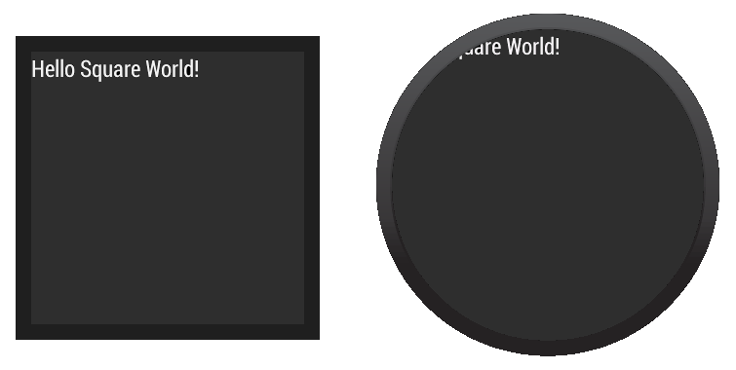

**Figure 1.** Demonstration of how a layout designed for square screens does not work well on round screens.

<LinearLayout xmlns:android="http://schemas.android.com/apk/res/android"  
    xmlns:tools="http://schemas.android.com/tools"  
    android:layout_width="match_parent"  
    android:layout_height="match_parent"  
    android:orientation="vertical">  
  
    <TextView  
        android:id="@+id/text"  
        android:layout_width="wrap_content"  
        android:layout_height="wrap_content"  
        android:text="@string/hello_square" />  
</LinearLayout>

The text does not display correctly on devices with round screens.

The Wearable UI Library provides two different approaches to solve this problem:

* Define different layouts for square and round devices. Your app detects the shape of the device screen and inflates the correct layout at runtime.
* Use a special layout included in the library for both square and round devices. This layout applies different window insets depending on the shape of the device screen.

You typically use the first approach when you want your app to look different depending on the shape of the device screen. You use the second approach when you want to use a similar layout on both screen shapes without having views cropped near the edges of round screens.

### Add the Wearable UI Library

Android Studio includes the Wearable UI Library on your wear module by default when you use the Project Wizard. To compile your project with this library, ensure that the Extras > Google Repository package is installed in the Android SDK manager and that the following dependency is included in the build.gradle file of yourwear module:

dependencies {  
    compile fileTree(dir: 'libs', include: ['*.jar'])  
    **compile 'com.google.android.support:wearable:+'**  
    compile 'com.google.android.gms:play-services-wearable:+'  
}

The 'com.google.android.support:wearable' dependency is required to implement the layout techniques shown in the following sections.

Browse the [API reference documentation](http://developer.android.com/reference/android/support/wearable/view/package-summary.html) for the Wearable UI Library classes.

### Specify Different Layouts for Square and Round Screens

The [WatchViewStub](http://developer.android.com/reference/android/support/wearable/view/WatchViewStub.html) class included in the Wearable UI Library lets you specify different layout definitions for square and round screens. This class detects the screen shape at runtime and inflates the corresponding layout.

To use this class for handling different screen shapes in your app:

1. Add [WatchViewStub](http://developer.android.com/reference/android/support/wearable/view/WatchViewStub.html) as the main element of your activity's layout.
2. Specify a layout definition file for square screens with the rectLayout attribute.
3. Specify a layout definition file for round screens with the roundLayout attribute.

Define your activity's layout as follows:

<android.support.wearable.view.WatchViewStub  
    xmlns:android="http://schemas.android.com/apk/res/android"  
    xmlns:app="http://schemas.android.com/apk/res-auto"  
    xmlns:tools="http://schemas.android.com/tools"  
    android:id="@+id/watch_view_stub"  
    android:layout_width="match_parent"  
    android:layout_height="match_parent"  
    **app:rectLayout="@layout/rect_activity_wear"**  
    **app:roundLayout="@layout/round_activity_wear"**>  
</android.support.wearable.view.WatchViewStub>

Inflate this layout in your activity:

@Override  
protected void onCreate(Bundle savedInstanceState) {  
    super.onCreate(savedInstanceState);  
    setContentView(R.layout.activity_wear);  
}

Then create different layout definition files for square and round screens. In this example, you need to create the files res/layout/rect_activity_wear.xml and res/layout/round_activity_wear.xml. You define these layouts in the same way that you create layouts for handheld apps, but taking into account the constraints of wearable devices. The system inflates the correct layout at runtime depending on the screen shape.

### Accessing layout views

The layouts that you specify for square or round screens are not inflated until [WatchViewStub](http://developer.android.com/reference/android/support/wearable/view/WatchViewStub.html) detects the shape of the screen, so your app cannot access their views immediately. To access these views, set a listener in your activity to be notified when the shape-specific layout has been inflated:

@Override  
protected void onCreate(Bundle savedInstanceState) {  
    super.onCreate(savedInstanceState);  
    setContentView(R.layout.activity_wear);  
  
    WatchViewStub stub = (WatchViewStub) findViewById(R.id.watch_view_stub);  
    stub.setOnLayoutInflatedListener(new WatchViewStub.OnLayoutInflatedListener() {  
        @Override public void onLayoutInflated(WatchViewStub stub) {  
            // Now you can access your views  
            TextView tv = (TextView) stub.findViewById(R.id.text);  
            ...  
        }  
    });  
}

### Use a Shape-Aware Layout

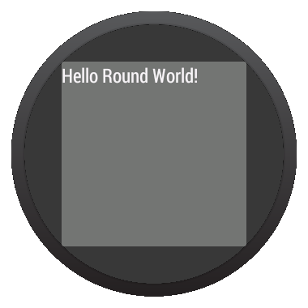

**Figure 2.** Window insets on a round screen.

The [BoxInsetLayout](http://developer.android.com/reference/android/support/wearable/view/BoxInsetLayout.html) class included in the Wearable UI Library extends [FrameLayout](http://developer.android.com/reference/android/widget/FrameLayout.html) and lets you define a single layout that works for both square and round screens. This class applies the required window insets depending on the screen shape and lets you easily align views on the center or near the edges of the screen.

The gray square in figure 2 shows the area where [BoxInsetLayout](http://developer.android.com/reference/android/support/wearable/view/BoxInsetLayout.html) can automatically place its child views on round screens after applying the required window insets. To be displayed inside this area, children views specify the layout_box attribute with these values:

* A combination of top, bottom, left, and right. For example, "left|top" positions the child's left and top edges inside the gray square in figure 2.
* The all value positions all the child's content inside the gray square in figure 2.

On square screens, the window insets are zero and the layout_box attribute is ignored.

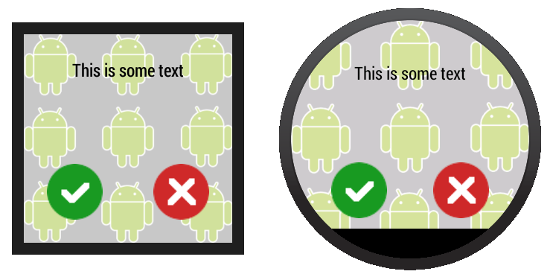

**Figure 3.** A layout definition that works on both square and round screens.

The layout shown in figure 3 uses the [<BoxInsetLayout>](http://developer.android.com/reference/android/support/wearable/view/BoxInsetLayout.html) element and works on square and round screens:

<**android.support.wearable.view.BoxInsetLayout**  
    xmlns:android="http://schemas.android.com/apk/res/android"  
    xmlns:app="http://schemas.android.com/apk/res-auto"  
    **android:background="@drawable/robot_background"**  
    android:layout_height="match_parent"  
    android:layout_width="match_parent"  
    **android:padding="15dp"**>  
  
    <FrameLayout  
        android:layout_width="match_parent"  
        android:layout_height="match_parent"  
        **android:padding="5dp"**  
        **app:layout_box="all"**>  
  
        <TextView  
            android:gravity="center"  
            android:layout_height="wrap_content"  
            android:layout_width="match_parent"  
            android:text="@string/sometext"  
            android:textColor="@color/black" />  
  
        <ImageButton  
            android:background="@null"  
            android:layout_gravity="bottom|left"  
            android:layout_height="50dp"  
            android:layout_width="50dp"  
            android:src="@drawable/ok" />  
  
        <ImageButton  
            android:background="@null"  
            android:layout_gravity="bottom|right"  
            android:layout_height="50dp"  
            android:layout_width="50dp"  
            android:src="@drawable/cancel" />  
    </FrameLayout>  
</android.support.wearable.view.BoxInsetLayout>

Notice the parts of the layout marked in bold:

* android:padding="15dp"

This line assigns padding to the [<BoxInsetLayout>](http://developer.android.com/reference/android/support/wearable/view/BoxInsetLayout.html) element. Because the window insets on round devices are larger than 15dp, this padding only applies to square screens.

* android:padding="5dp"

This line assigns padding to the inner [FrameLayout](http://developer.android.com/reference/android/widget/FrameLayout.html) element. This padding applies to both square and round screens. The total padding between the buttons and the window insets is 20 dp on square screens (15+5) and 5 dp on round screens.

* app:layout_box="all"

This line ensures that the [FrameLayout](http://developer.android.com/reference/android/widget/FrameLayout.html) element and its children are boxed inside the area defined by the window insets on round screens. This line has no effect on square screens.

## Creating Cards

Cards present information to users with a consistent look and feel across different apps. This lesson shows you how to create cards in your Android Wear apps.

The Wearable UI Library provides implementations of cards specifically designed for wearable devices. This library contains the [CardFrame](http://developer.android.com/reference/android/support/wearable/view/CardFrame.html) class, which wraps views inside a card-styled frame with a white background, rounded corners, and a light-drop shadow. A [CardFrame](http://developer.android.com/reference/android/support/wearable/view/CardFrame.html) instance can only contain one direct child, usually a layout manager, to which you can add other views to customize the content inside the card.

You can add cards to your app in two ways:

* Use or extend the [CardFragment](http://developer.android.com/reference/android/support/wearable/view/CardFragment.html) class.
* Add a card inside a [CardScrollView](http://developer.android.com/reference/android/support/wearable/view/CardScrollView.html) instance in your layout.

**Note:** This lesson shows you how to add cards to Android Wear activities. Android notifications on wearable devices are also displayed as cards. For more information, see [Adding Wearable Features to Notifications](http://developer.android.com/training/wearables/notifications/index.html).

### Create a Card Fragment

The [CardFragment](http://developer.android.com/reference/android/support/wearable/view/CardFragment.html) class provides a default card layout with a title, a description, and an icon. Use this approach to add cards to your app if the default card layout shown in figure 1 meets your needs.

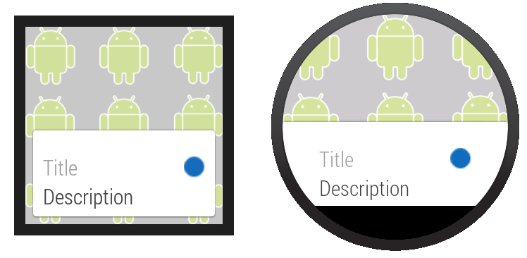

**Figure 1.** The default [CardFragment](http://developer.android.com/reference/android/support/wearable/view/CardFragment.html) layout.

To add a [CardFragment](http://developer.android.com/reference/android/support/wearable/view/CardFragment.html) instance to your app:

1. In your layout, assign an ID to the element that contains the card
2. Create a [CardFragment](http://developer.android.com/reference/android/support/wearable/view/CardFragment.html) instance in your activity
3. Use the fragment manager to add the [CardFragment](http://developer.android.com/reference/android/support/wearable/view/CardFragment.html) instance to its container

The following sample code shows the code for the screen display shown in figure 1:

<android.support.wearable.view.BoxInsetLayout  
xmlns:android="http://schemas.android.com/apk/res/android"  
xmlns:app="http://schemas.android.com/apk/res-auto"  
android:background="@drawable/robot_background"  
android:layout_height="match_parent"  
android:layout_width="match_parent">  
  
    <FrameLayout  
        **android:id="@+id/frame_layout"**  
        android:layout_width="match_parent"  
        android:layout_height="match_parent"  
        app:layout_box="bottom">  
  
    </FrameLayout>  
</android.support.wearable.view.BoxInsetLayout>

The following code adds the [CardFragment](http://developer.android.com/reference/android/support/wearable/view/CardFragment.html) instance to the activity in figure 1:

protected void onCreate(Bundle savedInstanceState) {  
    super.onCreate(savedInstanceState);  
    setContentView(R.layout.activity_wear_activity2);  
  
    FragmentManager fragmentManager = getFragmentManager();  
    FragmentTransaction fragmentTransaction = fragmentManager.beginTransaction();  
    CardFragment cardFragment = CardFragment.create(getString(R.string.cftitle),  
                                                    getString(R.string.cfdesc),  
                                                    R.drawable.p);  
    fragmentTransaction.add(R.id.frame_layout, cardFragment);  
    fragmentTransaction.commit();  
}

To create a card with a custom layout using the [CardFragment](http://developer.android.com/reference/android/support/wearable/view/CardFragment.html) class, extend the class and override its [onCreateContentView](http://developer.android.com/reference/android/support/wearable/view/CardFragment.html#onCreateContentView(android.view.LayoutInflater, android.view.ViewGroup, android.os.Bundle)) method.

### Add a CardFrame to Your Layout

You can also add a card directly to your layout definition, as shown in figure 2. Use this approach when you want to define a custom layout for the card inside a layout definition file.

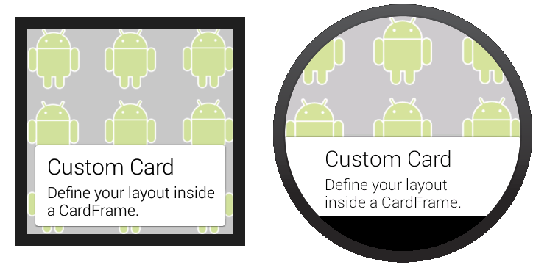

**Figure 2.** Adding a [CardFrame](http://developer.android.com/reference/android/support/wearable/view/CardFrame.html) to your layout.

The following layout code sample demonstrates a vertical linear layout with two elements. You can create more complex layouts to fit the needs of your app.

<android.support.wearable.view.BoxInsetLayout  
xmlns:android="http://schemas.android.com/apk/res/android"  
xmlns:app="http://schemas.android.com/apk/res-auto"  
android:background="@drawable/robot_background"  
android:layout_height="match_parent"  
android:layout_width="match_parent">  
  
    <**android.support.wearable.view.CardScrollView**  
        android:id="@+id/card_scroll_view"  
        android:layout_height="match_parent"  
        android:layout_width="match_parent"  
        app:layout_box="bottom">  
  
        <**android.support.wearable.view.CardFrame**  
            android:layout_height="wrap_content"  
            android:layout_width="fill_parent">  
  
            <LinearLayout  
                android:layout_height="wrap_content"  
                android:layout_width="match_parent"  
                android:orientation="vertical"  
                android:paddingLeft="5dp">  
                <TextView  
                    android:fontFamily="sans-serif-light"  
                    android:layout_height="wrap_content"  
                    android:layout_width="match_parent"  
                    android:text="@string/custom_card"  
                    android:textColor="@color/black"  
                    android:textSize="20sp"/>  
                <TextView  
                    android:fontFamily="sans-serif-light"  
                    android:layout_height="wrap_content"  
                    android:layout_width="match_parent"  
                    android:text="@string/description"  
                    android:textColor="@color/black"  
                    android:textSize="14sp"/>  
            </LinearLayout>  
        </android.support.wearable.view.CardFrame>  
    </android.support.wearable.view.CardScrollView>  
</android.support.wearable.view.BoxInsetLayout>

The CardScrollView element detects the shape of the screen and displays the card differently on round and square devices, using wider side margins on round screens. However, placing the [<CardScrollView>](http://developer.android.com/reference/android/supprot/wearable/view/CardScrollView.html) element inside a [<BoxInsetLayout>](http://developer.android.com/reference/android/support/wearable/view/BoxInsetLayout.html) and using the layout_box="bottom" attribute is useful to align the card to the bottom of round screens without cropping its content.

## Creating Lists

Lists let users select an item from a set of choices easily on wearable devices. This lesson shows you how to create lists in your Android Wear apps.

The Wearable UI Library includes the [WearableListView](http://developer.android.com/reference/android/support/wearable/view/WearableListView.html) class, which is a list implementation optimized for wearable devices.

To create a list in your Android Wear apps:

1. Add a [WearableListView](http://developer.android.com/reference/android/support/wearable/view/WearableListView.html) element to your activity's layout definition.
2. Create a custom layout implementation for your list items.
3. Use this implementation to create a layout definition file for your list items.
4. Create an adapter to populate the list.
5. Assign the adapter to the [WearableListView](http://developer.android.com/reference/android/support/wearable/view/WearableListView.html) element.

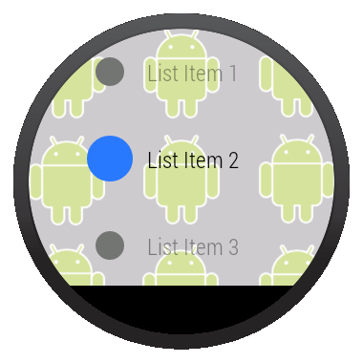

**Figure 1.** A list view on Android Wear.

These steps are described in detail in the following sections.

### Add a List View

The following layout adds a list view to an activity using a [<BoxInsetLayout>](http://developer.android.com/reference/android/support/wearable/view/BoxInsetLayout.html) element, so the list is displayed properly on both round and square devices:

<android.support.wearable.view.BoxInsetLayout  
    xmlns:android="http://schemas.android.com/apk/res/android"  
    xmlns:app="http://schemas.android.com/apk/res-auto"  
    android:background="@drawable/robot_background"  
    android:layout_height="match_parent"  
    android:layout_width="match_parent">  
  
    <FrameLayout  
        android:id="@+id/frame_layout"  
        android:layout_height="match_parent"  
        android:layout_width="match_parent"  
        app:layout_box="left|bottom|right">  
  
        <**android.support.wearable.view.WearableListView**  
            android:id="@+id/wearable_list"  
            android:layout_height="match_parent"  
            android:layout_width="match_parent">  
        </android.support.wearable.view.WearableListView>  
    </FrameLayout>  
</android.support.wearable.view.BoxInsetLayout>

### Create a Layout Implementation for List Items

In many cases, each list item consists of an icon and a description. The [Notifications](http://developer.android.com/samples/Notifications/index.html) sample implements a custom layout that extends [LinearLayout](http://developer.android.com/reference/android/widget/LinearLayout.html) to incorporate these two elements inside each list item. This layout also implements the methods in the [WearableListView.OnCenterProximityListener](http://developer.android.com/reference/android/support/wearable/view/WearableListView.OnCenterProximityListener.html) interface to change the color of the item's icon and fade the text in response to events from the [WearableListView](http://developer.android.com/reference/android/support/wearable/view/WearableListView.html) element as the user scrolls through the list.

public class WearableListItemLayout extends LinearLayout  
             implements WearableListView.OnCenterProximityListener {  
  
    private ImageView mCircle;  
    private TextView mName;  
  
    private final float mFadedTextAlpha;  
    private final int mFadedCircleColor;  
    private final int mChosenCircleColor;  
  
    public WearableListItemLayout(Context context) {  
        this(context, null);  
    }  
  
    public WearableListItemLayout(Context context, AttributeSet attrs) {  
        this(context, attrs, 0);  
    }  
  
    public WearableListItemLayout(Context context, AttributeSet attrs,  
                                  int defStyle) {  
        super(context, attrs, defStyle);  
  
        mFadedTextAlpha = getResources()  
                         .getInteger(R.integer.action_text_faded_alpha) / 100f;  
        mFadedCircleColor = getResources().getColor(R.color.grey);  
        mChosenCircleColor = getResources().getColor(R.color.blue);  
    }  
  
    // Get references to the icon and text in the item layout definition  
    @Override  
    protected void onFinishInflate() {  
        super.onFinishInflate();  
        // These are defined in the layout file for list items  
        // (see next section)  
        mCircle = (ImageView) findViewById(R.id.circle);  
        mName = (TextView) findViewById(R.id.name);  
    }  
  
    @Override  
    public void onCenterPosition(boolean animate) {  
        mName.setAlpha(1f);  
        ((GradientDrawable) mCircle.getDrawable()).setColor(mChosenCircleColor);  
    }  
  
    @Override  
    public void onNonCenterPosition(boolean animate) {  
        ((GradientDrawable) mCircle.getDrawable()).setColor(mFadedCircleColor);  
        mName.setAlpha(mFadedTextAlpha);  
    }  
}

You can also create animator objects to enlarge the icon of the center item in the list. You can use the[onCenterPosition()](http://developer.android.com/reference/android/support/wearable/view/WearableListView.OnCenterProximityListener.html#onCenterPosition(boolean)) and [onNonCenterPosition()](http://developer.android.com/reference/android/support/wearable/view/WearableListView.OnCenterProximityListener.html#onNonCenterPosition(boolean)) callback methods in the[WearableListView.OnCenterProximityListener](http://developer.android.com/reference/android/support/wearable/view/WearableListView.html) interface to manage your animators. For more information about animators, see [Animating with ObjectAnimator](http://developer.android.com/guide/topics/graphics/prop-animation.html#object-animator).

### Create a Layout Definition for Items

After you implement a custom layout for list items, you provide a layout definition file that specifies the layout parameters of each of the components inside a list item. The following layout definition uses the custom layout implementation from the previous section and defines an icon and a text view whose IDs match those in the layout implementation class:

res/layout/list_item.xml

<com.example.android.support.wearable.notifications.WearableListItemLayout  
    xmlns:android="http://schemas.android.com/apk/res/android"  
    android:gravity="center_vertical"  
    android:layout_width="match_parent"  
    android:layout_height="80dp">  
    <ImageView  
        android:id="@+id/circle"  
        android:layout_height="20dp"  
        android:layout_margin="16dp"  
        android:layout_width="20dp"  
        android:src="@drawable/wl_circle"/>  
    <TextView  
        android:id="@+id/name"  
        android:gravity="center_vertical|left"  
        android:layout_width="wrap_content"  
        android:layout_marginRight="16dp"  
        android:layout_height="match_parent"  
        android:fontFamily="sans-serif-condensed-light"  
        android:lineSpacingExtra="-4sp"  
        android:textColor="@color/text_color"  
        android:textSize="16sp"/>  
</com.example.android.support.wearable.notifications.WearableListItemLayout>

### Create an Adapter to Populate the List

The adapter populates the [WearableListView.OnCenterProximityListener](http://developer.android.com/reference/android/support/wearable/view/WearableListView.html) element with content. The following simple adapter populates the list with elements based on an array of strings:

private static final class Adapter extends WearableListView.Adapter {  
    private String[] mDataset;  
    private final Context mContext;  
    private final LayoutInflater mInflater;  
  
    // Provide a suitable constructor (depends on the kind of dataset)  
    public Adapter(Context context, String[] dataset) {  
        mContext = context;  
        mInflater = LayoutInflater.from(context);  
        mDataset = dataset;  
    }  
  
    // Provide a reference to the type of views you're using  
    public static class ItemViewHolder extends WearableListView.ViewHolder {  
        private TextView textView;  
        public ItemViewHolder(View itemView) {  
            super(itemView);  
            // find the text view within the custom item's layout  
            textView = (TextView) itemView.findViewById(R.id.name);  
        }  
    }  
  
    // Create new views for list items  
    // (invoked by the WearableListView's layout manager)  
    @Override  
    public WearableListView.ViewHolder onCreateViewHolder(ViewGroup parent,  
                                                          int viewType) {  
        // Inflate our custom layout for list items  
        return new ItemViewHolder(mInflater.inflate(R.layout.list_item, null));  
    }  
  
    // Replace the contents of a list item  
    // Instead of creating new views, the list tries to recycle existing ones  
    // (invoked by the WearableListView's layout manager)  
    @Override  
    public void onBindViewHolder(WearableListView.ViewHolder holder,  
                                 int position) {  
        // retrieve the text view  
        ItemViewHolder itemHolder = (ItemViewHolder) holder;  
        TextView view = itemHolder.textView;  
        // replace text contents  
        view.setText(mDataset[position]);  
        // replace list item's metadata  
        holder.itemView.setTag(position);  
    }  
  
    // Return the size of your dataset  
    // (invoked by the WearableListView's layout manager)  
    @Override  
    public int getItemCount() {  
        return mDataset.length;  
    }  
}

### Associate the Adapter and Set a Click Listener

In your activity, obtain a reference to the [WearableListView.OnCenterProximityListener](http://developer.android.com/reference/android/support/wearable/view/WearableListView.html) element from your layout, assign an instance of the adapter to populate the list, and set a click listener to complete an action when the user selects a particular list item.

public class WearActivity extends Activity  
                          implements WearableListView.ClickListener {  
  
    // Sample dataset for the list  
    String[] elements = { "List Item 1", "List Item 2", ... };  
  
    @Override  
    protected void onCreate(Bundle savedInstanceState) {  
        super.onCreate(savedInstanceState);  
        setContentView(R.layout.my_list_activity);  
  
        // Get the list component from the layout of the activity  
        WearableListView listView =  
            (WearableListView) findViewById(R.id.wearable_list);  
  
        // Assign an adapter to the list  
        listView.setAdapter(new Adapter(this, elements));  
  
        // Set a click listener  
        listView.setClickListener(this);  
    }  
  
    // WearableListView click listener  
    @Override  
    public void onClick(WearableListView.ViewHolder v) {  
        Integer tag = (Integer) v.itemView.getTag();  
        // use this data to complete some action ...  
    }  
  
    @Override  
    public void onTopEmptyRegionClick() {  
    }  
}

## Creating a 2D Picker

The [2D Picker](http://developer.android.com/design/wear/structure.html#2DPicker) pattern in Android Wear allows users to navigate and choose from a set of items shown as pages. The Wearable UI Library lets you easily implement this pattern using a page grid, which is a layout manager that allows users to scroll vertically and horizontally through pages of data.

To implement this pattern, you add a [GridViewPager](http://developer.android.com/reference/android/support/wearable/view/GridViewPager.html) element to the layout of your activity and implement an adapter that provides a set of pages by extending the [FragmentGridPagerAdapter](http://developer.android.com/reference/android/support/wearable/view/FragmentGridPagerAdapter.html) class.

### Add a Page Grid

Add a [GridViewPager](http://developer.android.com/reference/android/support/wearable/view/GridViewPager.html) element to your layout definition as follows:

<android.support.wearable.view.GridViewPager  
    xmlns:android="http://schemas.android.com/apk/res/android"  
    android:id="@+id/pager"  
    android:layout_width="match_parent"  
    android:layout_height="match_parent" />

You can use any of the techniques described in [Defining Layouts](http://developer.android.com/training/wearables/ui/layouts.html) to ensure that your 2D picker works on both round and square devices.

### Implement a Page Adapter

A page adapter provides a set of pages to populate a [GridViewPager](http://developer.android.com/reference/android/support/wearable/view/GridViewPager.html) component. To implement this adapter, you extend the [FragmentGridPagerAdapter](http://developer.android.com/reference/android/support/wearable/view/FragmentGridPagerAdapter.html) class from the Wearable UI Library

The following snippet shows how to provide a set of static cards with custom background images:

public class SampleGridPagerAdapter extends FragmentGridPagerAdapter {  
  
    private final Context mContext;  
    private List mRows;  
  
    public SampleGridPagerAdapter(Context ctx, FragmentManager fm) {  
        super(fm);  
        mContext = ctx;  
    }  
  
    static final int[] BG_IMAGES = new int[] {  
        R.drawable.debug_background_1, ...  
        R.drawable.debug_background_5  
    };  
  
    // A simple container for static data in each page  
    private static class Page {  
        // static resources  
        int titleRes;  
        int textRes;  
        int iconRes;  
        ...  
    }  
  
    // Create a static set of pages in a 2D array  
    private final Page[][] PAGES = { ... };  
  
    // Override methods in FragmentGridPagerAdapter  
    ...  
}

The adapter calls [getFragment()](http://developer.android.com/reference/android/support/wearable/view/FragmentGridPagerAdapter.html#getFragment(int, int)) and [getBackgroundForRow()](http://developer.android.com/reference/android/support/wearable/view/GridPagerAdapter.html#getBackgroundForRow(int)) to retrieve the content to display for each row:

// Obtain the UI fragment at the specified position  
@Override  
public Fragment getFragment(int row, int col) {  
    Page page = PAGES[row][col];  
    String title =  
        page.titleRes != 0 ? mContext.getString(page.titleRes) : null;  
    String text =  
        page.textRes != 0 ? mContext.getString(page.textRes) : null;  
    CardFragment fragment = CardFragment.create(title, text, page.iconRes);  
  
    // Advanced settings (card gravity, card expansion/scrolling)  
    fragment.setCardGravity(page.cardGravity);  
    fragment.setExpansionEnabled(page.expansionEnabled);  
    fragment.setExpansionDirection(page.expansionDirection);  
    fragment.setExpansionFactor(page.expansionFactor);  
    return fragment;  
}  
  
// Obtain the background image for the row  
@Override  
public Drawable getBackgroundForRow(int row) {  
    return mContext.getResources().getDrawable(  
            (BG_IMAGES[row % BG_IMAGES.length]), null);  
}

The following example shows how to retrieve the background to display for a specific page in the grid:

// Obtain the background image for the specific page  
@Override  
public Drawable getBackgroundForPage(int row, int column) {  
    if( row == 2 && column == 1) {  
        // Place image at specified position  
        return mContext.getResources().getDrawable(R.drawable.bugdroid_large, null);  
    } else {  
        // Default to background image for row  
        return GridPagerAdapter.BACKGROUND_NONE;  
    }  
}

The [getRowCount()](http://developer.android.com/reference/android/support/wearable/view/GridPagerAdapter.html#getRowCount()) method tells the adapter how many rows of content are available, and the[getColumnCount()](http://developer.android.com/reference/android/support/wearable/view/GridPagerAdapter.html#getColumnCount(int)) method tells the adapter how many columns of content are available for each of the rows.

// Obtain the number of pages (vertical)  
@Override  
public int getRowCount() {  
    return PAGES.length;   
}  
  
// Obtain the number of pages (horizontal)  
@Override  
public int getColumnCount(int rowNum) {  
    return PAGES[rowNum].length;  
}

The adapter implementation details depend on your particular set of pages. Each page provided by the adapter is of type [Fragment](http://developer.android.com/reference/android/app/Fragment.html). In this example, each page is a [CardFragment](http://developer.android.com/reference/android/support/wearable/view/CardFragment.html) instance that uses one of the default card layouts. However, you can combine different types of pages in the same 2D picker, such as cards, action icons, and custom layouts depending on your use cases.

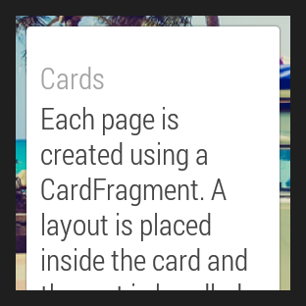

**Figure 1:** The GridViewPager sample.

Not all rows need to have the same number of pages. Notice that in this example the number of colums is different for each row. You can also use a [GridViewPager](http://developer.android.com/reference/android/support/wearable/view/GridViewPager.html) component to implement a 1D picker with only one row or only one column.

The [GridViewPager](http://developer.android.com/reference/android/support/wearable/view/GridViewPager.html) class provides support for scrolling in cards whose content does not fit the device screen. This example configures each card to expand as required, so users can scroll through the card's content. When users reach the end of a scrollable card, a swipe in the same direction shows the next page on the grid, if one is available.

You can specify a custom background for each page with the [getBackgroundForPage()](http://developer.android.com/reference/android/support/wearable/view/GridPagerAdapter.html#getBackgroundForPage(int, int)) method. When users swipe to navigate across pages, the [GridViewPager](http://developer.android.com/reference/android/support/wearable/view/GridViewPager.html) class applies parallax and crossfade effects between different backgrounds automatically.

### Assign an adapter instance to the page grid

In your activity, assign an instance of your adapter implementation to the [GridViewPager](http://developer.android.com/reference/android/support/wearable/view/GridViewPager.html) component:

public class MainActivity extends Activity {  
  
    @Override  
    protected void onCreate(Bundle savedInstanceState) {  
        super.onCreate(savedInstanceState);  
        setContentView(R.layout.activity_main);  
        ...  
        final GridViewPager pager = (GridViewPager) findViewById(R.id.pager);  
        pager.setAdapter(new SampleGridPagerAdapter(this, getFragmentManager()));  
    }  
}

## Showing Confirmations

[Confirmations](http://developer.android.com/design/wear/patterns.html#Countdown) in Android Wear apps use the whole screen or a larger portion of it than those in handheld apps. This ensures that users can see these confirmations by just glancing at the screen and that they have large enough touch targets to cancel an action.

The Wearable UI Library helps you show confirmation animations and timers in your Android Wear apps:

Confirmation timers - Automatic confirmation timers show users an animated timer that lets them cancel an action they just performed.

Confirmation animations - Confirmation animations give users visual feedback when they complete an action.

The following sections show you how to implement these patterns.

### Use Automatic Confirmation Timers

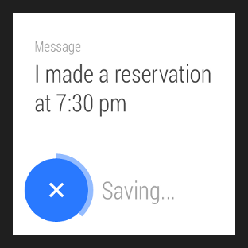

**Figure 1:** A confirmation timer.

Automatic confirmation timers let users cancel an action they just performed. When the user performs the action, your app shows a button to cancel the action with a timer animation and starts the timer. The user has the option to cancel the action until the timer finishes. Your app gets notified if the user cancels the action and when the timer expires.

To show a confirmation timer when users complete an action in your app:

1. Add a [<DelayedConfirmationView>](http://developer.android.com/reference/android/support/wearable/view/DelayedConfirmationView.html) element to your layout.
2. Implement the [DelayedConfirmationListener](http://developer.android.com/reference/android/support/wearable/view/DelayedConfirmationView.DelayedConfirmationListener.html) interface in your activity.
3. Set the duration of the timer and start it when the user completes an action.

Add the [<DelayedConfirmationView>](http://developer.android.com/reference/android/support/wearable/view/DelayedConfirmationView.html) element to your layout as follows:

<android.support.wearable.view.DelayedConfirmationView  
    android:id="@+id/delayed_confirm"  
    android:layout_width="40dp"  
    android:layout_height="40dp"  
    android:src="@drawable/cancel_circle"  
    app:circle_border_color="@color/lightblue"  
    app:circle_border_width="4dp"  
    app:circle_radius="16dp">  
</android.support.wearable.view.DelayedConfirmationView>

You can assign a drawable resource to display inside the circle with the android:src attribute and configure the parameters of the circle directly on the layout definition.

To be notified when the timer finishes or when users tap on it, implement the corresponding listener methods in your activity:

public class WearActivity extends Activity implements  
                           DelayedConfirmationView.DelayedConfirmationListener {  
  
    private DelayedConfirmationView mDelayedView;  
  
    @Override  
    protected void onCreate(Bundle savedInstanceState) {  
        super.onCreate(savedInstanceState);  
        setContentView(R.layout.activity_wear_activity);  
  
        mDelayedView =  
                (DelayedConfirmationView) findViewById(R.id.delayed_confirm);  
        mDelayedView.setListener(this);  
    }  
  
    @Override  
    public void onTimerFinished(View view) {  
        // User didn't cancel, perform the action  
    }  
  
    @Override  
    public void onTimerSelected(View view) {  
        // User canceled, abort the action  
    }  
}

To start the timer, add the following code to the point in your activity where users select an action:

// Two seconds to cancel the action  
mDelayedView.setTotalTimeMs(2000);  
// Start the timer  
mDelayedView.start();

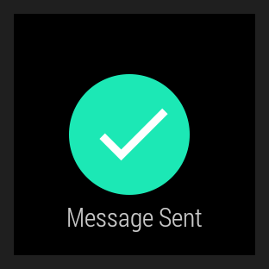

**Figure 2:** A confirmation animation.

### Show Confirmation Animation

To show a confirmation animation when users complete an action in your app, create an intent that starts [ConfirmationActivity](http://developer.android.com/reference/android/support/wearable/activity/ConfirmationActivity.html) from one of your activities. You can specify one of the these animations with the [EXTRA_ANIMATION_TYPE](http://developer.android.com/reference/android/support/wearable/activity/ConfirmationActivity.html#EXTRA_ANIMATION_TYPE) intent extra:

* [SUCCESS_ANIMATION](http://developer.android.com/reference/android/support/wearable/activity/ConfirmationActivity.html#SUCCESS_ANIMATION)
* [FAILURE_ANIMATION](http://developer.android.com/reference/android/support/wearable/activity/ConfirmationActivity.html#FAILURE_ANIMATION)
* [OPEN_ON_PHONE_ANIMATION](http://developer.android.com/reference/android/support/wearable/activity/ConfirmationActivity.html#OPEN_ON_PHONE_ANIMATION)

You can also add a message that appears under the confirmation icon.

To use the [ConfirmationActivity](http://developer.android.com/reference/android/support/wearable/activity/ConfirmationActivity.html) in your app, first declare this activity in your manifest file:

<manifest>  
  <application>  
    ...  
    <activity  
        android:name="android.support.wearable.activity.ConfirmationActivity">  
    </activity>  
  </application>  
</manifest>

Then determine the result of the user action and start the activity with an intent:

Intent intent = new Intent(this, ConfirmationActivity.class);  
intent.putExtra(ConfirmationActivity.EXTRA_ANIMATION_TYPE,  
                ConfirmationActivity.SUCCESS_ANIMATION);  
intent.putExtra(ConfirmationActivity.EXTRA_MESSAGE,  
                getString(R.string.msg_sent));  
startActivity(intent);

After showing the confirmation animation, [ConfirmationActivity](http://developer.android.com/reference/android/support/wearable/activity/ConfirmationActivity.html) finishes and your activity resumes.

## Exiting Full-Screen Activities

By default, users exit Android Wear activities by swiping from left to right. If the app contains horizontally scrollable content, users first have to navigate to the edge of the content and then swipe again from left to right to exit the app.

For more immersive experiences, like an app that can scroll a map in any direction, you can disable the swipe to exit gesture in your app. However, if you disable it, you must implement the long-press-to-dismiss UI pattern to let users exit your app using the [DismissOverlayView](http://developer.android.com/reference/android/support/wearable/view/DismissOverlayView.html) class from the Wearable UI Library. You must also inform your users the first time they run your app that they can exit using a long press.

For design guidelines about exiting Android Wear activities, see [Breaking out of the card](http://developer.android.com/design/wear/structure.html#Custom).

### Disable the Swipe-To-Dismiss Gesture

If the user interaction model of your app interferes with the swipe-to-dismiss gesture, you can disable it for your app. To disable the swipe-to-dismiss gesture in your app, extend the default theme and set theandroid:windowSwipeToDismiss attribute to false:

<style name="AppTheme" parent="Theme.DeviceDefault">  
    <item name="android:windowSwipeToDismiss">false</item>  
</style>

If you disable this gesture, you must implement the long-press-to-dismiss UI pattern to let users exit your app, as described in the next section.

### Implement the Long Press to Dismiss Pattern

To use the [DismissOverlayView](http://developer.android.com/reference/android/support/wearable/view/DismissOverlayView.html) class in your activity, add this element to your layout definition such that it covers the whole screen and is placed above all other views.

The following example shows how to add the [<DismissOverlayView>](http://developer.android.com/reference/android/support/wearable/view/DismissOverlayView.html) element:

<FrameLayout  
    xmlns:android="http://schemas.android.com/apk/res/android"  
    android:layout_height="match_parent"  
    android:layout_width="match_parent">  
  
    <!-- other views go here -->  
  
    <android.support.wearable.view.DismissOverlayView  
        android:id="@+id/dismiss_overlay"  
        android:layout_height="match_parent"  
        android:layout_width="match_parent"/>  
<FrameLayout>

In your activity, obtain the [<DismissOverlayView>](http://developer.android.com/reference/android/support/wearable/view/DismissOverlayView.html) element and set some introductory text. This text is shown to users the first time they run your app to inform them that they can exit the app using a long press gesture. Then use a [GestureDetector](http://developer.android.com/reference/android/view/GestureDetector.html) to detect a long press:

public class WearActivity extends Activity {  
  
    private DismissOverlayView mDismissOverlay;  
    private GestureDetector mDetector;  
  
    public void onCreate(Bundle savedState) {  
        super.onCreate(savedState);  
        setContentView(R.layout.wear_activity);  
  
        // Obtain the DismissOverlayView element  
        mDismissOverlay = (DismissOverlayView) findViewById(R.id.dismiss_overlay);  
        mDismissOverlay.setIntroText(R.string.long_press_intro);  
        mDismissOverlay.showIntroIfNecessary();  
  
        // Configure a gesture detector  
        mDetector = new GestureDetector(this, new SimpleOnGestureListener() {  
            public void onLongPress(MotionEvent ev) {  
                mDismissOverlay.show();  
            }  
        });  
    }  
  
    // Capture long presses  
    @Override  
    public boolean onTouchEvent(MotionEvent ev) {  
        return mDetector.onTouchEvent(ev) || super.onTouchEvent(ev);  
    }  
}

When the system detects a long press gesture, the [<DismissOverlayView>](http://developer.android.com/reference/android/support/wearable/view/DismissOverlayView.html) element shows an **Exit** button, which terminates your activity if the user presses it.

# Sending and Syncing Data

The Wearable Data Layer API, which is part of Google Play services, provides a communication channel for your handheld and wearable apps. The API consists of a set of data objects that the system can send and synchronize over the wire and listeners that notify your apps of important events with the data layer:

**Data Items -** A [DataItem](http://developer.android.com/reference/com/google/android/gms/wearable/DataItem.html) provides data storage with automatic syncing between the handheld and wearable.

**Messages -** The [MessageApi](http://developer.android.com/reference/com/google/android/gms/wearable/MessageApi.html) class can send messages and is good for remote procedure calls (RPC), such as controlling a handheld's media player from the wearable or starting an intent on the wearable from the handheld. Messages are also great for one-way requests or for a request/response communication model. If the handheld and wearable are connected, the system queues the message for delivery and returns a successful result code. If the devices are not connected, an error is returned. A successful result code does not indicate that the message was delivered successfully as the devices may disconnect after receiving the result code.

**Asset -** [Asset](http://developer.android.com/reference/com/google/android/gms/wearable/Asset.html) objects are for sending binary blobs of data, such as images. You attach assets to data items and the system automatically takes care of the transfer for you, conserving Bluetooth bandwidth by caching large assets to avoid re-transmission.

**WearableListenerService** (for services) - Extending [WearableListenerService](http://developer.android.com/reference/com/google/android/gms/wearable/WearableListenerService.html) lets you listen for important data layer events in a service. The system manages the lifecycle of the [WearableListenerService](http://developer.android.com/reference/com/google/android/gms/wearable/WearableListenerService.html), binding to the service when it needs to send data items or messages and unbinding the service when no work is needed.

**DataListener** (for foreground activities) - Implementing [DataListener](http://developer.android.com/reference/com/google/android/gms/wearable/DataApi.DataListener.html) in an activity lets you listen for important data layer events when an activity is in the foreground. Using this instead of the [WearableListenerService](http://developer.android.com/reference/com/google/android/gms/wearable/WearableListenerService.html) lets you listen for changes only when the user is actively using your app.

**Channel -** You can use the [ChannelApi](http://developer.android.com/reference/com/google/android/gms/wearable/ChannelApi.html) class to transfer large data items, such as music and movie files, from a handheld to a wearable device. The Channel API for data transfer has the following benefits:

* Transfer large data files between two or more connected devices, without the automatic synchronization provided when using [Asset](http://developer.android.com/reference/com/google/android/gms/wearable/Asset.html) objects attached to [DataItem](http://developer.android.com/reference/com/google/android/gms/wearable/DataItem.html) objects. The Channel API saves disk space unlike the [DataApi](http://developer.android.com/reference/com/google/android/gms/wearable/DataApi.html) class, which creates a copy of the assets on the local device before synchronizing with connected devices.
* Reliably send a file that is too large in size to send using the [MessageApi](http://developer.android.com/reference/com/google/android/gms/wearable/MessageApi.html) class.
* Transfer streamed data, such as music pulled from a network server or voice data from the microphone.

**Warning:** Because these APIs are designed for communication between handhelds and wearables, these are the only APIs you should use to set up communication between these devices. For instance, don't try to open low-level sockets to create a communication channel.

Android Wear supports multiple wearables connected to a handheld device. For example, when the user saves a note on a handheld, it automatically appears on both of the user's Wear devices. To synchronize data between devices, Google’s servers host a cloud node in the network of devices. The system synchronizes data to directly connected devices, the cloud node, and to wearable devices connected to the cloud node via Wi-Fi.

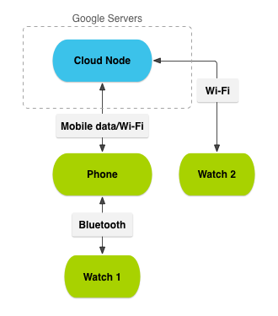

**Figure 1.** A sample network of nodes with handheld and wearable devices.

### Lessons

[Accessing the Wearable Data Layer](http://developer.android.com/training/wearables/data-layer/accessing.html) - This lesson shows you how to create a client to access the Data Layer APIs.

[Syncing Data Items](http://developer.android.com/training/wearables/data-layer/data-items.html) - Data items are objects that are stored in a replicated data store that is automatically synced from handhelds to wearables.

[Transferring Assets](http://developer.android.com/training/wearables/data-layer/assets.html) - Assets are binary blobs of data that you typically use to transfer images or media.

[Sending and Receiving Messages](http://developer.android.com/training/wearables/data-layer/messages.html) - Messages are designed for fire-and-forget messages that you can send back and forth between the wearable and handheld.

[Handling Data Layer Events](http://developer.android.com/training/wearables/data-layer/events.html) - Be notified of changes and events to the data layer.

## Accessing the Wearable Data Layer

To call the Data Layer API, create an instance of [GoogleApiClient](http://developer.android.com/reference/com/google/android/gms/common/api/GoogleApiClient.html), the main entry point for any of the Google Play services APIs.

[GoogleApiClient](http://developer.android.com/reference/com/google/android/gms/common/api/GoogleApiClient.html) provides a builder that makes it easy to create an instance of the client. A minimal [GoogleApiClient](http://developer.android.com/reference/com/google/android/gms/common/api/GoogleApiClient.html) looks like this:

**Note:** For now, this minimal client is enough to get started. However, see [Accessing Google Play services APIs](http://developer.android.com/google/auth/api-client.html) for more information about creating a [GoogleApiClient](http://developer.android.com/reference/com/google/android/gms/common/api/GoogleApiClient.html), implementing its callbacks, and handling error cases.

GoogleApiClient mGoogleApiClient = new GoogleApiClient.Builder(this)  
        .addConnectionCallbacks(new ConnectionCallbacks() {  
                @Override  
                public void onConnected(Bundle connectionHint) {  
                    Log.d(TAG, "onConnected: " + connectionHint);  
                    // Now you can use the Data Layer API  
                }  
                @Override  
                public void onConnectionSuspended(int cause) {  
                    Log.d(TAG, "onConnectionSuspended: " + cause);  
                }  
        })  
        .addOnConnectionFailedListener(new OnConnectionFailedListener() {  
                @Override  
                public void onConnectionFailed(ConnectionResult result) {  
                    Log.d(TAG, "onConnectionFailed: " + result);  
                }  
            })  
        // Request access only to the Wearable API  
        .addApi(Wearable.API)  
        .build();

**Important:** If you are adding multiple APIs to a [GoogleApiClient](http://developer.android.com/reference/com/google/android/gms/common/api/GoogleApiClient.html), you may run into client connection errors on devices that do not have the [Android Wear app](https://play.google.com/store/apps/details?id=com.google.android.wearable.app&hl=en) installed. To avoid connection errors, call the [addApiIfAvailable()](http://developer.android.com/reference/com/google/android/gms/common/api/GoogleApiClient.Builder.html#addApiIfAvailable(com.google.android.gms.common.api.Api<? extends com.google.android.gms.common.api.Api.ApiOptions.NotRequiredOptions>, com.google.android.gms.common.api.Scope...)) method and pass in the [Wearable](http://developer.android.com/reference/com/google/android/gms/wearable/Wearable.html) API to indicate that your client should gracefully handle the missing API. For more information, see [Access the Wearable API](http://developer.android.com/google/auth/api-client.html#WearableApi).

Before you use the data layer API, start a connection on your client by calling the [connect()](http://developer.android.com/reference/com/google/android/gms/common/api/GoogleApiClient.html#connect()) method, as described in [Start a Connection](http://developer.android.com/google/auth/api-client.html#Starting). When the system invokes the [onConnected()](http://developer.android.com/reference/com/google/android/gms/common/api/GoogleApiClient.ConnectionCallbacks.html#onConnected(android.os.Bundle)) callback for your client, you're ready to use the Data Layer API.

## Syncing Data Items

A [DataItem](http://developer.android.com/reference/com/google/android/gms/wearable/DataItem.html) defines the data interface that the system uses to synchronize data between handhelds and wearables. A [DataItem](http://developer.android.com/reference/com/google/android/gms/wearable/DataItem.html) generally consists of the following items:

* **Payload** - A byte array, which you can set with whatever data you wish, allowing you to do your own object serialization and deserialization. The size of the payload is limited to 100KB.
* **Path** - A unique string that must start with a forward slash (for instance, "/path/to/data")

You normally don't implement [DataItem](http://developer.android.com/reference/com/google/android/gms/wearable/DataItem.html) directly. Instead, you:

1. Create a [PutDataRequest](http://developer.android.com/reference/com/google/android/gms/wearable/PutDataRequest.html) object, specifying a string path to uniquely identify the item.
2. Call [setData()](http://developer.android.com/reference/com/google/android/gms/wearable/PutDataRequest.html#setData(byte%5B%5D)) to set the payload.
3. Call [DataApi.putDataItem()](http://developer.android.com/reference/com/google/android/gms/wearable/DataApi.html#putDataItem(com.google.android.gms.common.api.GoogleApiClient, com.google.android.gms.wearable.PutDataRequest)) to request the system to create the data item.
4. When requesting data items, the system returns objects that properly implement the [DataItem](http://developer.android.com/reference/com/google/android/gms/wearable/DataItem.html) interface.

However, instead of working with raw bytes using [setData()](http://developer.android.com/reference/com/google/android/gms/wearable/PutDataRequest.html#setData(byte%5B%5D)), we recommend you [use a data map](http://developer.android.com/training/wearables/data-layer/data-items.html#SyncData), which exposes a data item in an easy-to-use [Bundle](http://developer.android.com/reference/android/os/Bundle.html)-like interface.

### Sync Data with a Data Map

When possible, use the [DataMap](http://developer.android.com/reference/com/google/android/gms/wearable/DataMap.html) class. This approach lets you work with data items in the form of an Android [Bundle](http://developer.android.com/reference/android/os/Bundle.html), so object serialization and de-serialization is done for you, and you can manipulate data with key-value pairs.

To use a data map:

1. Create a [PutDataMapRequest](http://developer.android.com/reference/com/google/android/gms/wearable/PutDataMapRequest.html) object, setting the path of the data item.

**Note:** The path string is a unique identifier for the data item that allows you to access it from either side of the connection. The path must begin with a forward slash. If you're using hierarchical data in your app, you should create a path scheme that matches the structure of the data.

1. Call [PutDataMapRequest.getDataMap()](http://developer.android.com/reference/com/google/android/gms/wearable/PutDataMapRequest.html#getDataMap()) to obtain a data map that you can set values on.
2. Set any desired values for the data map using the put...() methods, such as [putString()](http://developer.android.com/reference/com/google/android/gms/wearable/DataMap.html#putString(java.lang.String, java.lang.String)).
3. Call [PutDataMapRequest.asPutDataRequest()](http://developer.android.com/reference/com/google/android/gms/wearable/PutDataMapRequest.html#asPutDataRequest()) to obtain a [PutDataRequest](http://developer.android.com/reference/com/google/android/gms/wearable/PutDataRequest.html) object.
4. Call [DataApi.putDataItem()](http://developer.android.com/reference/com/google/android/gms/wearable/DataApi.html#putDataItem(com.google.android.gms.common.api.GoogleApiClient, com.google.android.gms.wearable.PutDataRequest)) to request the system to create the data item.

**Note:** If the handset and wearable devices are disconnected, the data is buffered and synced when the connection is re-established.

The increaseCounter() method in the following example shows how to create a data map and put data in it:

public class MainActivity extends Activity implements  
        DataApi.DataListener,  
        GoogleApiClient.ConnectionCallbacks,  
        GoogleApiClient.OnConnectionFailedListener {  
  
    private static final String COUNT_KEY = "com.example.key.count";  
  
    private GoogleApiClient mGoogleApiClient;  
    private int count = 0;  
  
    ...  
  
    // Create a data map and put data in it  
    private void **increaseCounter**() {  
        PutDataMapRequest putDataMapReq = PutDataMapRequest.create("/count");  
        putDataMapReq.getDataMap().putInt(COUNT_KEY, count++);  
        PutDataRequest putDataReq = putDataMapReq.asPutDataRequest();  
        PendingResult<DataApi.DataItemResult> pendingResult =  
                Wearable.DataApi.putDataItem(mGoogleApiClient, putDataReq);  
    }  
  
    ...  
}

For more information about handling the [PendingResult](http://developer.android.com/reference/com/google/android/gms/common/api/PendingResult.html) object, see [Wait for the Status of Data Layer Calls](http://developer.android.com/training/wearables/data-layer/events.html#Wait).

### Listen for Data Item Events

If one side of the data layer connection changes a data item, you probably want to be notified of any changes on the other side of the connection. You can do this by implementing a listener for data item events.

The code snippet in the following example notifies your app when the value of the counter defined in the previous example changes:

public class MainActivity extends Activity implements  
        DataApi.DataListener,  
        GoogleApiClient.ConnectionCallbacks,  
        GoogleApiClient.OnConnectionFailedListener {  
  
    private static final String COUNT_KEY = "com.example.key.count";  
  
    private GoogleApiClient mGoogleApiClient;  
    private int count = 0;  
  
    @Override  
    protected void onCreate(Bundle savedInstanceState) {  
        super.onCreate(savedInstanceState);  
        setContentView(R.layout.activity_main);  
  
        mGoogleApiClient = new GoogleApiClient.Builder(this)  
                .addApi(Wearable.API)  
                .addConnectionCallbacks(this)  
                .addOnConnectionFailedListener(this)  
                .build();  
    }  
  
    @Override  
    protected void onResume() {  
        super.onStart();  
        mGoogleApiClient.connect();  
    }  
  
    @Override  
    public void onConnected(Bundle bundle) {  
        **Wearable.DataApi.addListener**(mGoogleApiClient, this);  
    }  
  
    @Override  
    protected void onPause() {  
        super.onPause();  
        **Wearable.DataApi.removeListener**(mGoogleApiClient, this);  
        mGoogleApiClient.disconnect();  
    }  
  
    @Override  
    public void **onDataChanged**(DataEventBuffer dataEvents) {  
        for (DataEvent event : dataEvents) {  
            if (event.getType() == DataEvent.TYPE_CHANGED) {  
                // DataItem changed  
                DataItem item = event.getDataItem();  
                if (item.getUri().getPath().compareTo("/count") == 0) {  
                    DataMap dataMap = DataMapItem.fromDataItem(item).getDataMap();  
                    updateCount(dataMap.getInt(COUNT_KEY));  
                }  
            } else if (event.getType() == DataEvent.TYPE_DELETED) {  
                // DataItem deleted  
            }  
        }  
    }  
  
    // Our method to update the count  
    private void updateCount(int c) { ... }  
  
    ...  
}

This activity implements the [DataItem.DataListener](http://developer.android.com/reference/com/google/android/gms/wearable/DataApi.DataListener.html) interface. This activity adds itself as a listener for data item events inside the onConnected() method and removes the listener in the onPause() method.

You can also implement the listener as a service. For more information, see [Listen for Data Layer Events](http://developer.android.com/training/wearables/data-layer/events.html#Listen).

## Transferring Assets

To send large blobs of binary data over the Bluetooth transport, such as images, attach an [Asset](http://developer.android.com/reference/com/google/android/gms/wearable/Asset.html) to a data item and the put the data item into the replicated data store.

Assets automatically handle caching of data to prevent retransmission and conserve Bluetooth bandwidth. A common pattern is for a handheld app to download an image, shrink it to an appropriate size for display on the wearable, and transmit it to the wearable app as an asset. The following examples demonstrate this pattern.

**Note:** Although the size of data items is limited to 100KB, assets can be as large as desired. However, transferring large assets affects the user experience in many cases, so test your apps to ensure that they perform well if you're transferring large assets.

### Transfer an Asset

Create the asset using one of the create...() methods in the [Asset](http://developer.android.com/reference/com/google/android/gms/wearable/Asset.html) class. Here, we convert a bitmap to a byte stream and then call [createFromBytes()](http://developer.android.com/reference/com/google/android/gms/wearable/Asset.html#createFromBytes(byte%5B%5D)) to create the asset.

private static Asset createAssetFromBitmap(Bitmap bitmap) {  
    final ByteArrayOutputStream byteStream = new ByteArrayOutputStream();  
    bitmap.compress(Bitmap.CompressFormat.PNG, 100, byteStream);  
    return Asset.createFromBytes(byteStream.toByteArray());  
}

When you have an asset, attach it to a data item with the putAsset() method in [DataMap](http://developer.android.com/reference/com/google/android/gms/wearable/DataMap.html) or [PutDataRequest](http://developer.android.com/reference/com/google/android/gms/wearable/PutDataRequest.html) and then put the data item into the data store with [putDataItem()](http://developer.android.com/reference/com/google/android/gms/wearable/DataApi.html#putDataItem(com.google.android.gms.common.api.GoogleApiClient, com.google.android.gms.wearable.PutDataRequest)):

**Using PutDataRequest**

Bitmap bitmap = BitmapFactory.decodeResource(getResources(), R.drawable.image);  
Asset asset = createAssetFromBitmap(bitmap);  
PutDataRequest request = PutDataRequest.create("/image");  
request.putAsset("profileImage", asset);  
Wearable.DataApi.putDataItem(mGoogleApiClient, request);

**Using PutDataMapRequest**

Bitmap bitmap = BitmapFactory.decodeResource(getResources(), R.drawable.image);  
Asset asset = createAssetFromBitmap(bitmap);  
PutDataMapRequest dataMap = PutDataMapRequest.create("/image");  
dataMap.getDataMap().putAsset("profileImage", asset)  
PutDataRequest request = dataMap.asPutDataRequest();  
PendingResult<DataApi.DataItemResult> pendingResult = Wearable.DataApi  
        .putDataItem(mGoogleApiClient, request);

### Receive assets

When an asset is created, you probably want to read and extract it on other side of the connection. Here's an example of how to implement the callback to detect an asset change and extract the asset:

@Override  
public void onDataChanged(DataEventBuffer dataEvents) {  
  for (DataEvent event : dataEvents) {  
    if (event.getType() == DataEvent.TYPE_CHANGED &&  
        event.getDataItem().getUri().getPath().equals("/image")) {  
      DataMapItem dataMapItem = DataMapItem.fromDataItem(event.getDataItem());  
      Asset profileAsset = dataMapItem.getDataMap().getAsset("profileImage");  
      Bitmap bitmap = loadBitmapFromAsset(profileAsset);  
      // Do something with the bitmap  
    }  
  }  
}  
  
public Bitmap loadBitmapFromAsset(Asset asset) {  
    if (asset == null) {  
        throw new IllegalArgumentException("Asset must be non-null");  
    }  
    ConnectionResult result =  
           mGoogleApiClient.blockingConnect(TIMEOUT_MS, TimeUnit.MILLISECONDS);  
    if (!result.isSuccess()) {  
        return null;  
    }  
    // convert asset into a file descriptor and block until it's ready  
    InputStream assetInputStream = Wearable.DataApi.getFdForAsset(  
            mGoogleApiClient, asset).await().getInputStream();  
            mGoogleApiClient.disconnect();  
  
    if (assetInputStream == null) {  
        Log.w(TAG, "Requested an unknown Asset.");  
        return null;  
    }  
    // decode the stream into a bitmap  
    return BitmapFactory.decodeStream(assetInputStream);  
}

## Sending and Receiving Messages

You send messages using the [MessageApi](http://developer.android.com/reference/com/google/android/gms/wearable/MessageApi.html) and attach the following items to the message:

* An arbitrary payload (optional)
* A path that uniquely identifies the message's action

Unlike with data items, there is no syncing between the handheld and wearable apps. Messages are a one-way communication mechanism that's good for remote procedure calls (RPC), such as sending a message to the wearable to start an activity.

Multiple wearable devices can be connected to a user’s handheld device. Each connected device in the network is considered a node. With multiple connected devices, you must consider which nodes receive the messages. For example, in a voice transcription app that receives voice data on the wearable device, you should send the message to a node with the processing power and battery capacity to handle the request, such as a handheld device.

**Note:** With versions of Google Play services prior to 7.3.0, only one wearable device could be connected to a handheld device at a time. You may need to update your existing code to take the multiple connected nodes feature into consideration. If you don’t implement the changes, your messages may not get delivered to intended devices.

### Send a Message

A wearable app can provide functionality for users such as voice transcription. Users can speak into their wearable device's microphone, and have a transcription saved to a note. Since a wearable device typically does not have the processing power and battery capacity required to handle the voice transcription activity, the app should offload this work to a more capable, connected device.

The following sections show you how to advertise device nodes that can process activity requests, discover the nodes capable of fulfilling a requested need, and send messages to those nodes.

### Advertise capabilities

To launch an activity on a handheld device from a wearable device, use the [MessageApi](http://developer.android.com/reference/com/google/android/gms/wearable/MessageApi.html) class to send the request. Since multiple wearables can be connected to the handheld device, the wearable app needs to determine that a connected node is capable of launching the activity. In your handheld app, advertise that the node it runs on provides specific capabilities.

To advertise the capabilities of your handheld app:

1. Create an XML configuration file in the res/values/ directory of your project and name it wear.xml.
2. Add a resource named android_wear_capabilities to wear.xml.
3. Define capabilities that the device provides.

**Note:** Capabilities are custom strings that you define and must be unique within your app.

The following example shows how to add a capability named voice_transcription to wear.xml:

<resources>  
    <string-array name="android_wear_capabilities">  
        <item>voice_transcription</item>  
    </string-array>  
</resources>

### Retrieve the nodes with the required capabilities

Initially, you can detect the capable nodes by calling the [CapabilityApi.getCapability()](http://developer.android.com/reference/com/google/android/gms/wearable/CapabilityApi.html#getCapability(com.google.android.gms.common.api.GoogleApiClient, java.lang.String, int)) method. The following example shows how to manually retrieve the results of reachable nodes with the voice_transcription capability:

private static final String  
        VOICE_TRANSCRIPTION_CAPABILITY_NAME = "voice_transcription";  
  
private GoogleApiClient mGoogleApiClient;  
  
...  
  
private void setupVoiceTranscription() {  
    CapabilityApi.GetCapabilityResult result =  
            Wearable.CapabilityApi.getCapability(  
                    mGoogleApiClient, VOICE_TRANSCRIPTION_CAPABILITY_NAME,  
                    CapabilityApi.FILTER_REACHABLE).await();  
  
    updateTranscriptionCapability(result.getCapability());  
}

To detect capable nodes as they connect to the wearable device, register a [CapabilityApi.CapabilityListener()](http://developer.android.com/reference/com/google/android/gms/wearable/CapabilityApi.CapabilityListener.html) instance to your [GoogleApiClient](http://developer.android.com/reference/com/google/android/gms/common/api/GoogleApiClient.html). The following example shows how to register the listener and retrieve the results of reachable nodes with the voice_transcription capability:

private void setupVoiceTranscription() {  
    ...  
  
    CapabilityApi.CapabilityListener capabilityListener =  
            new CapabilityApi.CapabilityListener() {  
                @Override  
                public void onCapabilityChanged(CapabilityInfo capabilityInfo) {  
                    updateTranscriptionCapability(capabilityInfo);  
                }  
            };  
  
    Wearable.CapabilityApi.addCapabilityListener(  
            mGoogleApiClient,  
            capabilityListener,  
            VOICE_TRANSCRIPTION_CAPABILITY_NAME);  
}

**Note:** If you create a service that extends [WearableListenerService](http://developer.android.com/reference/com/google/android/gms/wearable/WearableListenerService.html) to detect capability changes, you may want to override the [onConnectedNodes()](http://developer.android.com/reference/com/google/android/gms/wearable/WearableListenerService.html#onConnectedNodes(java.util.List<com.google.android.gms.wearable.Node>)) method to listen to finer-grained connectivity details, such as when a wearable device switches from Wi-Fi to a Bluetooth connection to the handset. For an example implementation, see the DisconnectListenerService class in the [FindMyPhone](https://github.com/googlesamples/android-FindMyPhone/) sample. For more information on how to listen for important events, see [Listen for Data Layer Events](http://developer.android.com/training/wearables/data-layer/events.html#Listen).

After detecting the capable nodes, determine where to send the message. You should pick a node that is in close proximity to your wearable device to minimize message routing through multiple nodes. A nearby node is defined as one that is directly connected to the device. To determine if a node is nearby, call the [Node.isNearby()](http://developer.android.com/reference/com/google/android/gms/wearable/Node.html#isNearby()) method.

The following example shows how you might determine the best node to use:

private String transcriptionNodeId = null;  
  
private void updateTranscriptionCapability(CapabilityInfo capabilityInfo) {  
    Set<Node> connectedNodes = capabilityInfo.getNodes();  
  
    transcriptionNodeId = pickBestNodeId(connectedNodes);  
}  
  
private String pickBestNodeId(Set<Node> nodes) {  
    String bestNodeId = null;  
    // Find a nearby node or pick one arbitrarily  
    for (Node node : nodes) {  
        if (node.isNearby()) {  
            return node.getId();  
         }  
         bestNodeId = node.getId();  
    }  
    return bestNodeId;  
}

### Deliver the message

Once you’ve identified the best node to use, send the message using the [MessageApi](http://developer.android.com/reference/com/google/android/gms/wearable/MessageApi.html) class.

The following example shows how to send a message to the transcription-capable node from a wearable device. Verify that the node is available before you attempt to send the message. This call is synchronous and blocks processing until the system queues the message for delivery.

**Note:** A successful result code does not guarantee delivery of the message. If your app requires data reliability, use [DataItem](http://developer.android.com/reference/com/google/android/gms/wearable/DataItem.html) objects or the [ChannelApi](http://developer.android.com/reference/com/google/android/gms/wearable/ChannelApi.html) class to send data between devices.

public static final String VOICE_TRANSCRIPTION_MESSAGE_PATH = "/voice_transcription";  
  
private void requestTranscription(byte[] voiceData) {  
    if (transcriptionNodeId != null) {  
        Wearable.MessageApi.sendMessage(googleApiClient, transcriptionNodeId,  
            VOICE_TRANSCRIPTION_MESSAGE_PATH, voiceData).setResultCallback(  
                  new ResultCallback() {  
                      @Override  
                      public void onResult(SendMessageResult sendMessageResult) {  
                          if (!sendMessageResult.getStatus().isSuccess()) {  
                              // Failed to send message  
                          }  
                      }  
                  }  
            );  
    } else {  
        // Unable to retrieve node with transcription capability  
    }  
}

**Note:** To learn more about asynchronous and synchronous calls to Google Play services and when to use each, see [Communicate with Google Play Services](http://developer.android.com/google/auth/api-client.html#Communicating).

You can also broadcast messages to all connected nodes. To retrieve all of the connected nodes that you can send messages to, implement the following code:

private Collection<String> getNodes() {  
    HashSet <String>results = new HashSet<String>();  
    NodeApi.GetConnectedNodesResult nodes =  
            Wearable.NodeApi.getConnectedNodes(mGoogleApiClient).await();  
    for (Node node : nodes.getNodes()) {  
        results.add(node.getId());  
    }  
    return results;  
}

### Receive a Message

To be notified of received messages, implement the [MessageListener](http://developer.android.com/reference/com/google/android/gms/wearable/MessageApi.MessageListener.html) interface to provide a listener for message events. Then, register the listener with the [MessageApi.addListener()](http://developer.android.com/reference/com/google/android/gms/wearable/MessageApi.html#addListener(com.google.android.gms.common.api.GoogleApiClient, com.google.android.gms.wearable.MessageApi.MessageListener)) method. This example shows how you might implement the listener to check the VOICE_TRANSCRIPTION_MESSAGE_PATH. If this condition istrue, start an activity to process the voice data.

@Override  
public void onMessageReceived(MessageEvent messageEvent) {  
    if (messageEvent.getPath().equals(VOICE_TRANSCRIPTION_MESSAGE_PATH)) {  
        Intent startIntent = new Intent(this, MainActivity.class);  
        startIntent.addFlags(Intent.FLAG_ACTIVITY_NEW_TASK);  
        startIntent.putExtra("VOICE_DATA", messageEvent.getData());  
        startActivity(startIntent);  
    }  
}

This is just a snippet that requires more implementation details. Learn about how to implement a full listener service or activity in [Listening for Data Layer Events](http://developer.android.com/training/wearables/data-layer/events.html#Listen).

## Handling Data Layer Events

When you make calls to the Data Layer API, you can receive the status of the call when it completes as well as listen for any changes that the call ends up making with listeners.

### Wait for the Status of Data Layer Calls

You'll notice that calls to the Data Layer API sometimes return a [PendingResult](http://developer.android.com/reference/com/google/android/gms/common/api/PendingResult.html), such as [putDataItem()](http://developer.android.com/reference/com/google/android/gms/wearable/DataApi.html#putDataItem(com.google.android.gms.common.api.GoogleApiClient, com.google.android.gms.wearable.PutDataRequest)). As soon as the [PendingResult](http://developer.android.com/reference/com/google/android/gms/common/api/PendingResult.html) is created, the operation is queued in the background. If you do nothing else after this, the operation eventually completes silently. However, you'll usually want to do something with the result after the operation completes, so the [PendingResult](http://developer.android.com/reference/com/google/android/gms/common/api/PendingResult.html) lets you wait for the result status, either synchronously or asynchronously.

#### Asynchronous calls

If your code is running on the main UI thread, do not make blocking calls to the Data Layer API. You can run the calls asynchronously by adding a callback method to the [PendingResult](http://developer.android.com/reference/com/google/android/gms/common/api/PendingResult.html) object, which fires when the operation is completed:

pendingResult.setResultCallback(new ResultCallback<DataItemResult>() {  
    @Override  
    public void onResult(final DataItemResult result) {  
        if(result.getStatus().isSuccess()) {  
            Log.d(TAG, "Data item set: " + result.getDataItem().getUri());  
        }  
    }  
});

#### Synchronous calls

If your code is running on a separate handler thread in a background service (which is the case in a [WearableListenerService](http://developer.android.com/reference/com/google/android/gms/wearable/WearableListenerService.html)), it's fine for the calls to block. In this case, you can call [await()](http://developer.android.com/reference/com/google/android/gms/common/api/PendingResult.html#await()) on the [PendingResult](http://developer.android.com/reference/com/google/android/gms/common/api/PendingResult.html) object, which blocks until the request completes and returns a [Result](http://developer.android.com/reference/com/google/android/gms/common/api/Result.html) object:

DataItemResult result = pendingResult.await();  
if(result.getStatus().isSuccess()) {  
    Log.d(TAG, "Data item set: " + result.getDataItem().getUri());  
}

### Listen for Data Layer Events

Because the data layer synchronizes and sends data across the handheld and wearable, you normally want to listen for important events, such as when data items are created, messages are received, or when the wearable and handset are connected.

To listen for data layer events, you have two options:

* Create a service that extends [WearableListenerService](http://developer.android.com/reference/com/google/android/gms/wearable/WearableListenerService.html).
* Create an activity that implements [DataApi.DataListener](http://developer.android.com/reference/com/google/android/gms/wearable/DataApi.DataListener.html).

With both these options, you override the data event callback methods for the events you are interested in handling.

#### With a WearableListenerService

You typically create instances of this service in both your wearable and handheld apps. If you are not interested in data events in one of these apps, then you don't need to implement this service in that particular app.

For example, you can have a handheld app that sets and gets data item objects and a wearable app that listens for these updates to update it's UI. The wearable never updates any of the data items, so the handheld app doesn't listen for any data events from the wearable app.

You can listen for the following events with [WearableListenerService](http://developer.android.com/reference/com/google/android/gms/wearable/WearableListenerService.html):

* [onDataChanged()](http://developer.android.com/reference/com/google/android/gms/wearable/WearableListenerService.html#onDataChanged(com.google.android.gms.wearable.DataEventBuffer)) - Called when data item objects are created, changed, or deleted. An event on one side of a connection triggers this callback on both sides.
* [onMessageReceived()](http://developer.android.com/reference/com/google/android/gms/wearable/WearableListenerService.html#onMessageReceived(com.google.android.gms.wearable.MessageEvent)) - A message sent from one side of a connection triggers this callback on the other side of the connection.
* [onPeerConnected()](http://developer.android.com/reference/com/google/android/gms/wearable/WearableListenerService.html#onMessageReceived(com.google.android.gms.wearable.MessageEvent)) and [onPeerDisconnected()](http://developer.android.com/reference/com/google/android/gms/wearable/WearableListenerService.html#onPeerDisconnected(com.google.android.gms.wearable.Node)) - Called when the connection with the handheld or wearable is connected or disconnected. Changes in connection state on one side of the connection trigger these callbacks on both sides of the connection.

To create a [WearableListenerService](http://developer.android.com/reference/com/google/android/gms/wearable/WearableListenerService.html):

1. Create a class that extends [WearableListenerService](http://developer.android.com/reference/com/google/android/gms/wearable/WearableListenerService.html).
2. Listen for the events that you're interested in, such as [onDataChanged()](http://developer.android.com/reference/com/google/android/gms/wearable/WearableListenerService.html#onDataChanged(com.google.android.gms.wearable.DataEventBuffer)).
3. Declare an intent filter in your Android manifest to notify the system about your [WearableListenerService](http://developer.android.com/reference/com/google/android/gms/wearable/WearableListenerService.html). This allows the system to bind your service as needed.

The following example shows how to implement a simple [WearableListenerService](http://developer.android.com/reference/com/google/android/gms/wearable/WearableListenerService.html):

public class DataLayerListenerService extends WearableListenerService {  
  
    private static final String TAG = "DataLayerSample";  
    private static final String START_ACTIVITY_PATH = "/start-activity";  
    private static final String DATA_ITEM_RECEIVED_PATH = "/data-item-received";  
  
    @Override  
    public void onDataChanged(DataEventBuffer dataEvents) {  
        if (Log.isLoggable(TAG, Log.DEBUG)) {  
            Log.d(TAG, "onDataChanged: " + dataEvents);  
        }  
        final List events = FreezableUtils  
                .freezeIterable(dataEvents);  
  
        GoogleApiClient googleApiClient = new GoogleApiClient.Builder(this)  
                .addApi(Wearable.API)  
                .build();  
  
        ConnectionResult connectionResult =  
                googleApiClient.blockingConnect(30, TimeUnit.SECONDS);  
  
        if (!connectionResult.isSuccess()) {  
            Log.e(TAG, "Failed to connect to GoogleApiClient.");  
            return;  
        }  
  
        // Loop through the events and send a message  
        // to the node that created the data item.  
        for (DataEvent event : events) {  
            Uri uri = event.getDataItem().getUri();  
  
            // Get the node id from the host value of the URI  
            String nodeId = uri.getHost();  
            // Set the data of the message to be the bytes of the URI  
            byte[] payload = uri.toString().getBytes();  
  
            // Send the RPC  
            Wearable.MessageApi.sendMessage(googleApiClient, nodeId,  
                    DATA_ITEM_RECEIVED_PATH, payload);  
        }  
    }  
}

Here's the corresponding intent filter in the Android manifest file:

<service android:name=".DataLayerListenerService">  
  <intent-filter>  
      <action android:name="com.google.android.gms.wearable.BIND_LISTENER" />  
  </intent-filter>  
</service>

#### Permissions within Data Layer Callbacks

To deliver callbacks to your application for data layer events, Google Play services binds to your [WearableListenerService](http://developer.android.com/reference/com/google/android/gms/wearable/WearableListenerService.html), and calls your callbacks via IPC. This has the consequence that your callbacks inherit the permissions of the calling process.

If you try to perform a privileged operation within a callback, the security check fails because your callback is running with the identity of the calling process, instead of the identity of your app's process.

To fix this, call [clearCallingIdentity()](http://developer.android.com/reference/android/os/Binder.html#clearCallingIdentity()) , to reset identity after crossing the IPC boundary, and then restore identity with [restoreCallingIdentity()](http://developer.android.com/reference/android/os/Binder.html#restoreCallingIdentity(long)) when you've completed the privileged operation:

long token = Binder.clearCallingIdentity();  
try {  
    performOperationRequiringPermissions();  
} finally {  
    Binder.restoreCallingIdentity(token);  
}

### With a Listener Activity

If your app only cares about data layer events when the user is interacting with the app and does not need a long-running service to handle every data change, you can listen for events in an activity by implementing one or more of the following interfaces:

* [DataApi.DataListener](http://developer.android.com/reference/com/google/android/gms/wearable/DataApi.DataListener.html)
* [MessageApi.MessageListener](http://developer.android.com/reference/com/google/android/gms/wearable/MessageApi.MessageListener.html)
* [NodeApi.NodeListener](http://developer.android.com/reference/com/google/android/gms/wearable/NodeApi.NodeListener.html)

To create an activity that listens for data events:

1. Implement the desired interfaces.
2. In [onCreate(Bundle)](http://developer.android.com/reference/android/app/Activity.html#onCreate(android.os.Bundle)), create an instance of [GoogleApiClient](http://developer.android.com/reference/com/google/android/gms/common/api/GoogleApiClient.html) to work with the Data Layer API.
3. In [onStart()](http://developer.android.com/reference/android/app/Activity.html#onStart()), call [connect()](http://developer.android.com/reference/com/google/android/gms/common/api/GoogleApiClient.html#connect()) to connect the client to Google Play services.
4. When the connection to Google Play services is established, the system calls [onConnected()](http://developer.android.com/reference/com/google/android/gms/common/api/GoogleApiClient.ConnectionCallbacks.html#onConnected(android.os.Bundle)). This is where you call [DataApi.addListener()](http://developer.android.com/reference/com/google/android/gms/wearable/DataApi.html#addListener(com.google.android.gms.common.api.GoogleApiClient, com.google.android.gms.wearable.DataApi.DataListener)), [MessageApi.addListener()](http://developer.android.com/reference/com/google/android/gms/wearable/MessageApi.html#addListener(com.google.android.gms.common.api.GoogleApiClient, com.google.android.gms.wearable.MessageApi.MessageListener)), or [NodeApi.addListener()](http://developer.android.com/reference/com/google/android/gms/wearable/NodeApi.html#addListener(com.google.android.gms.common.api.GoogleApiClient, com.google.android.gms.wearable.NodeApi.NodeListener)) to notify Google Play services that your activity is interested in listening for data layer events.
5. In [onStop()](http://developer.android.com/reference/android/app/Activity.html#onStop()), unregister any listeners with [DataApi.removeListener()](http://developer.android.com/reference/com/google/android/gms/wearable/DataApi.html#removeListener(com.google.android.gms.common.api.GoogleApiClient, com.google.android.gms.wearable.DataApi.DataListener)), [MessageApi.removeListener()](http://developer.android.com/reference/com/google/android/gms/wearable/MessageApi.html#removeListener(com.google.android.gms.common.api.GoogleApiClient, com.google.android.gms.wearable.MessageApi.MessageListener)), or[NodeApi.removeListener()](http://developer.android.com/reference/com/google/android/gms/wearable/NodeApi.html#removeListener(com.google.android.gms.common.api.GoogleApiClient, com.google.android.gms.wearable.NodeApi.NodeListener)).
6. Implement [onDataChanged(),](http://developer.android.com/reference/com/google/android/gms/wearable/DataApi.DataListener.html#onDataChanged(com.google.android.gms.wearable.DataEventBuffer))[onMessageReceived()](http://developer.android.com/reference/com/google/android/gms/wearable/NodeApi.NodeListener.html#onPeerConnected(com.google.android.gms.wearable.Node)), [onPeerConnected()](http://developer.android.com/reference/com/google/android/gms/wearable/NodeApi.NodeListener.html#onPeerConnected(com.google.android.gms.wearable.Node)), and [onPeerDisconnected()](http://developer.android.com/reference/com/google/android/gms/wearable/NodeApi.NodeListener.html#onPeerDisconnected(com.google.android.gms.wearable.Node)), depending on the interfaces that you implemented.

Here's an example that implements [DataApi.DataListener](http://developer.android.com/reference/com/google/android/gms/wearable/DataApi.DataListener.html):

public class MainActivity extends Activity implements  
        DataApi.DataListener, ConnectionCallbacks, OnConnectionFailedListener {  
  
    private GoogleApiClient mGoogleApiClient;  
  
    @Override  
    protected void onCreate(Bundle savedInstanceState) {  
        super.onCreate(savedInstanceState);  
  
        setContentView(R.layout.main);  
        mGoogleApiClient = new GoogleApiClient.Builder(this)  
                .addApi(Wearable.API)  
                .addConnectionCallbacks(this)  
                .addOnConnectionFailedListener(this)  
                .build();  
    }  
  
    @Override  
    protected void onStart() {  
        super.onStart();  
        if (!mResolvingError) {  
            mGoogleApiClient.connect();  
        }  
    }  
  
    @Override  
    public void onConnected(Bundle connectionHint) {  
        if (Log.isLoggable(TAG, Log.DEBUG)) {  
            Log.d(TAG, "Connected to Google Api Service");  
        }  
        Wearable.DataApi.addListener(mGoogleApiClient, this);  
    }  
  
    @Override  
    protected void onStop() {  
        if (null != mGoogleApiClient && mGoogleApiClient.isConnected()) {  
            Wearable.DataApi.removeListener(mGoogleApiClient, this);  
            mGoogleApiClient.disconnect();  
        }  
        super.onStop();  
    }  
  
    @Override  
    public void onDataChanged(DataEventBuffer dataEvents) {  
        for (DataEvent event : dataEvents) {  
            if (event.getType() == DataEvent.TYPE_DELETED) {  
                Log.d(TAG, "DataItem deleted: " + event.getDataItem().getUri());  
            } else if (event.getType() == DataEvent.TYPE_CHANGED) {  
                Log.d(TAG, "DataItem changed: " + event.getDataItem().getUri());  
            }  
        }  
    }  
}

# Creating Watch Faces

Watch faces in Android Wear leverage a dynamic digital canvas to tell time using colors, animations, and relevant contextual information. The [Android Wear companion app](https://play.google.com/store/apps/details?id=com.google.android.wearable.app) provides watch faces with different styles and shapes. When users select one of the available watch faces on the wearable or on the companion app, the wearable device previews the watch face and lets the user set configuration options.

Android Wear enables you to create custom watch faces for Wear devices. When users install a handheld app that contains a [wearable app](http://developer.android.com/training/wearables/apps/index.html) with watch faces, they become available in the Android Wear companion app on the handheld device and in the watch face picker on the wearable device.

This class teaches you to implement custom watch faces and to package them inside a wearable app. This class also covers design considerations and implementation tips to ensure that your designs integrate with system UI elements and are power-efficient.

**Note:** We recommend using [Android Studio](http://developer.android.com/sdk/index.html) for Android Wear development as it provides project setup, library inclusion, and packaging conveniences that aren't available in the Eclipse Android Developer Tools. This training assumes you are using Android Studio.

## Lessons

[Designing Watch Faces](http://developer.android.com/training/wearables/watch-faces/designing.html) - Learn how to design a watch face that works on any Android Wear device.

[Building a Watch Face Service](http://developer.android.com/training/wearables/watch-faces/service.html) - Learn how to respond to important events during the lifecycle of your watch face.

[Drawing Watch Faces](http://developer.android.com/training/wearables/watch-faces/drawing.html) - Learn how to draw your watch face on a Wear device screen.

[Showing Information in Watch Faces](http://developer.android.com/training/wearables/watch-faces/information.html) - Learn how to incorporate contextual information into your watch face.

[Providing Configuration Activities](http://developer.android.com/training/wearables/watch-faces/configuration.html) - Learn how to create watch faces with configurable parameters.

[Addressing Common Issues](http://developer.android.com/training/wearables/watch-faces/issues.html) - Learn how to fix common problems when developing a watch face.

[Optimizing Performance and Battery Life](http://developer.android.com/training/wearables/watch-faces/performance.html) - Learn how to improve the frame rate of your animations and how to save power.

## Designing Watch Faces

Similar to the process of designing a traditional watch face, creating one for Android Wear is an exercise in visualizing time clearly. Android Wear devices provide advanced capabilities for watch faces that you can leverage in your designs, such as vibrant colors, dynamic backgrounds, animations, and data integration. However, there are also many design considerations that you must take into account.

This lesson provides a summary of the design considerations for watch faces and general guidelines to get started implementing a design. For more information, read the [Watch Faces for Android Wear](https://developer.android.com/design/wear/watchfaces.html) design guide.

### Conform to the Design Guidelines

As you plan the look of your watch face and what kind of information it should present to users, consider these design guidelines:



**Figure 1.** Example watch faces.

Plan for square and round devices

Your design should work for both square and round Android Wear devices, including devices with [insets on the bottom of the screen](https://developer.android.com/training/wearables/ui/layouts.html#same-layout).

Support all display modes

Your watch face should support ambient mode with limited color and interactive mode with full color and animations.

Optimize for special screen technologies

In ambient mode, your watch face should keep most pixels black. Depending on the screen technology, you may need to avoid large blocks of white pixels, use only black and white, and disable anti-aliasing.

Accomodate system UI elements

Your design should ensure that system indicators remain visible and that users can still read the time when notification cards appear on the screen.

Integrate data

Your watch face can leverage sensors and cellular connectivity on the companion mobile device to show user data relevant to the context, such as the weather for the day or their next calendar event.

Provide configuration options

You can let users configure some aspects of your design (like colors and sizes) on the wearable or on the Android Wear companion app.

For more information about designing watch faces for Android Wear, see the [Watch Faces for Android Wear](https://developer.android.com/design/wear/watchfaces.html) design guide.

### Create an Implementation Strategy

After you finalize the design for your watch face, you need to determine how to obtain any necessary data and draw the watch face on the wearable device. Most implementations consist of the following components:

* One or more background images
* Application code to retrieve the required data
* Application code to draw text and shapes over the background images

You typically use one background image in interactive mode and a different background image in ambient mode. The background in ambient mode is often completely black. Background images for Android Wear devices with a screen density of hdpi should be 320 by 320 pixels in size to fit both square and round devices. The corners of the background image are not visible on round devices. In your code, you can detect the size of the device screen and scale down the background image if the device has a lower resolution than your image. To improve performance, you should scale the background image only once and store the resulting bitmap.

You should run the application code to retrieve contextual data only as often as required and store the results to reuse the data every time you draw the watch face. For example, you don't need to fetch weather updates every minute.

To increase battery life, the application code that draws your watch face in ambient mode should be relatively simple. You usually draw outlines of shapes using a limited set of colors in this mode. In interactive mode, you can use full color, complex shapes, gradients, and animations to draw your watch face.

The remaining lessons in this class show you how to implement watch faces in detail.

## Building a Watch Face Service

Watch faces in Android Wear are implemented as[services](https://developer.android.com/guide/components/services.html) and packaged inside a [wearable app](https://developer.android.com/training/wearables/apps/index.html). When users install a handheld app that contains a wearable app with watch faces, these watch faces become available in the [Android Wear companion app](https://play.google.com/store/apps/details?id=com.google.android.wearable.app&hl=en) on the handheld device and in the watch face picker on the wearable. When users select one of the available watch faces, the wearable device shows the watch face and invokes its service callback methods as required.

This lesson shows you how to configure an Android project to include watch faces and how to implement the watch face service.

### Create and Configure Your Project

To create an Android project for your watch face in Android Studio:

1. Start Android Studio.
2. Create a new project:
   * If you don't have a project opened, in the **Welcome** screen, click **New Project**.
   * If you have a project opened, from the **File** menu, select **New Project**.
3. Provide an application name and click **Next**.
4. Select the **Phone and Tablet** form factor.
5. Under **Minimum SDK**, choose API 18.
6. Select the **Wear** form factor.
7. Under **Minimum SDK**, choose API 21 and click **Next**.
8. Select **Add No Activity** and click **Next** in the two following screens.
9. Click **Finish**.
10. Click **View** > **Tool Windows** > **Project** in the IDE window.

Android Studio creates a project with the wear and mobile modules. For more information, see [Creating a Project](https://developer.android.com/sdk/installing/create-project.html).

### Dependencies

The [Wearable Support Library](https://developer.android.com/reference/android/support/wearable/watchface/package-summary.html) provides the necessary classes that you extend to create watch face implementations. The Google Play services client libraries (play-services and play-services-wearable) are required to sync data items between the companion device and the wearable with the [Wearable Data Layer API](https://developer.android.com/training/wearables/data-layer/index.html).

Android Studio automatically adds the required entries in your build.gradle files when you create the project in the instructions above.

#### Wearable Support Library API Reference

The reference documentation provides detailed information about the classes you use to implement watch faces. Browse the [API reference documentation](https://developer.android.com/reference/android/support/wearable/watchface/package-summary.html) for the Wearable Support Library.

#### Download the Wearable Support Library for Eclipse ADT

If you are using the ADT plugin for Eclipse, download the [Wearable Support Library](https://developer.android.com/shareables/training/wearable-support-lib.zip) and include it as a dependency in your project.

#### Declare Permissions

Watch faces require the PROVIDE_BACKGROUND and WAKE_LOCK permissions. Add the following permissions to the manifest files of both the wearable app and the mobile app under the manifest element:

<manifest ...>  
    <uses-permission  
        android:name="com.google.android.permission.PROVIDE_BACKGROUND" />  
    <uses-permission  
        android:name="android.permission.WAKE_LOCK" />  
    ...  
</manifest>

**Caution:** The handheld app must include all the permissions declared in the wearable app.

### Implement the Service and Callback Methods

Watch faces in Android Wear are implemented as [services](https://developer.android.com/guide/components/services.html). When a watch face is active, the system invokes the methods in its service when the time changes or when an important event occurs (like switching to ambient mode or receiving a new notification). The service implementation then draws the watch face on the screen using the updated time and any other relevant data.

To implement a watch face, you extend the [CanvasWatchFaceService](https://developer.android.com/reference/android/support/wearable/watchface/CanvasWatchFaceService.html) and [CanvasWatchFaceService.Engine](https://developer.android.com/reference/android/support/wearable/watchface/CanvasWatchFaceService.Engine.html) classes, and then you override the callback methods in the [CanvasWatchFaceService.Engine](https://developer.android.com/reference/android/support/wearable/watchface/CanvasWatchFaceService.Engine.html) class. These classes are included in the [Wearable Support Library](https://developer.android.com/reference/android/support/wearable/watchface/package-summary.html).

The following snippet outlines the key methods you need to implement:

public class AnalogWatchFaceService extends CanvasWatchFaceService {  
  
    @Override  
    public Engine onCreateEngine() {  
        /* provide your watch face implementation */  
        return new Engine();  
    }  
  
    /* implement service callback methods */  
    private class Engine extends CanvasWatchFaceService.Engine {  
  
        @Override  
        public void onCreate(SurfaceHolder holder) {  
            super.onCreate(holder);  
            /* initialize your watch face */  
        }  
  
        @Override  
        public void onPropertiesChanged(Bundle properties) {  
            super.onPropertiesChanged(properties);  
            /* get device features (burn-in, low-bit ambient) */  
        }  
  
        @Override  
        public void onTimeTick() {  
            super.onTimeTick();  
            /* the time changed */  
        }  
  
        @Override  
        public void onAmbientModeChanged(boolean inAmbientMode) {  
            super.onAmbientModeChanged(inAmbientMode);  
            /* the wearable switched between modes */  
        }  
  
        @Override  
        public void onDraw(Canvas canvas, Rect bounds) {  
            /* draw your watch face */  
        }  
  
        @Override  
        public void onVisibilityChanged(boolean visible) {  
            super.onVisibilityChanged(visible);  
            /* the watch face became visible or invisible */  
        }  
    }  
}

The [CanvasWatchFaceService](https://developer.android.com/reference/android/support/wearable/watchface/CanvasWatchFaceService.html) class provides an invalidate mechanism similar to the [View.invalidate()](https://developer.android.com/reference/android/view/View.html#invalidate()) method. You can call the [invalidate()](https://developer.android.com/reference/android/support/wearable/watchface/CanvasWatchFaceService.Engine.html#invalidate()) method throughout your implementation when you want the system to redraw the watch face. You can only use the [invalidate()](https://developer.android.com/reference/android/support/wearable/watchface/CanvasWatchFaceService.Engine.html#invalidate()) method in the main UI thread. To invalidate the canvas from another thread, call the [postInvalidate()](https://developer.android.com/reference/android/support/wearable/watchface/CanvasWatchFaceService.Engine.html#postInvalidate()) method.

For more information about implementing the methods in the [CanvasWatchFaceService.Engine](https://developer.android.com/reference/android/support/wearable/watchface/CanvasWatchFaceService.Engine.html) class, see [Drawing Watch Faces](https://developer.android.com/training/wearables/watch-faces/drawing.html).

## Register the Watch Face Service

After you implement the watch face service, you register the implementation in the manifest file of the wearable app. When users install this app, the system uses the information about the service to make the watch face available in the [Android Wear companion app](https://play.google.com/store/apps/details?id=com.google.android.wearable.app&hl=en) and in the watch face picker on the wearable device.

The following snippet shows how to register a watch face implementation under the [application](https://developer.android.com/guide/topics/manifest/application-element.html) element:

<service  
    android:name=".AnalogWatchFaceService"  
    android:label="@string/analog_name"  
    android:allowEmbedded="true"  
    android:taskAffinity=""  
    android:permission="android.permission.BIND_WALLPAPER" >  
    <meta-data  
        android:name="android.service.wallpaper"  
        android:resource="@xml/watch_face" />  
    <meta-data  
        android:name="com.google.android.wearable.watchface.preview"  
        android:resource="@drawable/preview_analog" />  
    <meta-data  
        android:name="com.google.android.wearable.watchface.preview_circular"  
        android:resource="@drawable/preview_analog_circular" />  
    <intent-filter>  
        <action android:name="android.service.wallpaper.WallpaperService" />  
        <category  
            android:name=  
            "com.google.android.wearable.watchface.category.WATCH_FACE" />  
    </intent-filter>  
</service>

The [Android Wear companion app](https://play.google.com/store/apps/details?id=com.google.android.wearable.app&hl=en) and the watch face picker on the wearable device use the preview image defined by the com.google.android.wearable.watchface.preview metadata entry when presenting users with all the watch faces installed on the device. To obtain this drawable, run the watch face on your Android Wear device or in an emulator instance and [take a screenshot](https://developer.android.com/sdk/installing/studio-debug.html#screenCap). On Android Wear devices with hdpi screens, the preview image is typically 320x320 pixels in size.

Watch faces that look substantially different on round devices can provide both round and square preview images. To specify a round preview image, use the com.google.android.wearable.watchface.preview_circular metadata entry. If a watch face includes both preview images, the companion app and the watch face picker on the wearable show the appropriate one, depending on the shape of the watch. If a round preview image is not included, the square preview image is used for both square and round devices. For round devices, a square preview image is cropped using a circular shape.

The android.service.wallpaper metadata entry specifies the watch_face.xml resource file, which contains a wallpaper element:

<?xml version="1.0" encoding="UTF-8"?>  
<wallpaper xmlns:android="http://schemas.android.com/apk/res/android" />

Your wearable app can contain more than one watch face. You must add a service entry to the manifest file of the wearable app for each of your watch face implementations.

## Drawing Watch Faces

After you have configured your project and added a class that implements the watch face service, you can start writing code to initialize and draw your custom watch face.

This lesson includes examples from the [WatchFace](https://developer.android.com/samples/WatchFace/index.html) sample to show how the system uses the watch face service. Many aspects of the service implementations described here (such as initialization and device features detection) apply to any watch face, so you can reuse some of the code in your own watch faces.

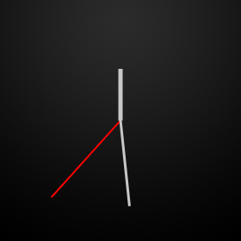 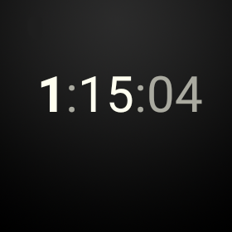

**Figure 1.** The analog and digital watch faces in the [WatchFace](https://developer.android.com/samples/WatchFace/index.html) sample.

### Initialize Your Watch Face

When the system loads your service, you should allocate and initialize most of the resources that your watch face needs, including loading bitmap resources, creating timer objects to run custom animations, configuring paint styles, and performing other computations. You can usually perform these operations only once and reuse their results. This practice improves the performance of your watch face and makes it easier to maintain your code.

To initialize your watch face, follow these steps:

1. Declare variables for a custom timer, graphic objects, and other elements.
2. Initialize the watch face elements in the [Engine.onCreate()](https://developer.android.com/reference/android/support/wearable/watchface/WatchFaceService.Engine.html#onCreate(android.view.SurfaceHolder)) method.
3. Initialize the custom timer in the [Engine.onVisibilityChanged()](https://developer.android.com/reference/android/support/wearable/watchface/WatchFaceService.Engine.html#onVisibilityChanged(boolean)) method.

The following sections describe these steps in detail.

#### Declare variables

The resources that you initialize when the system loads your service need to be accessible at different points throughout your implementation, so you can reuse them. You achieve this by declaring member variables for these resources in your [WatchFaceService.Engine](https://developer.android.com/reference/android/support/wearable/watchface/WatchFaceService.Engine.html) implementation.

Declare variables for the following elements:

Graphic objects

Most watch faces contain at least one bitmap image used as the background of the watch face, as described in [Create an Implementation Strategy](https://developer.android.com/training/wearables/watch-faces/designing.html#ImplementationStrategy). You can use additional bitmap images that represent clock hands or other design elements of your watch face.

Periodic timer

The system notifies the watch face once a minute when the time changes, but some watch faces run animations at custom time intervals. In these cases, you need to provide a custom timer that ticks with the frequency required to update your watch face.

Time zone change receiver

Users can adjust their time zone when they travel, and the system broadcasts this event. Your service implementation must register a broadcast receiver that is notified when the time zone changes and update the time accordingly.

The following snippet shows how to define these variables:

private class Engine extends CanvasWatchFaceService.Engine {  
    static final int MSG_UPDATE_TIME = 0;  
  
    Calendar mCalendar;  
  
    // device features  
    boolean mLowBitAmbient;  
  
    // graphic objects  
    Bitmap mBackgroundBitmap;  
    Bitmap mBackgroundScaledBitmap;  
    Paint mHourPaint;  
    Paint mMinutePaint;  
    ...  
  
    // handler to update the time once a second in interactive mode  
    final Handler mUpdateTimeHandler = new Handler() {  
        @Override  
        public void handleMessage(Message message) {  
            switch (message.what) {  
                case MSG_UPDATE_TIME:  
                    invalidate();  
                    if (shouldTimerBeRunning()) {  
                        long timeMs = System.currentTimeMillis();  
                        long delayMs = INTERACTIVE_UPDATE_RATE_MS  
                                - (timeMs % INTERACTIVE_UPDATE_RATE_MS);  
                        mUpdateTimeHandler  
                            .sendEmptyMessageDelayed(MSG_UPDATE_TIME, delayMs);  
                    }  
                    break;  
            }  
        }  
    };  
  
    // receiver to update the time zone  
    final BroadcastReceiver mTimeZoneReceiver = new BroadcastReceiver() {  
        @Override  
        public void onReceive(Context context, Intent intent) {  
            mCalendar.setTimeZone(TimeZone.getDefault());  
            invalidate();  
        }  
    };  
  
    // service methods (see other sections)  
    ...  
}

In the example above, the custom timer is implemented as a [Handler](https://developer.android.com/reference/android/os/Handler.html) instance that sends and processes delayed messages using the thread's message queue. For this particular watch face, the custom timer ticks once every second. When the timer ticks, the handler calls the [invalidate()](https://developer.android.com/reference/android/support/wearable/watchface/CanvasWatchFaceService.Engine.html#invalidate()) method and the system then calls the [onDraw()](https://developer.android.com/reference/android/support/wearable/watchface/CanvasWatchFaceService.Engine.html#onDraw(android.graphics.Canvas, android.graphics.Rect)) method to redraw the watch face.

#### Initialize watch face elements

After declaring member variables for bitmap resources, paint styles, and other elements that you reuse every time you redraw your watch face, initialize them when the system loads your service. Initializing these elements only once and reusing them improves performance and battery life.

In the [Engine.onCreate()](https://developer.android.com/reference/android/support/wearable/watchface/WatchFaceService.Engine.html#onCreate(android.view.SurfaceHolder)) method, initialize the following elements:

* Load the background image.
* Create styles and colors to draw graphic objects.
* Allocate an object to calculate the time.
* Configure the system UI.

The following snippet shows how to initialize these elements:

@Override  
public void onCreate(SurfaceHolder holder) {  
    super.onCreate(holder);  
  
    // configure the system UI (see next section)  
    ...  
  
    // load the background image  
    Resources resources = AnalogWatchFaceService.this.getResources();  
    Drawable backgroundDrawable = resources.getDrawable(R.drawable.bg, null);  
    mBackgroundBitmap = ((BitmapDrawable) backgroundDrawable).getBitmap();  
  
    // create graphic styles  
    mHourPaint = new Paint();  
    mHourPaint.setARGB(255, 200, 200, 200);  
    mHourPaint.setStrokeWidth(5.0f);  
    mHourPaint.setAntiAlias(true);  
    mHourPaint.setStrokeCap(Paint.Cap.ROUND);  
    ...  
  
    // allocate a Calendar to calculate local time using the UTC time and time zone  
    mCalendar = Calendar.getInstance();  
}

The background bitmap is loaded only once when the system initializes the watch face. The graphic styles are instances of the [Paint](https://developer.android.com/reference/android/graphics/Paint.html) class. Use these styles to draw the elements of your watch face inside the[Engine.onDraw()](https://developer.android.com/reference/android/support/wearable/watchface/CanvasWatchFaceService.Engine.html#onDraw(android.graphics.Canvas, android.graphics.Rect)) method, as described in [Drawing Your Watch Face](https://developer.android.com/training/wearables/watch-faces/drawing.html#Drawing).

#### Initialize the custom timer

As a watch face developer, you decide how often you want to update your watch face by providing a custom timer that ticks with the required frequency while the device is in interactive mode. This enables you to create custom animations and other visual effects.

**Note:** In ambient mode, the system does not reliably call the custom timer. To update the watch face in ambient mode, see [Update the watch face in ambient mode](https://developer.android.com/training/wearables/watch-faces/drawing.html#TimeTick).

An example timer definition from the AnalogWatchFaceService class that ticks once every second is shown in [Declare variables](https://developer.android.com/training/wearables/watch-faces/drawing.html#Variables). In the [Engine.onVisibilityChanged()](https://developer.android.com/reference/android/support/wearable/watchface/WatchFaceService.Engine.html#onVisibilityChanged(boolean)) method, start the custom timer if these two conditions apply:

* The watch face is visible.
* The device is in interactive mode.

The AnalogWatchFaceService class schedules the next timer tick if required as follows:

private void updateTimer() {  
    mUpdateTimeHandler.removeMessages(MSG_UPDATE_TIME);  
    if (shouldTimerBeRunning()) {  
        mUpdateTimeHandler.sendEmptyMessage(MSG_UPDATE_TIME);  
    }  
}  
  
private boolean shouldTimerBeRunning() {  
    return isVisible() && !isInAmbientMode();  
}

This custom timer ticks once every second, as described in [Declare variables](https://developer.android.com/training/wearables/watch-faces/drawing.html#Variables).

In the [onVisibilityChanged()](https://developer.android.com/reference/android/support/wearable/watchface/WatchFaceService.Engine.html#onVisibilityChanged(boolean)) method, start the timer if required and register the receiver for time zone changes as follows:

@Override  
public void onVisibilityChanged(boolean visible) {  
    super.onVisibilityChanged(visible);  
  
    if (visible) {  
        registerReceiver();  
  
        // Update time zone in case it changed while we weren't visible.  
        mCalendar.setTimeZone(TimeZone.getDefault());  
    } else {  
        unregisterReceiver();  
    }  
  
    // Whether the timer should be running depends on whether we're visible and  
    // whether we're in ambient mode, so we may need to start or stop the timer  
    updateTimer();  
}

When the watch face is visible, the [onVisibilityChanged()](https://developer.android.com/reference/android/support/wearable/watchface/WatchFaceService.Engine.html#onVisibilityChanged(boolean)) method registers the receiver for time zone changes. If the device is in interactive mode, this method also starts the custom timer. When the watch face is not visible, this method stops the custom timer and unregisters the receiver for time zone changes. The registerReceiver() and unregisterReceiver() methods are implemented as follows:

private void registerReceiver() {  
    if (mRegisteredTimeZoneReceiver) {  
        return;  
    }  
    mRegisteredTimeZoneReceiver = true;  
    IntentFilter filter = new IntentFilter(Intent.ACTION_TIMEZONE_CHANGED);  
    AnalogWatchFaceService.this.registerReceiver(mTimeZoneReceiver, filter);  
}  
  
private void unregisterReceiver() {  
    if (!mRegisteredTimeZoneReceiver) {  
        return;  
    }  
    mRegisteredTimeZoneReceiver = false;  
    AnalogWatchFaceService.this.unregisterReceiver(mTimeZoneReceiver);  
}

#### Update the watch face in ambient mode

In ambient mode, the system calls the [Engine.onTimeTick()](https://developer.android.com/reference/android/support/wearable/watchface/WatchFaceService.Engine.html#onTimeTick()) method every minute. It is usually sufficient to update your watch face once per minute in this mode. To update your watch face while in interactive mode, you must provide a custom timer as described in [Initialize the custom timer](https://developer.android.com/training/wearables/watch-faces/drawing.html#Timer).

In ambient mode, most watch face implementations simply invalidate the canvas to redraw the watch face in the [Engine.onTimeTick()](https://developer.android.com/reference/android/support/wearable/watchface/WatchFaceService.Engine.html#onTimeTick()) method:

@Override  
public void onTimeTick() {  
    super.onTimeTick();  
  
    invalidate();  
}

### Configure the System UI

Watch faces should not interfere with system UI elements, as described in [Accommodate System UI Elements](https://developer.android.com/design/wear/watchfaces.html#SystemUI). If your watch face has a light background or shows information near the bottom of the screen, you may have to configure the size of notification cards or enable background protection.

Android Wear enables you to configure the following aspects of the system UI when your watch face is active:

* Specify how far the first notification card peeks into the screen.
* Specify whether the system draws the time over your watch face.
* Show or hide cards when in ambient mode.
* Protect the system indicators with a solid background around them.
* Specify the positioning of the system indicators.

To configure these aspects of the system UI, create a [WatchFaceStyle](https://developer.android.com/reference/android/support/wearable/watchface/WatchFaceStyle.html) instance and pass it to the [Engine.setWatchFaceStyle()](https://developer.android.com/reference/android/support/wearable/watchface/WatchFaceService.Engine.html#setWatchFaceStyle(android.support.wearable.watchface.WatchFaceStyle)) method.

The AnalogWatchFaceService class configures the system UI as follows:

@Override  
public void onCreate(SurfaceHolder holder) {  
    super.onCreate(holder);  
  
    // configure the system UI  
    setWatchFaceStyle(new WatchFaceStyle.Builder(AnalogWatchFaceService.this)  
            .setCardPeekMode(WatchFaceStyle.PEEK_MODE_SHORT)  
            .setBackgroundVisibility(WatchFaceStyle.BACKGROUND_VISIBILITY_INTERRUPTIVE)  
            .setShowSystemUiTime(false)  
            .build());  
    ...  
}

The code snippet above configures peeking cards to be a single line tall, the background of a peeking card to show only briefly and only for interruptive notifications, and the system time not to be shown (since this watch face draws its own time representation).

You can configure the style of the system UI at any point in your watch face implementation. For example, if the user selects a white background, you can add background protection for the system indicators.

For more details about configuring the system UI, see the [Wear API reference documentation](https://developer.android.com/reference/packages-wearable-support.html).

### Obtain Information About the Device Screen

The system calls the [Engine.onPropertiesChanged()](https://developer.android.com/reference/android/support/wearable/watchface/WatchFaceService.Engine.html#onPropertiesChanged(android.os.Bundle)) method when it determines the properties of the device screen, such as whether the device uses low-bit ambient mode and whether the screen requires burn-in protection.

The following code snippet shows how to obtain these properties:

@Override  
public void onPropertiesChanged(Bundle properties) {  
    super.onPropertiesChanged(properties);  
    mLowBitAmbient = properties.getBoolean(PROPERTY_LOW_BIT_AMBIENT, false);  
    mBurnInProtection = properties.getBoolean(PROPERTY_BURN_IN_PROTECTION,  
            false);  
}

You should take these device properties into account when drawing your watch face:

For devices that use low-bit ambient mode, the screen supports fewer bits for each color in ambient mode, so you should disable anti-aliasing and bitmap filtering when the device switches to ambient mode.

For devices that require burn-in protection, avoid using large blocks of white pixels in ambient mode and do not place content within 10 pixels of the edge of the screen, since the system shifts the content periodically to avoid pixel burn-in.

For more information about low-bit ambient mode and burn-in protection, see [Optimize for Special Screens](https://developer.android.com/design/wear/watchfaces.html#SpecialScreens). For more information on how to disable bitmap filtering, see [Bitmap Filtering](https://developer.android.com/training/wearables/watch-faces/performance.html#BitmapFiltering).

### Respond to Changes Between Modes

When the device switches between ambient and interactive modes, the system calls the [Engine.onAmbientModeChanged()](https://developer.android.com/reference/android/support/wearable/watchface/WatchFaceService.Engine.html#onAmbientModeChanged(boolean)) method. Your service implementation should make any necessary adjustments to switch between modes and then call the [invalidate()](https://developer.android.com/reference/android/support/wearable/watchface/CanvasWatchFaceService.Engine.html#invalidate()) method for the system to redraw the watch face.

The following snippet shows how to implement this method:

@Override  
public void onAmbientModeChanged(boolean inAmbientMode) {  
  
    super.onAmbientModeChanged(inAmbientMode);  
  
    if (mLowBitAmbient) {  
        boolean antiAlias = !inAmbientMode;  
        mHourPaint.setAntiAlias(antiAlias);  
        mMinutePaint.setAntiAlias(antiAlias);  
        mSecondPaint.setAntiAlias(antiAlias);  
        mTickPaint.setAntiAlias(antiAlias);  
    }  
    invalidate();  
    updateTimer();  
}

This example makes adjustments to some graphic styles and invalidates the canvas so the system can redraw the watch face.

### Draw Your Watch Face

To draw a custom watch face, the system calls the [Engine.onDraw()](https://developer.android.com/reference/android/support/wearable/watchface/CanvasWatchFaceService.Engine.html#onDraw(android.graphics.Canvas, android.graphics.Rect)) method with a [Canvas](https://developer.android.com/reference/android/graphics/Canvas.html) instance and the bounds in which you should draw your watch face. The bounds take into account any inset areas, such as the "chin" on the bottom of some round devices. You can use this canvas to draw your watch face directly as follows:

* Override the [onSurfaceChanged()](https://developer.android.com/reference/android/support/wearable/watchface/CanvasWatchFaceService.Engine.html#onSurfaceChanged(android.view.SurfaceHolder, int, int, int)) method to scale your background to fit the device any time the view changes.

@Override  
public void onSurfaceChanged(  
        SurfaceHolder holder, int format, int width, int height) {  
    if (mBackgroundScaledBitmap == null  
            || mBackgroundScaledBitmap.getWidth() != width  
            || mBackgroundScaledBitmap.getHeight() != height) {  
        mBackgroundScaledBitmap = Bitmap.createScaledBitmap(mBackgroundBitmap,  
                width, height, true /* filter */);  
    }  
    super.onSurfaceChanged(holder, format, width, height);  
}

* Check whether the device is in ambient mode or interactive mode.
* Perform any required graphic computations.
* Draw your background bitmap on the canvas.
* Use the methods in the [Canvas](https://developer.android.com/reference/android/graphics/Canvas.html) class to draw your watch face.

The following snippet shows how to implement the [onDraw()](https://developer.android.com/reference/android/support/wearable/watchface/CanvasWatchFaceService.Engine.html#onDraw(android.graphics.Canvas, android.graphics.Rect)) method:

@Override  
public void onDraw(Canvas canvas, Rect bounds) {  
    // Update the time  
    mCalendar.setTimeInMillis(System.currentTimeMillis());  
  
    // Constant to help calculate clock hand rotations  
    final float TWO_PI = (float) Math.PI * 2f;  
  
    int width = bounds.width();  
    int height = bounds.height();  
  
    canvas.drawBitmap(mBackgroundScaledBitmap, 0, 0, null);  
  
    // Find the center. Ignore the window insets so that, on round watches  
    // with a "chin", the watch face is centered on the entire screen, not  
    // just the usable portion.  
    float centerX = width / 2f;  
    float centerY = height / 2f;  
  
    // Compute rotations and lengths for the clock hands.  
    float seconds = mCalendar.get(Calendar.SECOND) +  
                    mCalendar.get(Calendar.MILLISECOND) / 1000f;  
    float secRot = seconds / 60f * TWO_PI;  
    float minutes = mCalendar.get(Calendar.MINUTE) + seconds / 60f;  
    float minRot = minutes / 60f * TWO_PI;  
    float hours = mCalendar.get(Calendar.HOUR) + minutes / 60f;  
    float hrRot = hours / 12f * TWO_PI;  
  
    float secLength = centerX - 20;  
    float minLength = centerX - 40;  
    float hrLength = centerX - 80;  
  
    // Only draw the second hand in interactive mode.  
    if (!isInAmbientMode()) {  
        float secX = (float) Math.sin(secRot) * secLength;  
        float secY = (float) -Math.cos(secRot) * secLength;  
        canvas.drawLine(centerX, centerY, centerX + secX, centerY +  
                        secY, mSecondPaint);  
    }  
  
    // Draw the minute and hour hands.  
    float minX = (float) Math.sin(minRot) * minLength;  
    float minY = (float) -Math.cos(minRot) * minLength;  
    canvas.drawLine(centerX, centerY, centerX + minX, centerY + minY,  
                    mMinutePaint);  
    float hrX = (float) Math.sin(hrRot) * hrLength;  
    float hrY = (float) -Math.cos(hrRot) * hrLength;  
    canvas.drawLine(centerX, centerY, centerX + hrX, centerY + hrY,  
                    mHourPaint);  
}

This method computes the required positions for the clock hands based on the current time and draws them on top of the background bitmap using the graphic styles initialized in the [onCreate()](https://developer.android.com/reference/android/support/wearable/watchface/WatchFaceService.Engine.html#onCreate(android.view.SurfaceHolder)) method. The second hand is only drawn in interactive mode, not in ambient mode.

For more information about drawing on a Canvas instance, see [Canvas and Drawables](https://developer.android.com/guide/topics/graphics/2d-graphics.html).

The [WatchFace](https://developer.android.com/samples/WatchFace/index.html) sample includes additional watch faces that you can refer to as examples of how to implement the [onDraw()](https://developer.android.com/reference/android/support/wearable/watchface/CanvasWatchFaceService.Engine.html#onDraw(android.graphics.Canvas, android.graphics.Rect)) method.

## Showing Information in Watch Faces

In addition to telling time, Android Wear devices provide users with contextually relevant information in the form of cards, notifications, and other wearable apps. Creating a custom watch face not only gives you the opportunity to tell time in visually compelling ways, but also to show users relevant information whenever they glance at their device.

Like any other wearable app, your watch face can communicate with apps running on the handheld device using the [Wearable Data Layer API](https://developer.android.com/training/wearables/data-layer/index.html). In some cases, you need to create an activity in the handheld app module of your project that retrieves data from the Internet or from the user's profile and then shares it with your watch face.

 

**Figure 1.** Examples of watch faces with integrated data.

### Create a Compelling Experience

Before you design and implement a contextually-aware watch face, answer the following questions:

* What kind of data do you want to incorporate?
* Where can you obtain this data?
* How often does the data change significantly?
* How can you present the data such that users understand it at a glance?

Android Wear devices are usually paired with a companion device that has a GPS sensor and cellular connectivity, so you have endless possibilities to integrate different kinds of data in your watch face, such as location, calendar events, social media trends, picture feeds, stock market quotes, news events, sports scores, and so on. However, not all kinds of data are appropriate for a watch face, so you should consider what kinds of data are most relevant to your users throughout the day. Your watch face should also gracefully handle the case where the wearable is not paired with a companion device or when an Internet connection is not available.

The active watch face on an Android Wear device is an app that runs continuously, so you must retrieve data in a battery-efficient manner. For example, you can obtain the current weather every ten minutes and store the results locally, instead of requesting an update every minute. You can also refresh contextual data when the device switches from ambient to interactive mode, since the user is more likely to glance at the watch when this transition occurs.

You should summarize contextual information on your watch face, since there is limited space available on the screen and users just glance at their watch for a second or two at a time. Sometimes the best way to convey contextual information is to react to it using graphics and colors. For example, a watch face could change its background image depending on the current weather.

### Add Data to Your Watch Face

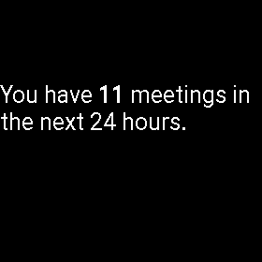

**Figure 2.** The calendar watch face.

The [WatchFace](https://developer.android.com/samples/WatchFace/index.html) sample demonstrates how to obtain calendar data from the user’s profile in the CalendarWatchFaceService class and shows how many meetings there are in the following twenty-four hours.

To implement a watch face that incorporates contextual data, follow these steps:

1. Provide a task that retrieves the data.
2. Create a custom timer to invoke your task periodically, or notify your watch face service when external data changes.
3. Redraw your watch face with the updated data.

The following sections describe these steps in detail.

#### Provide a task to retrieve data

Create a class inside your [CanvasWatchFaceService.Engine](https://developer.android.com/reference/android/support/wearable/watchface/CanvasWatchFaceService.Engine.html) implementation that extends [AsyncTask](https://developer.android.com/reference/android/os/AsyncTask.html) and add the code to retrieve the data you’re interested in.

The CalendarWatchFaceService class obtains the number of meetings in the next day as follows:

/* Asynchronous task to load the meetings from the content provider and  
 * report the number of meetings back using onMeetingsLoaded() */  
private class LoadMeetingsTask extends AsyncTask<Void, Void, Integer> {  
    @Override  
    protected Integer doInBackground(Void... voids) {  
        long begin = System.currentTimeMillis();  
        Uri.Builder builder =  
                WearableCalendarContract.Instances.CONTENT_URI.buildUpon();  
        ContentUris.appendId(builder, begin);  
        ContentUris.appendId(builder, begin + DateUtils.DAY_IN_MILLIS);  
        final Cursor cursor = getContentResolver() .query(builder.build(),  
                null, null, null, null);  
        int numMeetings = cursor.getCount();  
        if (Log.isLoggable(TAG, Log.VERBOSE)) {  
            Log.v(TAG, "Num meetings: " + numMeetings);  
        }  
        return numMeetings;  
    }  
  
    @Override  
    protected void onPostExecute(Integer result) {  
        /* get the number of meetings and set the next timer tick */  
        onMeetingsLoaded(result);  
    }  
}

The [WearableCalendarContract](https://developer.android.com/reference/android/support/wearable/provider/WearableCalendarContract.html) class from the Wearable Support Library provides direct access to the user's calendar events from the companion device.

When the task finishes retrieving data, your code invokes a callback method. The following sections describe how to implement the callback method in detail.

For more information about obtaining data from the calendar, see the [Calendar Provider](https://developer.android.com/guide/topics/providers/calendar-provider.html) API guide.

#### Create a custom timer

You can implement a custom timer that ticks periodically to update your data. The CalendarWatchFaceService class uses a [Handler](https://developer.android.com/reference/android/os/Handler.html) instance that sends and processes delayed messages using the thread's message queue:

private class Engine extends CanvasWatchFaceService.Engine {  
    ...  
    int mNumMeetings;  
    private AsyncTask<Void, Void, Integer> mLoadMeetingsTask;  
  
    /* Handler to load the meetings once a minute in interactive mode. */  
    final Handler mLoadMeetingsHandler = new Handler() {  
        @Override  
        public void handleMessage(Message message) {  
            switch (message.what) {  
                case MSG_LOAD_MEETINGS:  
                    cancelLoadMeetingTask();  
                    mLoadMeetingsTask = new LoadMeetingsTask();  
                    mLoadMeetingsTask.execute();  
                    break;  
            }  
        }  
    };  
    ...  
}

This method initializes the timer when the watch face becomes visible:

@Override  
public void onVisibilityChanged(boolean visible) {  
    super.onVisibilityChanged(visible);  
    if (visible) {  
        mLoadMeetingsHandler.sendEmptyMessage(MSG_LOAD_MEETINGS);  
    } else {  
        mLoadMeetingsHandler.removeMessages(MSG_LOAD_MEETINGS);  
        cancelLoadMeetingTask();  
    }  
}

The next timer tick is set in the onMeetingsLoaded() method, as shown in the next section.

#### Redraw your watch face with the updated data

When the task that retrieves your data finishes, call the [invalidate()](https://developer.android.com/reference/android/support/wearable/watchface/CanvasWatchFaceService.Engine.html#invalidate()) method so the system redraws your watch face. Store your data inside member variables of the Engine class so you can access it inside the [onDraw()](https://developer.android.com/reference/android/support/wearable/watchface/CanvasWatchFaceService.Engine.html#onDraw(android.graphics.Canvas, android.graphics.Rect)) method.

The CalendarWatchFaceService class provides a callback method for the task to invoke when it finishes retrieving calendar data:

private void onMeetingsLoaded(Integer result) {  
    if (result != null) {  
        mNumMeetings = result;  
        invalidate();  
    }  
    if (isVisible()) {  
        mLoadMeetingsHandler.sendEmptyMessageDelayed(  
                MSG_LOAD_MEETINGS, LOAD_MEETINGS_DELAY_MS);  
    }  
}

The callback method stores the result in a member variable, invalidates the view, and schedules the next timer tick to run the task again.

## Providing Configuration Activities

When users install a handheld app that contains a [wearable app](https://developer.android.com/training/wearables/apps/index.html) with watch faces, these watch faces become available in the Android Wear companion app on the companion device and in the watch face picker on the wearable. Users can choose the active watch face for their wearable device by selecting it on the companion app or using the watch face picker on the wearable device.

Some watch faces support configuration parameters to let users customize how the watch face looks and behaves. For example, some watch faces let users pick a custom background color, and watch faces that tell time for two different time zones can let users select which time zones they are interested in.

Watch faces that support configuration parameters can let users customize a watch face using an activity in the wearable app, an activity on the handheld app, or both. Users can start the wearable configuration activity on the wearable device, and they can start the companion configuration activity from the Android Wear companion app.

The digital watch face from the [WatchFace](https://developer.android.com/samples/WatchFace/index.html) sample demonstrates how to implement handheld and wearable configuration activities and how to update a watch face in response to configuration changes.

#### Specify an Intent for Configuration Activities

If your watch face includes configuration activities, add the following metadata entries to the service declaration in the manifest file of the wearable app:

<service  
    android:name=".DigitalWatchFaceService" ... />  
    <!-- companion configuration activity -->  
    <meta-data  
        android:name=  
           "com.google.android.wearable.watchface.companionConfigurationAction"  
        android:value=  
           "com.example.android.wearable.watchface.CONFIG_DIGITAL" />  
    <!-- wearable configuration activity -->  
    <meta-data  
        android:name=  
           "com.google.android.wearable.watchface.wearableConfigurationAction"  
        android:value=  
           "com.example.android.wearable.watchface.CONFIG_DIGITAL" />  
    ...  
</service>

Provide values for these entries that are preceded by the package name of your app. Configuration activities register intent filters for this intent, and the system fires this intent when users want to configure your watch face.

If your watch face only includes a companion or a wearable configuration activity, you only need to include the corresponding metadata entry from the example above.

#### Create a Wearable Configuration Activity

Wearable configuration activities provide a limited set of customization choices for a watch face, because complex menus are hard to navigate on smaller screens. Your wearable configuration activity should provide binary choices and just a few selections to customize the main aspects of your watch face.

To create a wearable configuration activity, add a new activity to your wearable app module and declare the following intent filter in the manifest file of the wearable app:

<activity  
    android:name=".DigitalWatchFaceWearableConfigActivity"  
    android:label="@string/digital_config_name">  
    <intent-filter>  
        <action android:name=  
            "com.example.android.wearable.watchface.CONFIG_DIGITAL" />  
        <category android:name=  
        **"com.google.android.wearable.watchface.category.WEARABLE_CONFIGURATION"** />  
        <category android:name="android.intent.category.DEFAULT" />  
    </intent-filter>  
</activity>

The name of the action in this intent filter must match the intent name you defined in [Specify an Intent for Configuration Activities](https://developer.android.com/training/wearables/watch-faces/configuration.html#Intent).

In your configuration activity, build a simple UI that provides selections for users to customize your watch face. When users make a selection, use the [Wearable Data Layer API](https://developer.android.com/training/wearables/data-layer/index.html) to communicate the configuration change to the watch face activity.

For more details, see the DigitalWatchFaceWearableConfigActivity and DigitalWatchFaceUtil classes in the [WatchFace](https://developer.android.com/samples/WatchFace/index.html) sample.

#### Create a Companion Configuration Activity

Companion configuration activities give users access to the full set of configuration choices for a watch face, because it is easier to interact with complex menus on the larger screen of a handheld device. For example, a configuration activity on a handheld device enables you to present users with elaborate color pickers to select the background color of a watch face.

To create a companion configuration activity, add a new activity to your handheld app module and declare the following intent filter in the manifest file of the handheld app:

<activity  
    android:name=".DigitalWatchFaceCompanionConfigActivity"  
    android:label="@string/app_name">  
    <intent-filter>  
        <action android:name=  
            "com.example.android.wearable.watchface.CONFIG_DIGITAL" />  
        <category android:name=  
        **"com.google.android.wearable.watchface.category.COMPANION_CONFIGURATION"** />  
        <category android:name="android.intent.category.DEFAULT" />  
    </intent-filter>  
</activity>

In your configuration activity, build a UI that provides options to customize all the configurable elements of your watch face. When users make a selection, use the [Wearable Data Layer API](https://developer.android.com/training/wearables/data-layer/index.html) to communicate the configuration change to the watch face activity.

For more details, see the DigitalWatchFaceCompanionConfigActivity class in the [WatchFace](https://developer.android.com/samples/WatchFace/index.html) sample.

#### Create a Listener Service in the Wearable App

To receive updated configuration parameters from the configuration activities, create a service that implements the [WearableListenerService](https://developers.google.com/android/reference/com/google/android/gms/wearable/WearableListenerService) interface from the [Wearable Data Layer API](https://developer.android.com/training/wearables/data-layer/index.html) in your wearable app. Your watch face implementation can redraw the watch face when the configuration parameters change.

For more details, see the DigitalWatchFaceConfigListenerService and DigitalWatchFaceService classes in the [WatchFace](https://developer.android.com/samples/WatchFace/index.html) sample.

## Addressing Common Issues

Creating a custom watch face for Android Wear is substantially different from creating notifications and wearable-specific activities. This class shows you how to resolve some issues that you may encounter as you implement your first few watch faces.

### Detect the Shape of the Screen

Some Android Wear devices have square screens, while others have round screens. Devices with round screens can contain an inset (or "chin") at the bottom of the screen. Your watch face should adapt to and take advantage of the particular shape of the screen, as described in the [design guidelines](https://developer.android.com/design/wear/watchfaces.html).

Android Wear lets your watch face determine the screen shape at runtime. To detect whether the screen is square or round, override the [onApplyWindowInsets()](https://developer.android.com/reference/android/service/wallpaper/WallpaperService.Engine.html#onApplyWindowInsets(android.view.WindowInsets)) method in the [CanvasWatchFaceService.Engine](https://developer.android.com/reference/android/support/wearable/watchface/CanvasWatchFaceService.Engine.html) class as follows:

private class Engine extends CanvasWatchFaceService.Engine {  
    boolean mIsRound;  
    int mChinSize;  
  
    @Override  
    public void onApplyWindowInsets(WindowInsets insets) {  
        super.onApplyWindowInsets(insets);  
        mIsRound = insets.isRound();  
        mChinSize = insets.getSystemWindowInsetBottom();  
    }  
    ...  
}

To adapt your design when you draw your watch face, check the value of the mIsRound and mChinSize member variables.

### Accomodate Peek Cards

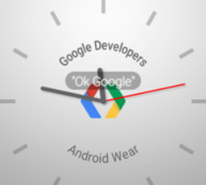 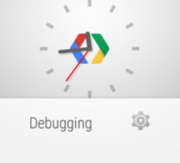

**Figure 1.** Some analog watch faces require adjustments when notification cards appear.

When users receive a notification, the notification card may cover a significant portion of the screen, depending on the [system UI style](https://developer.android.com/training/wearables/watch-faces/drawing.html#SystemUI). Your watch face should adapt to these situations by ensuring that users can still tell the time while the notification card is present.

Analog watch faces can make adjustments when a notification card is present, like scaling down the watch face to fit inside the portion of the screen not covered by the peek card. Digital watch faces that display the time in the area of the screen not covered by peek cards do not usually require adjustments. To determine the free space above the peek card so you can adapt your watch face, use the [WatchFaceService.Engine.getPeekCardPosition()](https://developer.android.com/reference/android/support/wearable/watchface/WatchFaceService.Engine.html#getPeekCardPosition()) method.

In ambient mode, peek cards have a transparent background. If your watch face contains details near the card in ambient mode, consider drawing a black rectangle over them to ensure that users can read the contents of the card.

### Configure the System Indicators



**Figure 2.** The status bar.

To ensure that the system indicators remain visible, you can configure their position on the screen and whether they need background protection when you create a [WatchFaceStyle](https://developer.android.com/reference/android/support/wearable/watchface/WatchFaceStyle.html) instance:

* To set the position of the status bar, use the [setStatusBarGravity()](https://developer.android.com/reference/android/support/wearable/watchface/WatchFaceStyle.Builder.html#setStatusBarGravity(int))method.
* To set the position of the hotword, use the [setHotwordIndicatorGravity()](https://developer.android.com/reference/android/support/wearable/watchface/WatchFaceStyle.Builder.html#setHotwordIndicatorGravity(int)) method.
* To protect the status bar and hotword with a semi-transparent gray background, use the [setViewProtection()](https://developer.android.com/reference/android/support/wearable/watchface/WatchFaceStyle.Builder.html#setViewProtection(int)) method. This is usually necessary if your watch face has a light background, since the system indicators are white.

For more information about the system indicators, see [Configure the System UI](https://developer.android.com/training/wearables/watch-faces/drawing.html#SystemUI) and read the [design guidelines](https://developer.android.com/design/wear/watchfaces.html).

### Use Relative Measurements

Android Wear devices from different manufacturers feature screens with a variety of sizes and resolutions. Your watch face should adapt to these variations by using relative measurements instead of absolute pixel values.

When you draw your watch face, obtain the size of the canvas with the [Canvas.getWidth()](https://developer.android.com/reference/android/graphics/Canvas.html#getWidth()) and [Canvas.getHeight()](https://developer.android.com/reference/android/graphics/Canvas.html#getHeight()) methods and set the positions of your graphic elements using values that are some fraction of the detected screen size. If you resize the elements of your watch face in response to a peek card, use values that are some fraction of the remaining space above the card to redraw your watch face.

## Optimizing Performance and Battery Life

In addition to accommodating notification cards and system indicators, you need to ensure that the animations in your watch face run smoothly and that your service does not perform unnecessary computations. Watch faces in Android Wear run continuously on the device, so it is critical that your watch face uses power efficiently.

This lesson provides some tips to speed up your animations and to measure and conserve power on the device.

### Reduce the Size of Your Bitmap Assets

Many watch faces consist of a background image and other graphic assets that are transformed and overlapped on top of the background image, such as clock hands and other elements of the design that move over time. Typically these graphic elements are rotated (and sometimes scaled) inside the [Engine.onDraw()](https://developer.android.com/reference/android/support/wearable/watchface/CanvasWatchFaceService.Engine.html#onDraw(android.graphics.Canvas, android.graphics.Rect)) method every time the system redraws the watch face, as described in [Draw Your Watch Face](https://developer.android.com/training/wearables/watch-faces/drawing.html#Drawing).

The larger these graphic assets are, the more computationally expensive it is to transform them. Transforming large graphic assets in the [Engine.onDraw()](https://developer.android.com/reference/android/support/wearable/watchface/CanvasWatchFaceService.Engine.html#onDraw(android.graphics.Canvas, android.graphics.Rect)) method drastically reduces the frame rate at which the system can run your animations.

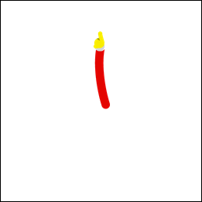 

**Figure 1.** Clock hands can be cropped to remove extra pixels.

To improve the performance of your watch face:

* Do not use graphic elements that are larger than you need.
* Remove extra transparent pixels around the edges.

The example clock hand on the left side of [Figure 1](https://developer.android.com/training/wearables/watch-faces/performance.html#fig1) can be reduced in size by 97%.

Reducing the size of your bitmap assets as described in this section not only improves the performance of your animations, but it also saves power.

### Combine Bitmap Assets

If you have bitmaps that are often drawn together, consider combining them into the same graphic asset. You can often combine the background image in interactive mode with the tick marks to avoid drawing two full-screen bitmaps every time the system redraws the watch face.

### Disable Anti-Aliasing when Drawing Scaled Bitmaps

When you draw a scaled bitmap on the [Canvas](https://developer.android.com/reference/android/graphics/Canvas.html) object using the [Canvas.drawBitmap()](https://developer.android.com/reference/android/graphics/Canvas.html#drawBitmap(android.graphics.Bitmap, float, float, android.graphics.Paint)) method, you can provide a [Paint](https://developer.android.com/reference/android/graphics/Paint.html) instance to configure several options. To improve performance, disable anti-aliasing using the [setAntiAlias()](https://developer.android.com/reference/android/graphics/Paint.html#setAntiAlias(boolean)) method, since this option does not have any effect on bitmaps.

 

**Figure 2.** Example of bitmap filtering disabled (left) and enabled (right).

### Use bitmap filtering

For bitmap assets that you draw on top of other elements, enable bitmap filtering on the same [Paint](https://developer.android.com/reference/android/graphics/Paint.html) instance using the [setFilterBitmap()](https://developer.android.com/reference/android/graphics/Paint.html#setFilterBitmap(boolean)) method. [Figure 2](https://developer.android.com/training/wearables/watch-faces/performance.html#fig2) shows a magnified view of a clock hand with and without bitmap filtering.

**Note:** In low-bit ambient mode, the system does not reliably render the colors in the image for bitmap filtering to process successfully. When ambient mode is active, disable bitmap filtering.

### Move Expensive Operations Outside the Drawing Method

The system calls the [Engine.onDraw()](https://developer.android.com/reference/android/support/wearable/watchface/CanvasWatchFaceService.Engine.html#onDraw(android.graphics.Canvas, android.graphics.Rect)) method every time it redraws your watch face, so you should only include operations that are strictly required to update the watch face inside this method to improve performance.

When possible, avoid performing these operations inside the [Engine.onDraw()](https://developer.android.com/reference/android/support/wearable/watchface/CanvasWatchFaceService.Engine.html#onDraw(android.graphics.Canvas, android.graphics.Rect)) method:

* Loading images and other resources.
* Resizing images.
* Allocating objects.
* Performing computations whose result does not change between frames.

You can usually perform these operations in the [Engine.onCreate()](https://developer.android.com/reference/android/support/wearable/watchface/WatchFaceService.Engine.html#onCreate(android.view.SurfaceHolder)) method instead. You can resize images ahead of time in the [Engine.onSurfaceChanged()](https://developer.android.com/reference/android/service/wallpaper/WallpaperService.Engine.html#onSurfaceChanged(android.view.SurfaceHolder, int, int, int)) method, which provides you with the size of the canvas.

To analyze the performance of your watch face, use the Android Device Monitor. In particular, ensure that the execution time for your [Engine.onDraw()](https://developer.android.com/reference/android/support/wearable/watchface/CanvasWatchFaceService.Engine.html#onDraw(android.graphics.Canvas, android.graphics.Rect)) implementation is short and consistent across invocations. For more information, see [Using DDMS](https://developer.android.com/tools/debugging/ddms.html).

### Follow Best Practices to Save Power

In addition to the techniques described in the previous sections, follow the best practices in this section to reduce the power consumption of your watch face.

#### Reduce the frame rate of animations

Animations are often computationally expensive and consume a significant amount of power. Most animations look fluid at 30 frames per second, so you should avoid running your animations at a higher frame rate.

#### Let the CPU sleep

Animations and small changes to the contents of the watch face wake up the CPU. Your watch face should let the CPU sleep in between animations. For example, you can use short bursts of animation every second in interactive mode and then let the CPU sleep until the next second. Letting the CPU sleep often, even briefly, can significantly reduce power consumption.

To maximize battery life, use animations sparingly. Even a blinking colon wakes up the CPU with every blink and hurts battery life.

#### Monitor power consumption

The [Android Wear companion app](https://play.google.com/store/apps/details?id=com.google.android.wearable.app&hl=en) lets developers and users see how much battery different processes on the wearable device are consuming under **Settings** > **Watch battery**.

For more information about new features in Android 5.0 that help you improve battery life, see [Project Volta](https://developer.android.com/about/versions/android-5.0.html#Power).

# Detecting Location on Android Wear

Location awareness on wearable devices enables you to create apps that give users a better understanding of their geographic position, movement and what's around them. With the small form factor and glanceable nature of a wearable device, you can build low-friction apps that record and respond to location data.

Some wearable devices include a GPS sensor that can retrieve location data without another tethered device. However, when you request location data in a wearable app, you don't have to worry about where the location data originates; the system retrieves the location updates using the most power-efficient method. Your app should be able to handle loss of location data, in case the wear device loses connection with its paired device and does not have a built-in GPS sensor.

This document shows you how to check for on-device location sensors, receive location data, and monitor tethered data connections.

**Note:** The article assumes that you know how to use the Google Play services API to retrieve location data. For more information, see [Making Your App Location-Aware](https://developer.android.com/training/location/index.html).

### Connect to Google Play Services

Location data on wearable devices is obtained though the Google Play services location APIs. You use the [FusedLocationProviderApi](https://developer.android.com/reference/com/google/android/gms/location/FusedLocationProviderApi.html) and its accompanying classes to obtain this data. To access location services, create an instance of [GoogleApiClient](https://developer.android.com/reference/com/google/android/gms/common/api/GoogleApiClient.html), which is the main entry point for any of the Google Play services APIs.

**Caution:** Do not use the existing [Location](https://developer.android.com/reference/android/location/package-summary.html) APIs in the Android framework. The best practice for retrieving location updates is through the Google Play services API as outlined in this article.

To connect to Google Play services, configure your app to create an instance of [GoogleApiClient](https://developer.android.com/reference/com/google/android/gms/common/api/GoogleApiClient.html):

1. Create an activity that specifies an implementation for the interfaces [ConnectionCallbacks](https://developer.android.com/reference/com/google/android/gms/common/api/GoogleApiClient.ConnectionCallbacks.html),[OnConnectionFailedListener](https://developer.android.com/reference/com/google/android/gms/common/api/GoogleApiClient.OnConnectionFailedListener.html), and [LocationListener](https://developer.android.com/reference/com/google/android/gms/location/LocationListener.html).
2. In your activity's [onCreate()](https://developer.android.com/reference/android/app/Activity.html#onCreate(android.os.Bundle)) method, create an instance of [GoogleApiClient](https://developer.android.com/reference/com/google/android/gms/common/api/GoogleApiClient.html) and add the Location service.
3. To gracefully manage the lifecycle of the connection, call [connect()](https://developer.android.com/reference/com/google/android/gms/common/api/GoogleApiClient.html#connect()) in the [onResume()](https://developer.android.com/reference/android/app/Activity.html#onResume()) method and [disconnect()](https://developer.android.com/reference/com/google/android/gms/common/api/GoogleApiClient.html#disconnect()) in the [onPause()](https://developer.android.com/reference/android/app/Activity.html#onPause()) method.

The following code example shows an implementation of an activity that implements the [LocationListener](https://developer.android.com/reference/com/google/android/gms/location/LocationListener.html) interface:

public class WearableMainActivity extends Activity implements  
    GoogleApiClient.ConnectionCallbacks,  
    GoogleApiClient.OnConnectionFailedListener,  
    LocationListener {  
  
    private GoogleApiClient mGoogleApiClient;  
    ...  
  
    @Override  
    protected void onCreate(Bundle savedInstanceState) {  
        super.onCreate(savedInstanceState);  
  
        ...  
        mGoogleApiClient = new GoogleApiClient.Builder(this)  
                .addApi(LocationServices.API)  
                .addApi(Wearable.API)  // used for data layer API  
                .addConnectionCallbacks(this)  
                .addOnConnectionFailedListener(this)  
                .build();  
    }  
  
    @Override  
    protected void onResume() {  
        super.onResume();  
        mGoogleApiClient.connect();  
        ...  
    }  
  
    @Override  
    protected void onPause() {  
        super.onPause();  
        ...  
        mGoogleApiClient.disconnect();  
    }  
}

For more information on connecting to Google Play services, see [Accessing Google APIs](https://developer.android.com/google/auth/api-client.html).

### Request Location Updates

After your app has connected to the Google Play services API, it is ready to start receiving location updates. When the system invokes the [onConnected()](https://developer.android.com/reference/com/google/android/gms/common/api/GoogleApiClient.ConnectionCallbacks.html#onConnected(android.os.Bundle)) callback for your client, you build the location data request as follows:

1. Create a [LocationRequest](https://developer.android.com/reference/com/google/android/gms/location/LocationRequest.html) object and set any options using methods like [setPriority()](https://developer.android.com/reference/com/google/android/gms/location/LocationRequest.html#setPriority(int)).
2. Request location updates using [requestLocationUpdates()](https://developer.android.com/reference/com/google/android/gms/location/FusedLocationProviderApi.html#requestLocationUpdates(com.google.android.gms.common.api.GoogleApiClient, com.google.android.gms.location.LocationRequest, com.google.android.gms.location.LocationListener)).
3. Remove location updates using [removeLocationUpdates()](https://developer.android.com/reference/com/google/android/gms/location/FusedLocationProviderApi.html#removeLocationUpdates(com.google.android.gms.common.api.GoogleApiClient, com.google.android.gms.location.LocationListener)) in the [onPause()](https://developer.android.com/reference/android/app/Activity.html#onPause()) method.

The following example shows how to retrieve and remove location updates:

@Override  
public void onConnected(Bundle bundle) {  
    LocationRequest locationRequest = LocationRequest.create()  
            .setPriority(LocationRequest.PRIORITY_HIGH_ACCURACY)  
            .setInterval(UPDATE_INTERVAL_MS)  
            .setFastestInterval(FASTEST_INTERVAL_MS);  
  
    LocationServices.FusedLocationApi  
            .requestLocationUpdates(mGoogleApiClient, locationRequest, this)  
            .setResultCallback(new ResultCallback() {  
  
                @Override  
                public void onResult(Status status) {  
                    if (status.getStatus().isSuccess()) {  
                        if (Log.isLoggable(TAG, Log.DEBUG)) {  
                            Log.d(TAG, "Successfully requested location updates");  
                        }  
                    } else {  
                        Log.e(TAG,  
                                "Failed in requesting location updates, "  
                                        + "status code: "  
                                        + status.getStatusCode()  
                                        + ", message: "  
                                        + status.getStatusMessage());  
                    }  
                }  
            });  
}  
  
@Override  
protected void onPause() {  
    super.onPause();  
    if (mGoogleApiClient.isConnected()) {  
        LocationServices.FusedLocationApi  
             .removeLocationUpdates(mGoogleApiClient, this);  
    }  
    mGoogleApiClient.disconnect();  
}  
  
@Override  
public void onConnectionSuspended(int i) {  
    if (Log.isLoggable(TAG, Log.DEBUG)) {  
        Log.d(TAG, "connection to location client suspended");  
    }  
}

Now that you have enabled location updates, the system calls the [onLocationChanged()](https://developer.android.com/reference/android/location/LocationListener.html#onLocationChanged(android.location.Location)) method with the updated location at the interval specified in [setInterval()](https://developer.android.com/reference/com/google/android/gms/location/LocationRequest.html#setInterval(long))

### Detect On-Board GPS

Not all wearables have a GPS sensor. If your user goes out for a run and leaves their phone at home, your wearable app cannot receive location data through a tethered connection. If the wearable device does not have a sensor, you should detect this situation and warn the user that location functionality is not available.

To determine whether your Android Wear device has a built-in GPS sensor, use the [hasSystemFeature()](https://developer.android.com/reference/android/content/pm/PackageManager.html#hasSystemFeature(java.lang.String))method. The following code detects whether the device has built-in GPS when you start an activity:

protected void onCreate(Bundle savedInstanceState) {  
    super.onCreate(savedInstanceState);  
  
    setContentView(R.layout.main_activity);  
    if (!hasGps()) {  
        Log.d(TAG, "This hardware doesn't have GPS.");  
        // Fall back to functionality that does not use location or  
        // warn the user that location function is not available.  
    }  
  
    ...  
}  
  
private boolean hasGps() {  
    return getPackageManager().hasSystemFeature(PackageManager.FEATURE_LOCATION_GPS);  
}

### Handle Disconnection Events

Wearable devices relying on a tethered connection for location data may lose their connections abruptly. If your wearable app expects a constant stream of data, you must handle the disconnection based upon where that data is interrupted or unavailable. On a wearable device with no onboard GPS sensor, loss of location data occurs when the device loses its tethered data connection.

In cases where your app depends on a tethered data connection for location data and the wear device does not have a GPS sensor, you should detect the loss of that connection, warn the user, and gracefully degrade the functionality of your app.

To detect the loss of a tethered data connection:

1. Extend a [WearableListenerService](https://developer.android.com/reference/com/google/android/gms/wearable/WearableListenerService.html) that lets you listen for important data layer events.
2. Declare an intent filter in your Android manifest to notify the system about your [WearableListenerService](https://developer.android.com/reference/com/google/android/gms/wearable/WearableListenerService.html). This filter allows the system to bind your service as needed.

<service android:name=".NodeListenerService">  
    <intent-filter>  
        <action android:name="com.google.android.gms.wearable.BIND_LISTENER" />  
    </intent-filter>  
</service>

1. Implement the [onPeerDisconnected()](https://developer.android.com/reference/com/google/android/gms/wearable/WearableListenerService.html#onPeerDisconnected(com.google.android.gms.wearable.Node)) method and handle cases of whether or not the device has built-in GPS.

public class NodeListenerService extends WearableListenerService {  
  
    private static final String TAG = "NodeListenerService";  
  
    @Override  
    public void onPeerDisconnected(Node peer) {  
        Log.d(TAG, "You have been disconnected.");  
        if(!hasGPS()) {  
            // Notify user to bring tethered handset  
            // Fall back to functionality that does not use location  
        }  
    }  
    ...  
}

For more information, read the [Listen for Data Layer Events](https://developer.android.com/training/wearables/data-layer/events.html#Listen) guide.

### Handle Location Not Found

When the GPS signal is lost, you can still retrieve the last known location using [getLastLocation()](https://developer.android.com/reference/com/google/android/gms/location/FusedLocationProviderApi.html#getLastLocation(com.google.android.gms.common.api.GoogleApiClient)). This method can be helpful in situations where you are unable to get a GPS fix, or when your wearable doesn't have built-in GPS and loses its connection with the phone.

The following code uses [getLastLocation()](https://developer.android.com/reference/com/google/android/gms/location/FusedLocationProviderApi.html#getLastLocation(com.google.android.gms.common.api.GoogleApiClient)) to retrieve the last known location if available:

Location location = LocationServices.FusedLocationApi.getLastLocation(mGoogleApiClient);

### Synchronize Data

If your wearable app records data using the built-in GPS, you may want to synchronize the location data with the handset. With the [LocationListener](https://developer.android.com/reference/android/location/LocationListener.html), you implement the [onLocationChanged()](https://developer.android.com/reference/android/location/LocationListener.html#onLocationChanged(android.location.Location)) method to detect and record the location as it changes.

The following code for wearable apps detects when the location changes and uses the data layer API to store the data for later retrieval by your phone app:

@Override  
public void onLocationChanged(Location location) {  
    ...  
    addLocationEntry(location.getLatitude(), location.getLongitude());  
  
}  
  
private void addLocationEntry(double latitude, double longitude) {  
    if (!mSaveGpsLocation || !mGoogleApiClient.isConnected()) {  
        return;  
    }  
  
    mCalendar.setTimeInMillis(System.currentTimeMillis());  
  
    // Set the path of the data map  
    String path = Constants.PATH + "/" + mCalendar.getTimeInMillis();  
    PutDataMapRequest putDataMapRequest = PutDataMapRequest.create(path);  
  
    // Set the location values in the data map  
    putDataMapRequest.getDataMap().putDouble(Constants.KEY_LATITUDE, latitude);  
    putDataMapRequest.getDataMap().putDouble(Constants.KEY_LONGITUDE, longitude);  
    putDataMapRequest.getDataMap().putLong(Constants.KEY_TIME, mCalendar.getTimeInMillis());  
  
    // Prepare the data map for the request  
    PutDataRequest request = putDataMapRequest.asPutDataRequest();  
  
    // Request the system to create the data item  
    Wearable.DataApi.putDataItem(mGoogleApiClient, request)  
            .setResultCallback(new ResultCallback() {  
                @Override  
                public void onResult(DataApi.DataItemResult dataItemResult) {  
                    if (!dataItemResult.getStatus().isSuccess()) {  
                        Log.e(TAG, "Failed to set the data, "  
                                + "status: " + dataItemResult.getStatus()  
                                .getStatusCode());  
                    }  
                }  
            });  
}

For more information on how to use the Data Layer API, see the [Sending and Syncing Data](https://developer.android.com/training/wearables/data-layer/index.html) guide.

# Articles

## Android Wear Security Analysis

Author: Jahmel Harris

As the name suggests, Android Wear is a version of Android designed to be run on Wearables; devices which are designed to be worn and provide functionality by interacting with smartphones and tablets. Wearables contain very little storage and processing power and are instead used to display notifications and messages sent from the main device. According to the marketing, Android Wear will allow its wearers to respond to important notifications and messages quicker than ever before. Motivated by the rise in popularity of wearable devices, MWR decided to perform a security review of Android Wear running on the LG G watch. The goal was to understand if introducing Android Wear to current Android applications introduces any additional security risk that developers and users should be aware of.

By studying the Android Wear documentation and writing some sample applications it became apparent that Android Wear works as follows:

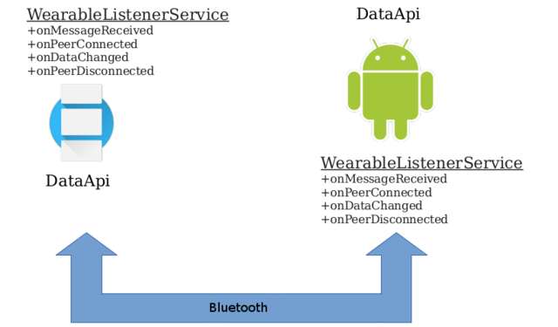

Android Wear applications must implement the wearable listener interface, the life cycle of which is handled by the Google Play Service (as will be shown later in this article). By analyzing applications built for a wearable device, the way Android Wear handles messages becomes clear.

Wearable applications must define a WearableListenerService class with the intent filter com.google.android.gms.wearable.BIND_LISTENER. Using an intent filter has the effect of exporting the service even though recent versions of Android do not export services by default. This allows another application to bind to an instance of the WearableListenerService. Interestingly, no permission is required to bind to services defined for Android Wear.

The goal of this research was to understand any security controls implemented in Android Wear and to determine the possibility of sending messages to arbitrary applications exporting the WearableListenerService.

First let’s assess the services running on the LG G watch.

### WearableListenerService

Looking at the services running on the device, there are a few with wearable listeners. One example is com.google.android.music/com.google.android.music.MusicWearListenerService.

The first step is to generate an app which will try to bind to the MusicWearListenerService. For readability, only the relevant code is shown.

bind.java

BindToService() {

Intent intent = new Intent();

intent.setClassName("com.google.android.music",

"com.google.android.music.MusicWearListenerService");

this.bindService(intent, connection, Context.BIND_AUTO_CREATE);

private ServiceConnection connection = new ServiceConnection() {

public void onServiceConnected(ComponentName className, IBinder iservice) {

Log.d(TAG, "onServiceConnected: " + className.getClassName);

}

public void onServiceDisconnected(ComponentName className) {

Log.d(TAG, "onServiceDisconnected");

}

}

bindService is an asynchronous method, the second argument to which is an object containing methods which will be called when the service is available. Unfortunately, when executing the code above, onServiceConnected is never called. By decompiling MusicWearListenerService, it could be seen that it extends WearableDataListenerService. Similarly, decompiling WearableDataListenerService shows that it in turn extends WearableListenerService.

WearableListenerService.java contained a method onBind(), which is called when a request to bind to the service is made.

WearableListenerService.java

public final IBinder onBind(Intent paramIntent) {

if

("com.google.android.gms.wearable.BIND_LISTENER".equals(paramIntent.getAction()))

return this.Qv;

return null;

}

onBind will return an object if the action sent with the intent is equal to com.google.android.gms.wearable.BIND_LISTENER. Shown below is code with such an action added:

bind.java

BindToService() {

Intent intent = new Intent();

intent.setClassName("com.google.android.music", "com.google.android.music.MusicWearListenerService");

intent.setAction("com.google.android.gms.wearable.BIND_LISTENER");

this.bindService(intent, connection, Context.BIND_AUTO_CREATE);

}

Viewing logcat on the wearable, the following message can be seen, indicating that it is indeed possible bind to a wearable service:

01-29 11:20:38.772 4311-4311/com.example.harrisj.servicebindwear D/SERVICETEST: onServiceConnected: com.google.android.music.MusicWearListenerService

What does the ability to bind to a wearable service allow an attacker to do? To determine this it is necessary to identify how an attacker could interact with the IBinder object received in onServiceConnected().

To interact with the IBinder object, it first needs to be cast to the correct type. Unfortunately for attackers, Google have obfuscated the binaries which contain the correct type, making identification more difficult. However, with a little inference it is possible to work out the required information. In the WearableListenerService class, the object returned in onBind(), named qV, is of type a and is instantiated in onCreate(). “a” is a private class which extends ae.a and contains four methods:

public void a(final ah paramah)

public void a(final ak paramak)

public void ab(final DataHolder paramDataHolder)

public void b(final ak paramak)

In order to aid in debugging, Google has included calls to Log.d in each of these methods. Although these methods are obfuscated, looking at the data that gets logged shows what appears to be pre-obfuscated method names, meaning that the above obfuscated names map to:

onMessageReceived

onPeerConnected

onDataItemChanged

onPeerDisconnected

These are methods of WearableListenerService1.

When interacting with services across applications, an AIDL file is usually used to generate the interface for the IBinder object received. Without this interface, it would not be possible to cast the IBinder object to the correct type, or know which methods are available. Unfortunately, the AIDL file is not available, so it is necessary to look at the decompiled code in more detail to see how to interact with this service.

As the received binder object extends ae, this is the class to decompile next. Although this class is obfuscated, it does follows the structure of an AIDL stub class. According to Google2:

“The Android SDK tools generate an interface in the Java programming language, based on your .aidl file. This interface has an inner abstract class named Stub that extends Binder and implements methods from your AIDL interface. You must extend the Stub class and implement the methods.”

An AIDL file is usually generated by the Android SDK tools to generate an interface for the object. This interface contains a class, called Stub, which has an onTransact method. onTransact takes several arguments, an integer representing which method to call, along with Parcel objects containing data. This allows data to be marshalled and unmarshalled between objects in different processes.

The interface generated from the AIDL file uses the following structure:

public abstract interface < interface name > extends Iinterface {

public abstract void < method description > throws RemoteException

public static abstract class Stub extends Binder implements < interface name > {

public static < interface name > asInterface(IBinder ibinder) {

//do stuff

}

public IBinder asBinder() {

return this;

}

public boolean onTransact(int paramInt1, Parcel, Parcel, int) {

//call methods based on paramInt1 using proxy object

}

private static class Proxy implements < interface name > {

private IBinder mRemote;

Proxy(IBinder) {

//set mRemote to IBinder parameter

}

public IBinder asBinder() {

return mRemote;

}

//methods belonging to interface, called from onTransact

}

}

}

This can be compared to the structure of ae.class

public interface ae extends android.os.IInterface {

void aa(com.google.android.gms.common.data.DataHolder dataHolder)

throws android.os.RemoteException;

void a(com.google.android.gms.wearable.internal.ai ai)

throws android.os.RemoteException;

void a(com.google.android.gms.wearable.internal.al al)

throws android.os.RemoteException;

void b(com.google.android.gms.wearable.internal.al al)

throws android.os.RemoteException;

static abstract class a extends android.os.Binder implements

com.google.android.gms.wearable.internal.ae {

public a() { /* compiled code */

}

public static com.google.android.gms.wearable.internal.ae bY(android.os.IBinder iBinder)

{ /* compiled code */

}

public android.os.IBinder asBinder()

{ /* compiled code */

}

public boolean onTransact(int code,

android.os.Parcel data, android.os.Parcel reply, int flags)

throws android.os.RemoteException {

/* compiled code */

}

private static class a implements

com.google.android.gms.wearable.internal.ae {

private android.os.IBinder le;

a(android.os.IBinder iBinder) { /* compiled code */

}

public android.os.IBinder asBinder() { /* compiled code */

}

public void aa(com.google.android.gms.common.data.DataHolder dataHolder)

throws android.os.RemoteException { /* compiled code */

}

public void a(com.google.android.gms.wearable.internal.ai ai)

throws android.os.RemoteException { /* compiled code */

}

public void a(com.google.android.gms.wearable.internal.al al)

throws android.os.RemoteException { /* compiled code */

}

public void b(com.google.android.gms.wearable.internal.al al)

throws android.os.RemoteException { /* compiled code */

}

}

}

}

From this it can be seen that, although names have been obfuscated, ae.a is in fact the interface generated by the AIDL file including the stub class which will handle our requests. With this in mind, the IBinder object received in onServiceConnected can be cast to ae, and methods subsequently called, as follows:

bind.java

public void onServiceConnected(ComponentName className, IBinder iservice) {

Log.d(TAG, "onServiceConnected: " + className.getClassName());

try {

/*in a non obfuscated class, this would correlate

to YourServiceInterface.Stub.asInterface(service)*/

ae my_ae = ae.a.bY(iservice);

my_ae.a((ai) null);

}

By calling method aa(DataHolder), it is possible to see that this relates to onDataItemChanged by matching the function definitions in ae to those of WearableListenerService. For the observant reader, it would appear that the methods defined in ae are named differently to those discovered before. Whilst this is true, the methods are in fact the same. It is thought to be likely that the version of the SDK used to create the MusicWearListenerService has been compiled and obfuscated differently to that used to create our test application. Ultimately, it is still possible to call the required methods.

After calling a method on the bound service, the following is found in the Android Wear logs:

01-29 13:07:04.175 4542-4542/com.example.harrisj.servicebindwear D/SERVICETEST: onServiceConnected: com.google.android.music.MusicWearListenerService

01-29 13:07:04.175 4542-4542/com.example.harrisj.servicebindwear D/SERVICETEST: iservice is not null

01-29 13:07:04.176 4542-4542/com.example.harrisj.servicebindwear D/SERVICETEST: calling my_ae.a

01-29 13:07:04.189 984-998/? W/Binder: Caught a RuntimeException from the binder stub implementation.

java.lang.SecurityException: Caller is not GooglePlayServices

at com.google.android.gms.wearable.WearableListenerService.pr(Unknown Source)

at com.google.android.gms.wearable.WearableListenerService.b(Unknown Source)

at com.google.android.gms.wearable.WearableListenerService$a.ab(Unknown Source)

at com.google.android.gms.wearable.internal.ae$a.onTransact(Unknown Source)

at android.os.Binder.execTransact(Binder.java:446)

This shows that although a service is exported with no permissions, there is a security check in place in WearableListenerService. WearableListenerService contains the following methods:

private void pr()

throws SecurityException {

int i = Binder.getCallingUid();

if (i == this.SX) return;

if ((GooglePlayServicesUtil.isPackageGoogleSigned(getPackageManager(),

"com.google.android.gms")) && (cU(i))) {

this.SX = i;

return;

}

throw new SecurityException("Caller is not GooglePlayServices");

}

private boolean cU(int paramInt) {

String[] arrayOfString = getPackageManager().getPackagesForUid(paramInt);

boolean bool = false;

if (arrayOfString != null);

for (int i = 0;; i++) {

int j = arrayOfString.length;

bool = false;

if (i < j) {

if ("com.google.android.gms".equals(arrayOfString[i])) bool = true;

} else return bool;

}

}

The method pr() first checks if com.google.android.gms is Google signed and then calls cU() to check if the calling process UID is for the package com.google.android.gms (the Google Play Service package). If the class is further decompiled, it can be seen that this security check happens in each method exposed in WearableListenerService.

The next obvious question is how Android Wear messages go from the Google Play Service to the applications.

### WearableService

WearableService is a service with no permissions, exported from com.google.android.gms (i.e. the Google Play Service package). This can be discovered by either using Drozer, or by viewing the Android Manifest for com.google.android.gms.

dz> run app.service.info

Package: com.google.android.gms

com.google.android.gms.wearable.service.WearableService

Permission: null

The possibility of binding to the WearableService can now be investigated, and the controls which stop messages from passing the package boundary analyzed.

The WearableService is responsible for sending and receiving data over Bluetooth and moving messages between the main applications and the wearable applications. This service can now be investigated to determine if it is possible to bind to it and identify any security controls which would stop an attacker from crafting messages destined for arbitrary applications.

After decompiling WearableService from the Google play package, the following code was found:

private List a() {

List localList = getPackageManager().queryIntentServices(new

Intent("com.google.android.gms.wearable.BIND_LISTENER"), 4);

ArrayList localArrayList = new ArrayList(localList.size());

Iterator localIterator = localList.iterator();

while (localIterator.hasNext()) {

ResolveInfo localResolveInfo = (ResolveInfo) localIterator.next();

try {

localArrayList.add(com.google.android.gms.wearable.node.b.a(this,

localResolveInfo.serviceInfo.packageName));

} catch (PackageManager.NameNotFoundException localNameNotFoundException) {}

}

if (Log.isLoggable("WearableService", 2)) Log.v("WearableService",

"getAllListenerServices: count=" + localArrayList.size());

return localArrayList;

}

This shows how Android Wear’s WearableService loads Wearable applications; it searches for services with an intent of com.google.android.gms.wearable.BIND_LISTENER and loads these packages into a list. It is assumed at this point, that the Google Play Service will then bind to the WearableListenerService service in each package. From the analysis of WearableListenerService it is clear that as WearableService belongs to a Google signed package, this will succeed and will be able to successfully communicate and call methods on this object.

As well as delivering messages to wearable applications, WearableService is also used to receive messages from wearable applications so they can be passed on to the relevant app. To understand how this works, the APIs used to communicate between the wearable app and its companion app can be analyzed; these are MessageAPI, DataAPI and NodeAPI.

DataAPI is an API used to read and write data items and assets. By decompiling and then searching a test application which uses this API, it is possible to find the code that implements the DataApi interface in com/google/android/gms/wearable/internal/f.java.

f.java

public PendingResult < DataApi.DataItemResult > putDataItem(GoogleApiClient paramGoogleApiClient,

final PutDataRequest paramPutDataRequest) {

return paramGoogleApiClient.a(new d(paramGoogleApiClient) {

protected void a(ba paramAnonymousba)

throws RemoteException {

paramAnonymousba.a(this, paramPutDataRequest);

}

public DataApi.DataItemResult aE(Status paramAnonymousStatus) {

return new f.b(paramAnonymousStatus, null);

}

});

}

Following the code flow, it is possible to find the Binder object (af.java) used to communicate with the IWearbleService class exported from com.google.android.gms. It is now clear how an application communicates with the WearableService, but is there anything that stops an attacker from performing the same actions manually?

As with WearableListenerService, no AIDL is made available. As before then, an application can be decompiled to identify an appropriate interface.

Once again, analysis starts with the WearableService onBind() method:

public IBinder onBind(Intent paramIntent) {

String str = paramIntent.getAction();

if ((Build.VERSION.SDK_INT >= 18) &&

("com.google.android.gms.wearable.BIND".equals(str))) return new o(this, this).asBinder();

return null;

}

By following the code flow, it is clear that when an application binds to the WearableService, it receives an object of type IGmsServiceBroker. IGmsServiceBroker has a method which takes an IGmsCallbacks class. A method in IGmscallbacks will eventually return a WearableService class.

At this stage it is finally possible to call WearableService as follows, specifying the package to which the should be delivered:

bind.java

my_jt.e(my_js,1,"com.google.android.music");

This generates a message using the data in my_js, destined for the package specified in the third argument. Logcat shows a security exception is thrown stating that the package specified must belong to the calling application.

W/AppOps ( 1077): Bad call: specified package com.google.android.music under UID 10203 but it is really 10082

E/AndroidRuntime(13094): FATAL EXCEPTION: main

E/AndroidRuntime(13094): Process: com.example.harrisj.servicetest, PID: 13094

E/AndroidRuntime(13094): java.lang.SecurityException: Unknown calling package name 'com.google.android.music'.

By further analysing the Google Play Service application, the following security check is performed in this function:

public static void c(Context paramContext, String paramString) {

int i = Binder.getCallingUid();

if (i == Process.myUid());

while (a(paramContext, i, paramString))

return;

throw new SecurityException(String.format("Unknown calling package name '%s'.", new Object[] {

paramString

}));

}

Note that there are often inaccuracies in decompiled code, hence this code may not be completely accurate.

In the call to a(paramContext, I, paramString), the UID from Binder.getCallingUid is used to get a list of all packages for that UID and compared to the string passed in as an argument. This means the security check will fail if the UID does not belong to the package name specified and a security exception will occur.

### Conclusion

This research aimed to discover how Android Wear applications communicate and whether there are controls in place that stop non-privileged malware from delivering messages to arbitrary applications. The two methods explored (binding to WearableListenerService, and WearableService) showed that Google have taken the time to perform adequate security checks and unless a flaw is found in these checks, developing for Android Wear should not add a significant risk to your application from low privileged malware.

#### References

* <https://developer.android.com/reference/com/google/android/gms/wearable/WearableListenerService.html>
* <http://developer.android.com/guide/components/aidl.html>
* <https://developer.android.com/reference/com/google/android/gms/wearable/DataApi.html>